**EE6306**

**APPLICATION SPECIFIC INTEGRATED CIRCUIT DESIGN**

**Design of a Mini Stereo Digital Audio Processor**

**PROJECT REPORT**

**Submitted by –**

**Lavanya Samiti Parameswara (lxs141630)**

**Merin Thomas (mxt142430)**

**TABLE OF CONTENTS**

|  |  |  |
| --- | --- | --- |
| 1 | ASIC Design Flow | 3 |
| 2 | Objectives and Introduction | 5 |
| 3 | Design Specifications | 6 |
| 4 | Block Diagram | 7 |
| 5 | Operation Modes and FSM | 8 |
| 6 | Pin Assignment and Description | 10 |
| 7 | Signal and Data Format | 11 |
| 8 | System Setting | 13 |
| 9 | Architecture of MSDAP | 13 |
| 10 | Definition and Spec of Functional Blocks | 14 |
| 11 | Simulation Results of State Transitions | 45 |
| 12 | Pin Diagram of Complete MSDAP | 51 |
| 13 | Schematic of MSDAP | 52 |
| 14 | Critical Path of MSDAP | 52 |
| 15 | Design Vision Reports | 52 |
| 16 | Physical Design Flow | 59 |
| 17 | Physical Verification | 65 |
| 18 | Challenges in Physical Design | 66 |
| 19 | Optimization | 66 |
| 20 | Conclusion | 68 |
| 21 | Appendix: Results | 68 |

**ASIC Design Flow**

ASIC flow in designing an Integrated Circuit for the desired specification is summarized below:

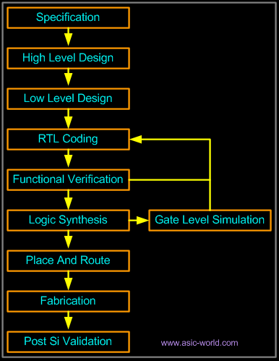

**Step 1: Specification**

First step in the ASIC flow is to get the requirements of the application through analyzing. For IC design, getting the specification is a very significant step.

**Step 2: High Level Design (Behavioral Description)**

In this step in the ASIC design flow is to get design specifications based on the application being implemented. Behavioral modeling is a high-level modeling technique where behavior of the logic is modeled based on the specifications obtained. The behavioral logic is then tested by generating waveform and verifying the functionalities of the application. In this stage the structural implementation is not significant. In this step any redundant logics are removed.

**Step 3: Low level design (RTL Design)**

Register Transfer Logic (RTL) is used to describe the logic design part of the flow. Unlike behavioral modeling where code is written in high-level, RTL is written in transistor level. In this step in ASIC design flow the application specification is implemented in register level hence the name register –transfer level. Registers are responsible for storing values in it and all other computations are implemented in combinational logic.

**Step 4: RTL verification**

In this step the written RTL code is verified by checking its functionality. This can be achieved by writing test benches. Writing test benches must cover all the possible cases to determine its correct functioning of the application. If we find any flaw in the design, we should go back to the previous step and fix the RTL code. This is one of the significant step to implement a correct application. We can also generate timing, area and power details which will be useful in case of overhead issues.

**Step 5: Logic synthesis**

In this step, The RTL code is synthesized using the standard library and the physical realization of the RTL code can be seen. All the logics in the code will be mapped to the gates in the standard library. During synthesis with the help of logic optimization in the tool will help to speed up the logic and optimize the area. FSM decomposition, power and data-path optimization is done in this step. The tool will also makes use of area, timing and power information for efficient mapping to the gates and flip-flops.

**Step 6: Floor planning Automatic Place and route**

The gate level net-list which is obtained from the previous step is used for the physical implementation on the chip. Physical implementation includes partitioning, floor planning, placement and route. All these steps are using Synopsys IC compiler. Several iterations are run by the tool to reduce the overall wire length and area.

Route is first performed, this will give an abstract wire length and specified channel where actual routing should takes place. After this a detailed routing will takes place on the already routed lines. If there is more delay on this path different placement will be performed.

**Design of Mini Stereo Digital Audio Processor**

**Objective**

To design and implement an MSDAP in Hardware Descriptive Language by:

1. Defining the input & output ports and other specifications in detail.
2. Writing the behavioral model for MSDAP.
3. Writing a Test Bench to simulate all the cases of the specification.
4. Performing the Functional Verification to validate the specification.

**Introduction**

Most of the modern multimedia systems require the implementation of audio processors which are highly accurate and efficient being the first priority. In order to achieve this, the cost becomes invariantly high. So, when the same design is to be used for portable devices or household applications such as audio systems, cost of the audio processor and power consumption are of major concern. Most of the similar audio processing designs are implemented using the Digital Signal Processing (DSP) chips with separate left and right channel processing that performs the basic function of Finite Impulse Response (FIR) Digital Filter.

A new approach ‘Mini Stereo Digital Audio Processor (MSDAP)’ is proposed wherein a single MSDAP chip is capable of producing the same result as that of two DSP chips for two channels, thereby reducing the power and hardware and hence the cost of the chip. The FIR filter is implemented based on the following linear convolution:

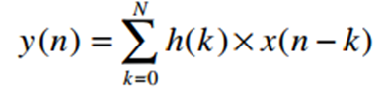

Where,

x (n) = input audio samples

y (n) = output audio samples

h (k) = Filter co-efficients

N = Filter order

It follows from the above expression that N additions and (N +1) multiplications are required. In hardware, implementing the multiplication either floating or fixed point is very costly with regard to power, area and complexity. The proposed model can overcome these issues by replacing the multiplication unit with a one bit shifter and either an addition/subtraction unit which proves to be much faster and efficient than the former.

**Design Specifications**

Our application of the hearing aid has the MSDAP chip as the critical part. The system specification for this application can be divided into three parts –

1. System level view and algorithm
2. Operation modes and FSM
3. Pins, data formats and signals

**System level view and algorithm**

**Algorithm Description:**

The MSDAP will focus on the FIR Digital filtering for the hearing aid application, which involves the following linear convolution:

N

*y (n)* =Ʃ *h (k)* x *x (n-k)*

k=0

Where *x (n)* and *y (n)* are the input and output audio sequences, and *h (k)* are filter coefficients with the filter order *N*.

The steps involved in computing the linear convolution shown above is discussed in detail below:

*y*(*n*) *= h*(0)*x*(*n*-0) *+ h*(1)*x*(*n*-1) *+ h*(2)*x*(*n-*2) *+ …… + h*(N)*x(n*-N)

*h* (0), *h* (1), *h* (2)… *h* (N) are expressed in terms of POT.

In order to reduce the hardware complexity of using a shifter of up to 16 bits, a one bit shifter is employed in the design. Accordingly, the above expression is transformed to –

*y (n) =* 2-1(….2-1 (2-1 (2-1*u1+ u2*) *+ u3*) *+ ….*) *+ u16*)

Where *u0, u1, u2, u3 … u16* are addition/subtraction of the input samples defined by the rj values.

*uj = xj* (1) *+ xj* (2) *+ …. + xj* (*rj*) 1≤ j ≤ 16

Where *xj* (*l*) є {±*x* (*n-k*)}, 1≤ *l* ≤ *rj*

With this approach, MSDAP can implement two FIR filters for left and right channels and the order of the filter can go up N = 255.

**Block Diagram:**

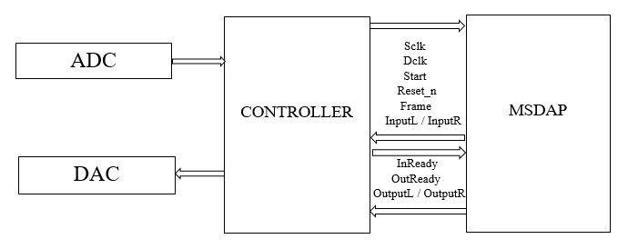

As we can see from the block diagram above, we have input signals Sclk, Dclk, Start, Reset_n, Frame, InputL/R and output signals Inready, Outready, OutputL/R to and from the MSDAP chip respectively, from the controller system.

**Operation modes and FSM**

**State Description of FSM:**

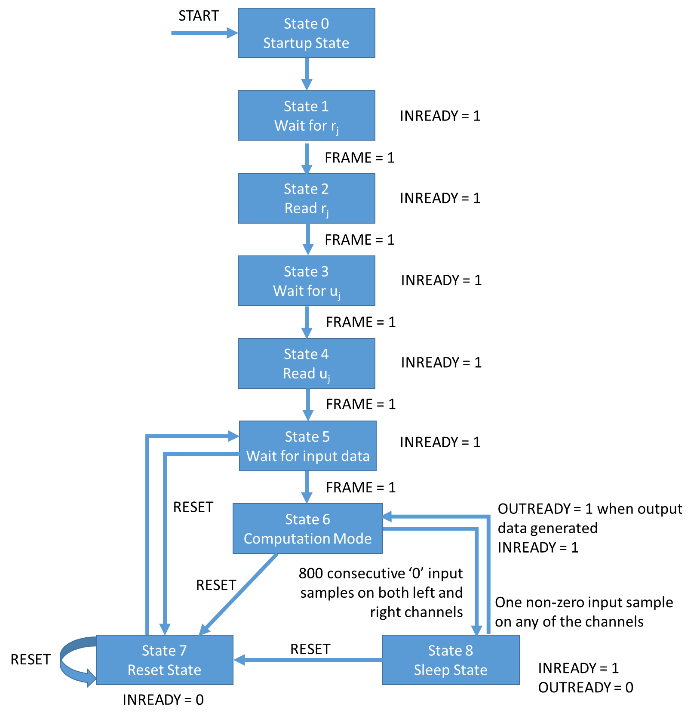

**Operation modes:**

1. **State 0 (Startup State):**

The START signal, when set high, initializes the chip and prepares it for working by clearing memories and registers, and then the chip enters State 1.

1. **State 1 (Wait for rj):**

INREADY is set high. If FRAME = 1 is seen on the line, the chip enters state 2.

1. **State 2 (Read rj):**

The chip starts reading rj values and INREADY remains high. Once all the rj values have been collected, the chip enters state 3.

1. **State 3 (Wait for uj):**

INREADY is set high. If FRAME = 1 is seen on the line, the chip enters state 4.

1. **State 4 (Read uj):**

The chip starts reading uj values and INREADY remains high. Once all the uj coefficient values have been collected, the chip enters state 5.

1. **State 5 (Wait for input data):**

INREADY is set high. If FRAME = 1 is seen on the line, the chip enters State 6. Or else, if RESET_N = 0 is seen, the chip enters State 7.

1. **State 6 (Computation mode):**

Here the chip accepts incoming input data, computes the output values for convolution, and puts out output values too. INREADY remains high. If RESET_N = 0 is detected, the chip enters State 7. Or else, if 800 consecutive input samples on both channels are detected as zero, the chip enters the Sleep mode (State 8).

1. **State 7 (Reset mode):**

Here, INREADY is set low. All registers and memories except rj and coefficients are cleared. If RESET_N = 0 is seen on the line, the chip restarts the same process. Once reset is completed, the chip automatically goes to State 5.

1. **State 8 (Sleep mode):**

Here, the chip in sleep mode until a non-zero input sample is detected on either left or right channel. INREADY is kept high. If RESET_N = 0 is detected, the chip goes to State 7.

**Pin assignment and description**

**Pin Diagram:**

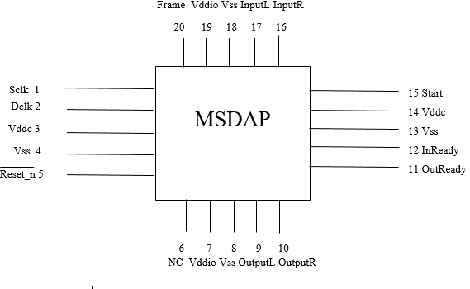

**Function of Signals:**

* Sclk - 1: Sclk is the system clock that is used to synchronize all the control signals and IO signals. All the state changes and the computation happen with the negative or falling edge of the System clock. The frequency of the Sclk determines the frequency of operation of the entire system/ chip. This is an input signal to the MSDAP from the controller.
* Dclk - 2: Dclk is the Data clock that is used as the timing reference to receive and send the input samples. A bit is received or sent at the falling edge of the Dclk. Hence to receive a 16 bit data, 16 Dclk cycles are required. One Dclk is 35 Sclk cycles. This is an input signal to the MSDAP from the controller.
* Frame - 20: Frame is an input signal from the controller to the MSDAP. While sending or receiving the input or output to or from the MSDAP, the Frame is set high. Frame signifies the start of the first bit of data-input, output, Rj or co-efficient. Frame is used as active high signal and is made high for one Dclk cycle. After receiving the first bit of the data, the Frame goes inactive i.e. low. Frame is made active after every 16 Dclk cycles and hence a 16 bit data is received between two successive Frames.
* Start - 15: Start is an asynchronous input signal from the Controller to MSDAP. It is used to indicate the start of the FSM and initialization of chip begins. Until then the chip is said to be idle. Start is an active high input signal.
* Reset_n - 5: Reset is an active low asynchronous input signal to the MSDAP. The chip goes to the reset mode when this signal is applied.
* InputL - 17: This is a one bit wide left input channel. It allows left co-efficient, Rj values and left input audio samples in serial format.
* InputR - 16: This is same as InputL but used for the right audio channel.
* InReady - 12: InReady is an input signal to the Controller from the MSDAP which is set high when the chip is ready to receive the data from both the channels. InReady is aligned with the Frame.
* OutputL - 9: This is a one bit wide left output channel. It allows left output audio samples in serial format.
* OutputR - 10: This is same as OutputL but used for the right audio channel.
* OutReady - 11: It is an output signal from the MSDAP to the Controller that goes high when the output is ready to be sent. It goes low when the last bit of the output data sample is sent. This signal is aligned with the rising edge of the Frame signal.

**Signal and Data Format**

All the input data x (n), coefficients uj, and rj values are transmitted as 16-bit 2’s complement form values. Zero-padding is done to bring each value to 16 bits. The values are received by the chip with the MSB leading in first. All the input received must be synchronized to the data clock (Dclk), which is given as 768 kHz per bit. Since there are 16 bits for each value, the frame is 16 bits long, and the frame rate will be 768/16 = 48 kHz. However, the Sclk will depend on how the system is implemented.

1. **Rj format** –

The rj value is 8 bits long and is stored in the lower half of the 16-bit frame, while the other higher order bits are zero padded to form the frame. The frame is as shown below –

|  |  |  |  |  |  |
| --- | --- | --- | --- | --- | --- |
| 0 | . . . . . . . . . . . . . . . . . . . . . . | 7 | 8 | . . . . . . . . . . . . . . . . . . . . . . | 15 |
|  | Unused/Padded bits |  | MSB | Rj data | LSB |

1. **Uj format** –

The coefficient uj value is 8 bits long with a sign bit, and the rest of the frame is zero padded. The 16-bit frame is as shown below –

|  |  |  |  |  |  |  |
| --- | --- | --- | --- | --- | --- | --- |
| 0 | . . . . . . . . . . . . . . . . . . . . . . | 6 | 7 | 8 | . . . . . . . . . . . . . . . . . . . . . . | 15 |
|  | Unused/Padded bits |  | Sign bit | MSB | Coefficient data | LSB |

1. **Input/Output data format** –

The input/output data frames are 16 bit 2’s complement values.

|  |  |  |
| --- | --- | --- |
| 0 | . . . . . . . . . . . . . . . . . . . . . . | 15 |
| MSB | Input/output data bits | LSB |

The timing diagram for the input is as given below –

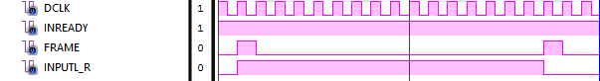

As we see, the FRAME signal is raised high for one clock cycle whenever a new frame with new data starts. The data is transmitted as one bit per clock cycle for 16 cycles of DCLK i.e. for 16 bits. During this time, the INREADY signal is kept high to signal that inputs are ready to be accepted.

The timing diagram for the output is as follows –



As we see, the FRAME signal works according to DCLK (16 cycles), while OUTREADY and OUTPUTL/R are synchronized according to the system clock SCLK. SCLK depends on the architecture of the implementation. Once OUTREADY is set high, OUTPUTL/R gives the 40-bit output, and once all 40 bits are put on the line, one every clock cycle, and then OUTREADY is set low.

**System Setting**

The main blocks in the system is ADC, Controller, MSDAP and DAC (Refer Block Diagram above)

**ADC:** Analog to Digital Converter is used to convert the analog audio samples to digital values. The analog data is sampled at the rate of 48 KHz.

**Controller:** Controller is responsible for generating the control signals to the MSDAP. It also sends the converted digital samples from ADC to the MSDAP at the rate of Dclk for the computation. After the computation, MSDAP sends the output samples to the controller at the rate of Dclk which is 768 KHz.

**MSDAP:** MSDAP is responsible for the computation on the received input samples. The computation is carried out at the rate of Sclk which is 26.88MHz. For one complete computation on the input data sample, the number of Sclk cycles required will determine the frequency of operation of MSDAP chip. For one computation, 512 additions and 16 shifts are required. Rj value add upto a total of 512, requiring 512 additions/subtractions to calculate 16 U values. After each U value calculation, it is to be shifted once. Hence, a total of 528 Sclk cycles are required. Based on these calculations, we decided the Sclk frequency to be 26.88MHz and Dclk frequency to be 768 KHz.

**DAC:** Once the output digital samples are received by the Controller, it is fed to the Digital to Analog Converter that converts the digital samples to actual audio output signals.

**Architecture of MSDAP**

The architecture for MSDAP contains the following blocks:

* MSDAP Control Unit
* Memory Bank
* Serial In Parallel Out (SIPO) Unit
* Zero Detector Unit
* ALU Control Unit
* Sign Extend Unit
* Adder Unit
* Accumulate and Shift Unit
* Parallel In Serial Out (PISO) Unit.

Below figure shows the architecture of MSDAP for both left and right channels.

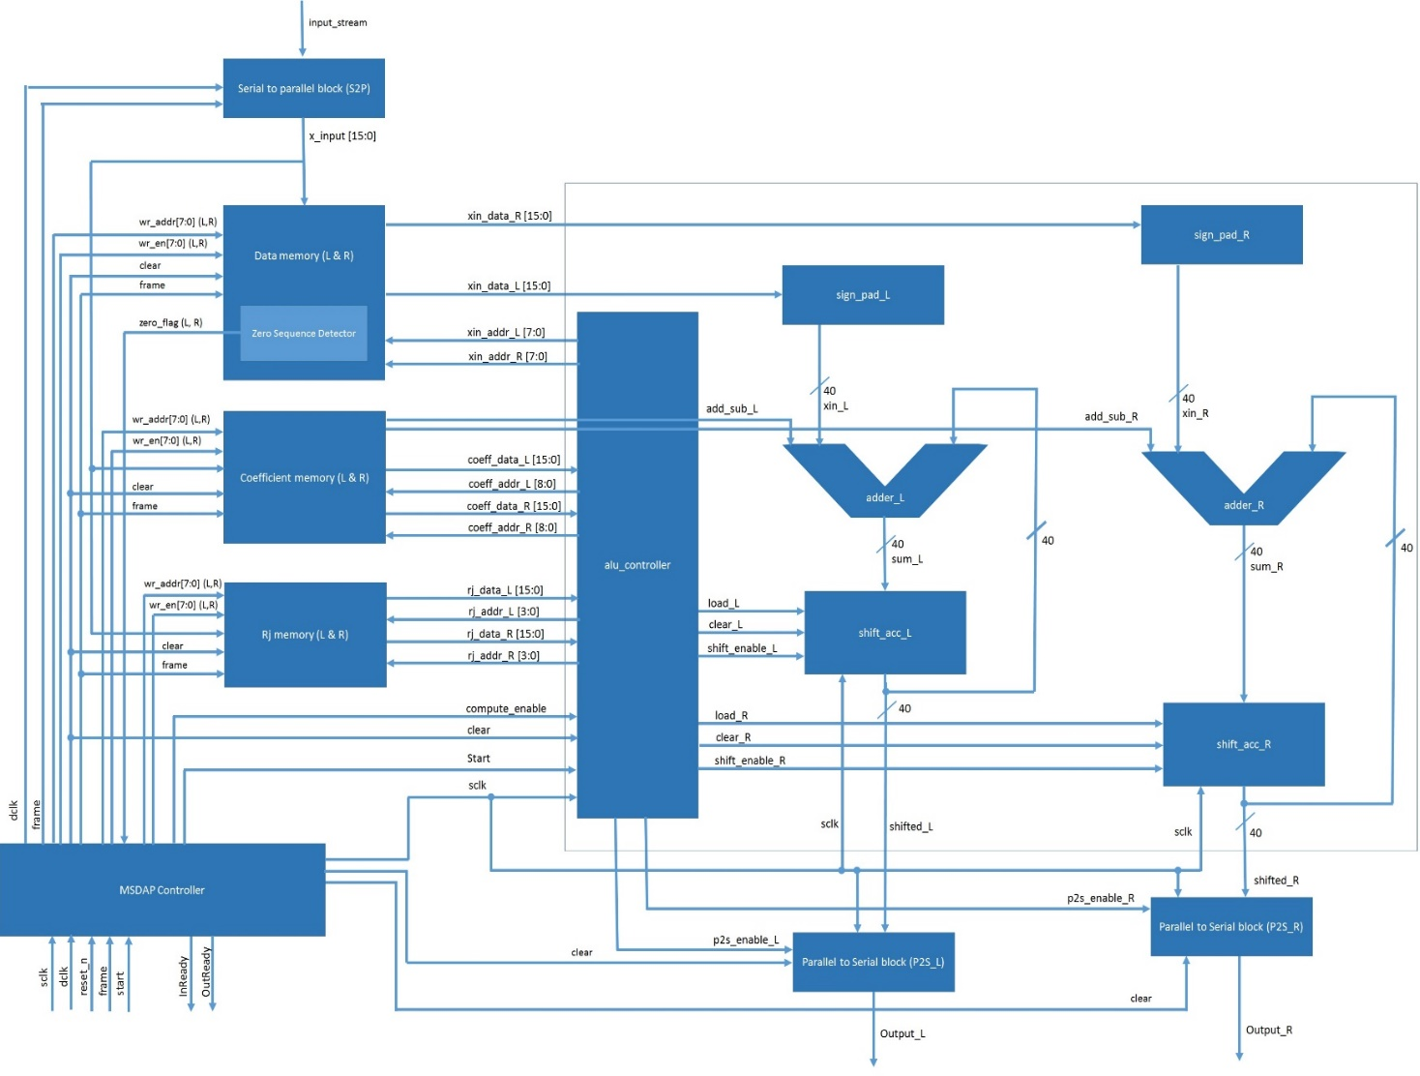

**Definition and Specification of each functional block:**

1. **Serial In Parallel Out [S2P]:**

**Functionality:**

This functional block operates on the rising edge of the Dclk and the FRAME. Serial data starting from the MSB of the 16bits input data is received at the arrival of frame and it is captured in the rising edge of the Dclk. Once the frame goes high, the MSB data is received on that edge and the rest 15 bits of data is received at every Dclk positive edge. Once the data is packed into a 16 bit word, the S2P block signals the FSM Controller to enable the respective data memory and passes the address.

|  |  |  |
| --- | --- | --- |
| **Signal** | **Input/output** | **Description** |
| Frame | Input | Frame is aligned with the Dclk and the input data. For the first bit from 16 bit word data, the Frame will be active, after first Dclk clock cycle, the Frame goes inactive. |
| Clear | Input | Clear is used to clear the SIPO whenever a reset condition arises from the main controller |
| Dclk | Input | Dclk is the timing reference for receiving the input data serially. Data is received serially at the positive edge of the Dclk. |
| InputL, InputR | Input | InputL, InputR are the serial inputs to the S2P. These input data are captured on the positive edge of Dclk. MSB at the 0th position is transmitted first and the LSB at 15th position is transmitted last. |
| data_L, data_R [15:0] | Output | data_L, data_R are the 16 bit parallel data fed as data to be written to the memory. |
| input_rdy_flag | Output | input_rdy_flag is used to signal to the main controller that data is ready to write to memory |

**Verilog Code:**

module SIPO (Frame, Dclk, Clear, InputL, InputR, data_L, data_R, input_rdy_flag);

input Frame, Dclk, Clear, InputL, InputR;

output reg input_rdy_flag;

output reg [15:0] data_L;

output reg [15:0] data_R;

reg [3:0] bit_count;

reg frame_status;

always @(negedge Dclk or posedge Clear)

begin

if (Clear == 1'b1)

begin

bit_count = 4'd15;

//temp_L = 16'd0;

//temp_R = 16'd0;

data_L = 16'd0;

data_R = 16'd0;

input_rdy_flag = 1'b0;

frame_status = 1'b0;

end

else

begin

if (Frame == 1'b1)

begin

bit_count = 4'd15;

input_rdy_flag = 1'b0;

data_L [bit_count] = InputL;

data_R [bit_count] = InputR;

frame_status = 1'b1;

end

else if (frame_status == 1'b1)

begin

bit_count = bit_count - 1'b1;

data_L [bit_count] = InputL;

data_R [bit_count] = InputR;

if (bit_count == 4'd0)

begin

//data_L = temp_L;

//data_R = temp_R;

input_rdy_flag = 1'b1;

frame_status = 1'b0;

end

else

begin

//data_L = data_L;

//data_R = data_R;

input_rdy_flag = 1'b0;

frame_status = 1'b1;

end

end

else

begin

bit_count = 4'd15;

data_L = 16'd0;

data_R = 16'd0;

input_rdy_flag = 1'b0;

frame_status = 1'b0;

end

end

end

endmodule

**Simulation Results:**

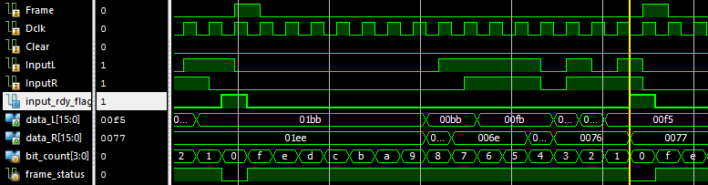

Operation starts at the beginning of Frame appearing and is completed when input_rdy_flag is raised and data_L and data_R is considered valid for writing to memory.

1. **Rj Memory (L & R):**

**Functionality:**

Rj block is 16 bits wide and a depth of 16 locations. It is used to save the Rj values. There are 2 such blocks for left and right channel Rj samples. This Block is insensitive to the clear signal from the FSM controller. Based on the address and write enable, the data is being written into the memory at the positive edge of the Sclk. Data is read out for the computation by using read address signal. 4 bits address is required.

|  |  |  |
| --- | --- | --- |
| **Signal** | **Input/output** | **Description** |
| Sclk | Input | Sclk is the timing reference for the rj memory. |
| data_in [15:0] | Input | data_in is a 16 bit input word from the S2P. Based on the address and the write enable signals, the x_input is written to either rj memory at the positive edge of the Sclk. |
| rd_en | Input | rd_en is used by the ALU to enable reading from the memory |
| rj_wr_addr [3:0] (L/R) | Input | Address is 4 bits wide. This address comes from the MSDAP controller. It is used to write the data into the block. There are two signals for both right and left channel. |
| wr_en (L/R) | Input | Write enable is used by the main controller to enable writing to the memory |
| rj_data [15:0] (L/R) | Output | rj_data_L, rj_data_R is the 16 bit data from the left and right Rj memory respectively and is fed to the left and right ALU Control Block. The data is read when the Frame goes high. |
| rj_rd_addr [3:0] (L/R) | Input | rj_rd_addr is 4 bit address from the ALU controller. This is used to fetch the corresponding data from the left and right rj memory. |
| input_rdy_flag | Output | input_rdy_flag signals the main controller that the input is ready for processing |

**Verilog Code:**

module rj_memory (input wr_en, rd_en, Sclk,

input [3:0] rj_wr_addr, rj_rd_addr,

input [15:0] data_in,

output [15:0] rj_data);

reg [15:0] rj_mem [0:15];

always @(negedge Sclk)

begin

if(wr_en == 1'b1)

rj_mem[rj_wr_addr] = data_in;

else

rj_mem[rj_wr_addr] = rj_mem[rj_wr_addr];

end

assign rj_data = (rd_en) ? rj_mem[rj_rd_addr] : 16'd0;

endmodule

**Simulation Results:**

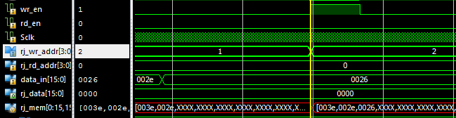

As we see, when wr_en is enabled, the rj_wr_addr is used to write the data 0026 to the rj_mem.

1. **Co-efficient Memory (L & R):**

**Functionality:**

Co-efficient Block is 16 bits wide and a depth of 512 locations. Based on the address and write enable, the data is being written into the memory at the positive edge of the Sclk. Data is read out for the computation by using read address signal. There are 2 such blocks for left and right channel Co-efficient values. 9 bits address is required.

|  |  |  |
| --- | --- | --- |
| **Signal** | **Input/output** | **Description** |
| Sclk | Input | Sclk is the timing reference for the coeff memory. |
| data_in [15:0] | Input | data_in is a 16 bit input word from the S2P. Based on the address and the write enable signals, the data_in is written to either coeff memory at the positive edge of the Sclk. |
| rd_en | Input | rd_en is used by the ALU to enable reading from the memory |
| coeff_wr_addr [8:0] (L/R) | Input | Address is 9 bits wide. This address comes from the MSDAP controller. It is used to write the data into the block. There are two signals for both right and left channel. |
| wr_en (L/R) | Input | Write enable is used by the main controller to enable writing to the memory |
| coeff_data [15:0] (L/R) | Output | coeff_data_L, coeff_data_R is the 16 bit data from the left and right coeff memory respectively and is fed to the left and right ALU Control Block. The data is read when the Frame goes high. |
| coeff_rd_addr [8:0] (L/R) | Input | coeff_rd_addr is 9 bit address from the ALU controller. This is used to fetch the corresponding data from the left and right coeff memory. |
| input_rdy_flag | Output | input_rdy_flag signals the main controller that the input is ready for processing |

**Verilog Code:**

module coeff_memory (input wr_en, rd_en, Sclk,

input [8:0] coeff_wr_addr, coeff_rd_addr,

input [15:0] data_in,

output [15:0] coeff_data);

reg [15:0] coeff_mem [0:511];

always @(negedge Sclk)

begin

if(wr_en == 1'b1)

coeff_mem[coeff_wr_addr] = data_in;

else

coeff_mem[coeff_wr_addr] = coeff_mem[coeff_wr_addr];

end

assign coeff_data = (rd_en) ? coeff_mem[coeff_rd_addr] : 16'd0;

endmodule

**Simulation Results:**

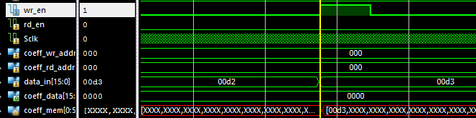

As we see, when wr_en is enabled, the coeff_wr_addr is used to write the data 00d3 to the coeff_mem at location 000.

1. **Data Memory (L & R):**

**Functionality:**

Data block is 16 bits wide and a depth of 256 locations. Each time a Frame is received by the SIPO from the FSM controller, upon activation of write enable signal and address, the data is being written to the Data block at the positive edge of the Sclk. Once the Data block is filled, it is re-used for the new incoming data from the 0th location. Hence, it acts like a circular / cyclic buffer. There 2 such data blocks for left and right channel input data samples. When a clear signal is sent by the FSM controller, all the data in the Data Block memory is cleared. 8 bits address is required.

|  |  |  |
| --- | --- | --- |
| **Signal** | **Input/output** | **Description** |
| Sclk | Input | Sclk is the timing reference for the data memory. |
| data_in [15:0] | Input | data_in is a 16 bit input word from the S2P. Based on the address and the write enable signals, the data_in is written to either data memory at the positive edge of the Sclk. |
| rd_en | Input | rd_en is used by the ALU to enable reading from the memory |
| data_wr_addr [7:0] (L/R) | Input | Address is 8 bits wide. This address comes from the MSDAP controller. It is used to write the data into the block. There are two signals for both right and left channel. |
| wr_en (L/R) | Input | Write enable is used by the main controller to enable writing to the memory |
| xin_data [15:0] (L/R) | Output | xin_data_L, xin_data_R is the 16 bit data from the left and right data memory respectively and is fed to the left and right ALU Control Block. The data is read when the Frame goes high. |
| data_rd_addr [7:0] (L/R) | Input | coeff_rd_addr is 8 bit address from the ALU controller. This is used to fetch the corresponding data from the left and right data memory. |
| input_rdy_flag | Output | input_rdy_flag signals the main controller that the input is ready for processing |
| zero_flag | Output | zero_flag is used to enforce the 800 zeroes condition for sleep mode |

**Verilog Code:**

module data_memory (input wr_en, rd_en, Sclk, input_rdy_flag,

input [7:0] data_wr_addr, data_rd_addr,

input [15:0] data_in,

output [15:0] xin_data,

output reg zero_flag);

reg [15:0] data_mem [0:255];

reg [11:0] zero_cnt;

always @(negedge Sclk)

begin

if(wr_en == 1'b1)

data_mem[data_wr_addr] = data_in;

else

data_mem[data_wr_addr] = data_mem[data_wr_addr];

end

always @(posedge input_rdy_flag)

begin

if (data_in == 16'd0)

begin

zero_cnt = zero_cnt + 1'b1;

if (zero_cnt == 12'd800)

zero_flag = 1'b1;

else if (zero_cnt > 12'd800)

begin

zero_cnt = 12'd800;

zero_flag = 1'b1;

end

end

else if (data_in != 16'd0)

begin

zero_cnt = 12'd0;

zero_flag = 1'b0;

end

end

assign xin_data = (rd_en) ? data_mem[data_rd_addr] : 16'd0;

endmodule

**Simulation Results:**

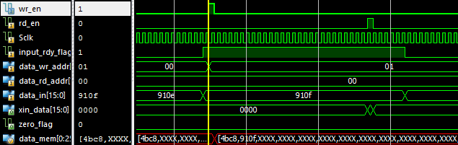

As we see, when wr_en is enabled, the data_wr_addr is used to write the data 910F to the data_mem at location 01. Also, rd_en is enabled to read the data from location 00 i.e. 4BC8.

1. **Adder Block:**

**Functionality:**

Addition/Subtraction is performed in this block depending on the add_sub_L or add_sub_R signal from the coefficient memory block. The total number of additions or subtractions in this unit is 512 for one computation of the input data sample. Addition/subtraction takes place at the positive edge of the Sclk. One of the operands come from the sign extension block and the other operand comes from the Shifter block. Both operands are 40 bits wide. The result which is 40 bits is fed back to the Shifter block.

**Adder (L & R)**

|  |  |  |
| --- | --- | --- |
| **Signal** | **Input/Output** | **Description** |
| add_sub | Input | add_sub_L is 1 bit wide coming from the ALU controller based on the MSB of the coefficient value read from memory. This bit decides whether addition or subtraction that has to be performed between the operands of the adder_L. |
| a | Input | a is 40 bits wide which is sign extended and padded version of xin_data_L coming from the sign_pad_L block. This is one of the operands for adder_L. |
| b | Input | b is 40 bits wide which is fed as another operand to the adder_L block. |
| adder_en | Input | adder_en is used to enable the adder to perform addition/subtraction at required times |
| sum | Output | This is the result of a and b which is 40 bits wide. This data is fed to the shift_acc_L block. |

**Verilog Code:**

module adder(

input [39:0] a,

input [39:0] b,

input add_sub,

input adder_en,

output [39:0] sum

);

assign sum = (add_sub == 1'b1) ? (b - a) :

(add_sub == 1'b0) ? (b + a) :

sum;

endmodule

**Simulation Results:**

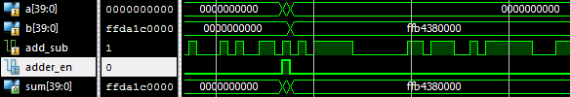

The addition operation is carried out when adder_en is activated. As we can see, subtraction is carried out i.e. (b – a) to retain the value 0xFFB4380000.

1. **Shift and Accumulate block:**

**Functionality:**

The content in this block is initially set to 40 bit zero. It holds the result of the adder block when a load signal from the ALU control block is applied to it. One bit is right shifted whenever shift_enable signal from the ALU controller is applied. Shifting is done in the positive edge of the Sclk. Whenever there is a Reset signal from the ALU control block, the contents in the accumulator is cleared. The shiftout_L or shiftout_R is 40 bits which is fed back as one of the operand to the respective adder block.

**shift_acc (L & R)**

|  |  |  |
| --- | --- | --- |
| **Signal** | **Input/output** | **Description** |
| shift_enable | Input | shift_enable signal indicates that shift operation has to be done in the shift_acc block. |
| load | Input | load signal indicates that accumulator register is loaded with the result of the adder block. |
| clear | Input | clear signal indicates that accumulator register which is of 40 bits wide has to be made zero. It is also used when global reset is applied. |
| sclk | Input | Sclk is the timing reference signal to perform right shift operation on the data in the 40 bit accumulator register. |
| sum | Input | This is the result of xin and shifted signal which is 40 bits wide. This data is fed to the shift_acc block. |
| shifted | Output | This is 40 bits wide which is sent to the PISO after the computation is done. The 40 bits is also fed back as one of the operand to adder block. |

**Verilog Code:**

module shift_acc(

input shift_enable,

input load,

input clear,

input sclk,

input [39:0] blk_in,

output [39:0] blk_out

);

reg [39:0] shift_acc_reg;

always @(posedge sclk)

begin

if (clear)

shift_acc_reg = 40'd0;

if (load && shift_enable)

shift_acc_reg = {blk_in[39], blk_in[39:1]};

else if (load && !shift_enable)

shift_acc_reg = blk_in;

else

shift_acc_reg = shift_acc_reg;

end

assign blk_out = shift_acc_reg;

endmodule

**Simulation Results:**

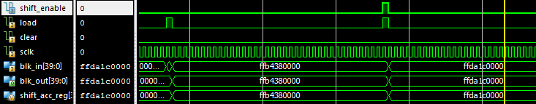

We see that as shift_enable is asserted, the shift is carried out.

1. **ALU Controller:**

**Functionality:**

This block receives the required signals from FSM control block and the data from the memory block. The ALU control block is activated by the FSM control block whenever the computation on the input data sample has to be started.

**alu_controller**

|  |  |  |
| --- | --- | --- |
| **Signal** | **Input/output** | **Description** |
| compute_enable | Input | This is a 1 bit enable signal from FSM control block to activate the ALU control block. This signal will be high whenever computation is started on the input data sample. |
| Clear | Input | Clear signal indicates that ALU control block has to send clear_L and clear_R signal to the accumulator to clear the data in the accumulator. |
| rj_data_L, rj_en_L  rj_data_R, rj_en_R | Input | rj_data_L and rj_data_R are the 16 bit data from the left rj block and right rj block respectively and is fed to the alu_controller block, while rj_en are enables to the memories |
| coeff_data_L, coeff_en_L  coeff_data_R, coeff_en_R | Input | This is a 16 bit data from the left coefficient block and right coefficient block and are fed to the ALU control block based on the rj values, while coeff_en are the enables to the memories |
| sclk | Input | sclk is the timing reference signal to the ALU control block to perform load or shift operation. |
| sleep_flag | Input | sleep_flag indicates to the ALU that the main controller is now in sleep mode and all operations must stop |
| rj_addr_L,  rj_addr_R | Output | rj_addr_L and rj_addr_R are the 4-bit addresses to the left rj block and right rj block respectively |
| coeff_addr_L,  coeff_addr_R | Output | These are 9 bit addresses to the left coefficient block and right coefficient block based on the rj values. |
| xin_addr_L, xin_en_L,  xin_addr_R, xin_en_R | Output | This is an 8 bit read address to access input data with respect to left and right channels. Once the address is passed to the memory block, the data from the memory can be accessed. xin_en are the enables to the memories |
| add_inp_L, add_inp_R | Output | These signals represent the sign extended and padded forms of the input data coming in, and are given to the adder blocks respectively. |
| shift_enable_L,  shift_enable_R | Output | shift_enable_L and shift_enable_R signals indicate that shift operation has to be done in the shift_acc_L or shift_acc_R block. |
| load_L,  load_R | Output | load_L or load_R signal indicates that accumulator register is loaded with zero. This signal is aligned with Frame. |
| clear_L,  clear_R | Output | clear_L or clear_R signal indicates that accumulator register which is of 40 bits wide has to be made zero. |
| p2s_enable_L,  p2s_enable_R | Output | This is 1 bit wide output coming from ALU controller to the PISO. This enables the PISO to send out the output serially. |
| add_sub_L,  add_sub_R | Output | add_sub_L and add_sub_R is 1 bit wide coming from the ALU controller based on the MSB of the coefficient value read from memory. This bit decides whether addition or subtraction that has to be performed between the operands of the adder_L. |

**Verilog Code:**

module alu_controller (

input compute_enable,

input Clear,

input Sclk,

input sleep_flag,

input [15:0] rj_data_L, coeff_data_L, xin_data_L,

input [15:0] rj_data_R, coeff_data_R, xin_data_R,

output [39:0] add_inp_L, add_inp_R,

output reg [3:0] rj_addr_L,

output reg [8:0] coeff_addr_L,

output reg [7:0] xin_addr_L,

output reg [3:0] rj_addr_R,

output reg [8:0] coeff_addr_R,

output reg [7:0] xin_addr_R,

output reg rj_en_L, coeff_en_L, xin_en_L,

output reg rj_en_R, coeff_en_R, xin_en_R,

output reg add_sub_L, adder_en_L, shift_enable_L, load_L, clear_L, p2s_enable_L,

output reg add_sub_R, adder_en_R, shift_enable_R, load_R, clear_R, p2s_enable_R

);

parameter initial_state = 2'b00, comp_state = 2'b01, sleep_state = 2'b10;

reg [1:0] pr_state_L, next_state_L;

reg [1:0] pr_state_R, next_state_R;

reg [7:0] x_count_L, x_index_L;

reg [7:0] x_count_R, x_index_R;

reg [7:0] k_L, k_R;

reg xmem_overflow_L, start_comp_L, compute_status_L, out_done_L;

reg xmem_overflow_R, start_comp_R, compute_status_R, out_done_R;

//wire [39:0] shifted_L, shifted_R, sum_L, sum_R;

assign add_inp_L = (xin_data_L[15]) ? {8'hFF, xin_data_L, 16'h0000} : {8'h00, xin_data_L, 16'h0000};

assign add_inp_R = (xin_data_R[15]) ? {8'hFF, xin_data_R, 16'h0000} : {8'h00, xin_data_R, 16'h0000};

always @(Clear, next_state_L)

begin

if (Clear == 1'b1)

pr_state_L <= initial_state;

else

pr_state_L <= next_state_L;

end

always @(posedge Sclk)

begin

//next_state_L <= initial_state;

case (pr_state_L)

initial_state:

begin

xmem_overflow_L <= 1'b0;

//out_done_L = 1'b0;

if (Clear == 1'b1)

next_state_L <= initial_state;

else if (compute_enable == 1'b1)

begin

next_state_L <= comp_state;

x_count_L <= 8'd1;

start_comp_L <= 1'b1;

compute_status_L <= 1'b1;

end

else

begin

next_state_L <= initial_state;

x_count_L <= x_count_L;

start_comp_L <= 1'b0;

end

end

comp_state:

begin

if (compute_enable == 1'b1)

begin

x_count_L <= x_count_L + 1'b1;

start_comp_L <= 1'b1;

compute_status_L <= 1'b1;

if (x_count_L == 8'hFF)

xmem_overflow_L <= 1'b1;

else

xmem_overflow_L <= xmem_overflow_L;

end

else

begin

start_comp_L <= 1'b0;

xmem_overflow_L <= xmem_overflow_L;

if (rj_addr_L == 4'hF && coeff_addr_L == 9'h1FF && k_L == rj_data_L)

compute_status_L <= 1'b0;

else

compute_status_L <= compute_status_L;

end

if (Clear == 1'b1)

next_state_L <= initial_state;

else if (sleep_flag == 1'b1)

next_state_L <= sleep_state;

else

next_state_L <= comp_state;

end

sleep_state:

begin

x_count_L <= x_count_L;

xmem_overflow_L <= xmem_overflow_L;

start_comp_L <= 1'b0;

compute_status_L <= 1'b0;

if (Clear == 1'b1)

next_state_L <= initial_state;

else if (sleep_flag == 1'b0)

begin

x_count_L <= x_count_L + 1'b1;

start_comp_L <= 1'b1;

compute_status_L <= 1'b1;

if (x_count_L == 8'hFF)

xmem_overflow_L <= 1'b1;

else

xmem_overflow_L <= xmem_overflow_L;

next_state_L <= comp_state;

end

else

next_state_L <= sleep_state;

end

default: next_state_L <= initial_state;

endcase

end

always @(posedge Sclk)

begin

if (out_done_L)

begin

p2s_enable_L = 1'b1;

rj_addr_L = 4'd0;

coeff_addr_L = 9'd0;

k_L = 8'd0;

out_done_L = 1'b0;

clear_L = 1'b1;

end

else

p2s_enable_L = 1'b0;

if (start_comp_L == 1'b1)

begin

out_done_L = 1'b0;

rj_addr_L = 4'd0;

rj_en_L = 1'b1;

coeff_addr_L = 9'd0;

coeff_en_L = 1'b1;

xin_en_L = 1'b0;

adder_en_L = 1'b0;

shift_enable_L = 1'b0;

k_L = 8'd0;

clear_L = 1'b1;

load_L = 1'b0;

end

else if (compute_status_L == 1'b1)

begin

if (k_L == rj_data_L)

begin

xin_en_L = 1'b0;

shift_enable_L = 1'b1;

clear_L = 1'b0;

load_L = 1'b1;

adder_en_L = 1'b1;

k_L = 8'd0;

if (rj_addr_L < 4'd15)

begin

rj_addr_L = rj_addr_L + 1'b1;

end

else

begin

rj_addr_L = 4'd0;

out_done_L = 1'b1;

coeff_addr_L = 9'd0;

end

end

else

begin

shift_enable_L = 1'b0;

clear_L = 1'b0;

load_L = 1'b0;

xin_en_L = 1'b0;

x_index_L = coeff_data_L[7:0];

add_sub_L = coeff_data_L[8];

if (x_count_L - 1'b1 >= x_index_L)

begin

xin_addr_L = x_count_L - 1'b1 - x_index_L;

xin_en_L = 1'b1;

adder_en_L = 1'b1;

load_L = 1'b1;

end

else if (x_count_L - 1'b1 < x_index_L && xmem_overflow_L == 1'b1)

begin

xin_addr_L = x_count_L - 1'b1 + (9'd256 - x_index_L);

xin_en_L = 1'b1;

adder_en_L = 1'b1;

load_L = 1'b1;

end

else

begin

xin_addr_L = xin_addr_L;

adder_en_L = 1'b0;

end

if (coeff_addr_L < 9'h1FF)

coeff_addr_L = coeff_addr_L + 1'b1;

else

coeff_addr_L = coeff_addr_L;

k_L = k_L + 1'b1;

end

end

else

begin

rj_addr_L = 4'd0;

rj_en_L = 1'b0;

coeff_addr_L = 9'd0;

coeff_en_L = 1'b0;

xin_en_L = 1'b0;

adder_en_L = 1'b0;

shift_enable_L = 1'b0;

k_L = 8'd0;

load_L = 1'b0;

clear_L = 1'b1;

end

end

/*always @ (negedge p2s_enable_L)

begin

$display("%d : %X \n",x_count_L,shifted_L);

end*/

// Right side FSM

always @(Clear, next_state_R)

begin

if (Clear == 1'b1)

pr_state_R <= initial_state;

else

pr_state_R <= next_state_R;

end

always @(posedge Sclk)

begin

//next_state_R <= initial_state;

case (pr_state_R)

initial_state:

begin

xmem_overflow_R <= 1'b0;

//out_done_R = 1'b0;

if (Clear == 1'b1)

next_state_R <= initial_state;

else if (compute_enable == 1'b1)

begin

next_state_R <= comp_state;

x_count_R <= 8'd1;

start_comp_R <= 1'b1;

compute_status_R <= 1'b1;

end

else

begin

next_state_R <= initial_state;

x_count_R <= x_count_R;

start_comp_R <= 1'b0;

end

end

comp_state:

begin

if (compute_enable == 1'b1)

begin

x_count_R <= x_count_R + 1'b1;

start_comp_R <= 1'b1;

compute_status_R <= 1'b1;

if (x_count_R == 8'hFF)

xmem_overflow_R <= 1'b1;

else

xmem_overflow_R <= xmem_overflow_R;

end

else

begin

start_comp_R <= 1'b0;

xmem_overflow_R <= xmem_overflow_R;

if (rj_addr_R == 4'hF && coeff_addr_R == 9'h1FF && k_R == rj_data_R)

compute_status_R <= 1'b0;

else

compute_status_R <= compute_status_R;

end

if (Clear == 1'b1)

next_state_R <= initial_state;

//else if (sleep_flag == 1'b1)

// next_state_R <= sleep_state;

else

next_state_R <= comp_state;

end

sleep_state:

begin

x_count_R <= x_count_R;

xmem_overflow_R <= xmem_overflow_R;

start_comp_R <= 1'b0;

compute_status_R <= 1'b0;

if (Clear == 1'b1)

next_state_R <= initial_state;

else if (sleep_flag == 1'b0)

begin

x_count_R <= x_count_R + 1'b1;

start_comp_R <= 1'b1;

compute_status_R <= 1'b1;

if (x_count_R == 8'hFF)

xmem_overflow_R <= 1'b1;

else

xmem_overflow_R <= xmem_overflow_R;

next_state_R <= comp_state;

end

else

next_state_R <= sleep_state;

end

default:

begin

end

endcase

end

always @(posedge Sclk)

begin

if (out_done_R)

begin

p2s_enable_R = 1'b1;

rj_addr_R = 4'd0;

coeff_addr_R = 9'd0;

k_R = 8'd0;

out_done_R = 1'b0;

end

else

p2s_enable_R = 1'b0;

if (start_comp_R == 1'b1)

begin

out_done_R = 1'b0;

rj_addr_R = 4'd0;

rj_en_R = 1'b1;

coeff_addr_R = 9'd0;

coeff_en_R = 1'b1;

xin_en_R = 1'b0;

adder_en_R = 1'b0;

shift_enable_R = 1'b0;

k_R = 8'd0;

clear_R = 1'b1;

load_R = 1'b0;

end

else if (compute_status_R == 1'b1)

begin

if (k_R == rj_data_R)

begin

xin_en_R = 1'b0;

shift_enable_R = 1'b1;

clear_R = 1'b0;

load_R = 1'b1;

adder_en_R = 1'b1;

k_R = 8'd0;

if (rj_addr_R < 4'd15)

begin

rj_addr_R = rj_addr_R + 1'b1;

end

else

begin

rj_addr_R = 4'd0;

out_done_R = 1'b1;

coeff_addr_R = 9'd0;

end

end

else

begin

shift_enable_R = 1'b0;

clear_R = 1'b0;

load_R = 1'b0;

xin_en_R = 1'b0;

x_index_R = coeff_data_R[7:0];

add_sub_R = coeff_data_R[8];

if (x_count_R - 1'b1 >= x_index_R)

begin

xin_addr_R = x_count_R - 1'b1 - x_index_R;

xin_en_R = 1'b1;

adder_en_R = 1'b1;

load_R = 1'b1;

end

else if (x_count_R - 1'b1 < x_index_R && xmem_overflow_R == 1'b1)

begin

xin_addr_R = x_count_R - 1'b1 + (9'd256 - x_index_R);

xin_en_R = 1'b1;

adder_en_R = 1'b1;

load_R = 1'b1;

end

else

begin

xin_addr_R = xin_addr_R;

adder_en_R = 1'b0;

end

if (coeff_addr_R < 9'h1FF)

coeff_addr_R = coeff_addr_R + 1'b1;

else

coeff_addr_R = coeff_addr_R;

k_R = k_R + 1'b1;

end

end

else

begin

rj_addr_R = 4'd0;

rj_en_R = 1'b0;

coeff_addr_R = 9'd0;

coeff_en_R = 1'b0;

xin_en_R = 1'b0;

adder_en_R = 1'b0;

shift_enable_R = 1'b0;

k_R = 8'd0;

load_R = 1'b0;

clear_R = 1'b1;

end

end

/*always @ (negedge p2s_enable_R)

begin

$display("%d : %X \n",x_count_R,shifted_R);

end*/

endmodule

**Simulation Results:**

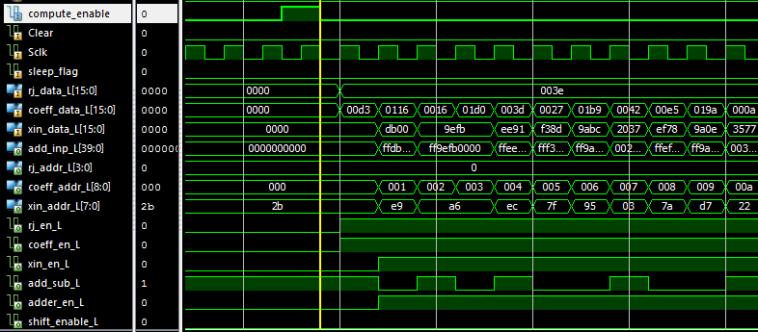

Here we see the computation beginning with the compute_enable signal asserted and the entire rj, coeff and data streams beginning to be fetched – memories are being activated, values are checked and add/subtracts and shifts carried out.

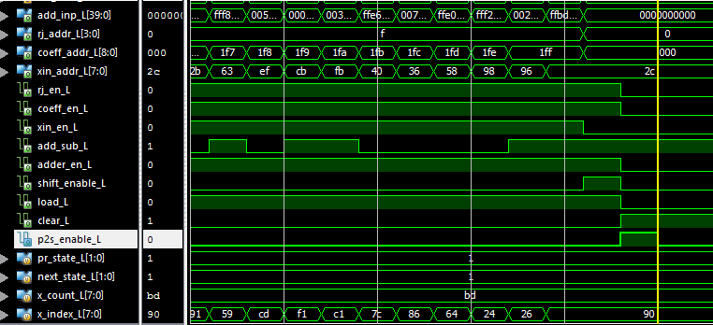

In the above diagram, we see the signal p2s_enable_L being asserted which signals to the PISO block that the data at the shift_acc block output is valid as output for this computation iteration.

1. **MSDAP Controller:**

**Functionality:**

|  |  |  |
| --- | --- | --- |
| **Signal** | **Input/output** | **Description** |
| Sclk | Input | Sclk is the system clock that is used to synchronize all the control signals and IO signals. All the state changes and the computation happen with the negative or falling edge of the System clock. The frequency of the Sclk determines the frequency of operation of the entire system/ chip. This is an input signal to the MSDAP from the controller |
| Dclk | Input | Dclk is the Data clock that is used as the timing reference to receive and send the input samples. A bit is received or sent at the falling edge of the Dclk. Hence to receive a 16 bit data, 16 Dclk cycles are required. One Dclk is 35 Sclk cycles. This is an input signal to the MSDAP from the controller |
| Frame | Input | Frame is an input signal from the controller to the MSDAP. While sending or receiving the input or output to or from the MSDAP, the Frame is set high. Frame signifies the start of the first bit of data-input, output, Rj or co-efficient. Frame is used as active high signal and is made high for one Dclk cycle. After receiving the first bit of the data, the Frame goes inactive i.e. low. Frame is made active after every 16 Dclk cycles and hence a 16 bit data is received between two successive Frames. |
| Start | Input | Start is an asynchronous input signal from the Controller to MSDAP. It is used to indicate the start of the FSM and initialization of chip begins. Until then the chip is said to be idle. Start is an active high input signal. |
| Reset_n | Input | Reset is an active low asynchronous input signal to the MSDAP. The chip goes to the reset mode when this signal is applied. |
| input_rdy_flag | Input | input_rdy_flag signals to the controller that the input data is ready for processing |
| zero_flag_L, zero_flag_R | Input | Signals from the data memory block that indicate that there have been 800 zeroes detected and both flags are ANDed to generate sleep_flag |
| rj_wr_addr, coeff_wr_addr, data_wr_addr | Output | These signals are used for signaling the memories of the addresses where the incoming data must be written. |
| rj_en, coeff_en, data_en | Output | Enables for routing the data to the correct memories as it comes in. |
| Frame_out, Dclk_out, Sclk_out | Output | Internal signals for Frame, Dclk and Sclk, distributed from the main controller |
| compute_enable | Output | Indicates to the ALU that a computation iteration can begin |
| sleep_flag | Output | Signals to the ALU that the main controller will be in sleep mode and that computations must cease |
| InReady | Output | InReady is an output signal to the Controller from the MSDAP which is set high when the chip is ready to receive the data from both the channels. InReady is aligned with the Frame. |

**Verilog Code:**

module MSDAP_controller (input Sclk, Dclk, Start, Reset_n, Frame, input_rdy_flag, zero_flag_L, zero_flag_R,

output reg [3:0] rj_wr_addr,

output reg [8:0] coeff_wr_addr,

output reg [7:0] data_wr_addr,

output reg rj_en, coeff_en, data_en, Clear,

output Frame_out, Dclk_out, Sclk_out,

output reg compute_enable, sleep_flag, InReady);

parameter [3:0] Startup = 4'd0, Wait_rj = 4'd1, Read_rj = 4'd2,

Wait_coeff = 4'd3, Read_coeff = 4'd4, Wait_input = 4'd5,

Compute = 4'd6, Reset = 4'd7, Sleep = 4'd8;

reg [3:0] pr_state, next_state;

reg [15:0] real_count;

reg [4:0] rj_count;

reg [9:0] coeff_count;

reg [7:0] data_count;

reg taken;

assign Frame_out = Frame;

assign Dclk_out = Dclk;

assign Sclk_out = Sclk;

always @(negedge Sclk or negedge Reset_n) // Sequential block

begin

if (!Reset_n)

begin

if (pr_state > 4'd4)

pr_state = Reset;

else

pr_state = next_state;

end

else

pr_state = next_state;

end

always @(negedge Sclk or posedge Start)

begin

if (Start == 1'b1)

next_state = Startup;

else

begin

case (pr_state)

Startup: begin

rj_wr_addr = 4'd0;

coeff_wr_addr = 9'd0;

data_wr_addr = 8'd0;

rj_en = 1'b0;

coeff_en = 1'b0;

data_en = 1'b0;

Clear = 1'b1;

compute_enable = 1'b0;

InReady = 1'b0;

sleep_flag = 1'b0;

next_state = Wait_rj;

real_count = 16'd0;

rj_count = 4'd0;

coeff_count = 9'd0;

data_count = 8'd0;

end

Wait_rj: begin

rj_wr_addr = 4'd0;

coeff_wr_addr = 9'd0;

data_wr_addr = 8'd0;

rj_en = 1'b0;

coeff_en = 1'b0;

data_en = 1'b0;

Clear = 1'b0;

compute_enable = 1'b0;

InReady = 1'b1;

sleep_flag = 1'b0;

rj_count = 4'd0;

coeff_count = 9'd0;

data_count = 8'd0;

taken = 1'b0;

if (Frame == 1'b1)

next_state = Read_rj;

else

next_state = Wait_rj;

end

Read_rj: begin

coeff_wr_addr = 9'd0;

data_wr_addr = 8'd0;

coeff_en = 1'b0;

data_en = 1'b0;

Clear = 1'b0;

compute_enable = 1'b0;

InReady = 1'b1;

sleep_flag = 1'b0;

coeff_count = 9'd0;

data_count = 8'd0;

if (input_rdy_flag == 1'b1 && taken == 1'b0)

begin

if (rj_count < 5'd16)

begin

rj_en = 1'b1;

rj_wr_addr = rj_count;

rj_count = rj_count + 1'b1;

next_state = Read_rj;

taken = 1'b1;

end

if (rj_count == 5'd16)

begin

next_state = Wait_coeff;

end

else

next_state = Read_rj;

end

else if (input_rdy_flag == 1'b0)

begin

taken = 1'b0;

rj_en = 1'b0;

rj_wr_addr = rj_wr_addr;

next_state = Read_rj;

end

else

next_state = Read_rj;

end

Wait_coeff:

begin

rj_wr_addr = 4'd0;

coeff_wr_addr = 9'd0;

data_wr_addr = 8'd0;

rj_en = 1'b0;

coeff_en = 1'b0;

data_en = 1'b0;

Clear = 1'b0;

compute_enable = 1'b0;

InReady = 1'b1;

sleep_flag = 1'b0;

coeff_count = 9'd0;

data_count = 8'd0;

if (Frame == 1'b1)

next_state = Read_coeff;

else

next_state = Wait_coeff;

end

Read_coeff: begin

rj_wr_addr = 4'd0;

data_wr_addr = 8'd0;

rj_en = 1'b0;

data_en = 1'b0;

Clear = 1'b0;

compute_enable = 1'b0;

InReady = 1'b1;

sleep_flag = 1'b0;

data_count = 8'd0;

if (input_rdy_flag == 1'b1 && taken == 1'b0)

begin

if (coeff_count < 10'h200)

begin

coeff_en = 1'b1;

coeff_wr_addr = coeff_count;

coeff_count = coeff_count + 1'b1;

next_state = Read_coeff;

taken = 1'b1;

end

if (coeff_count == 10'h200)

next_state = Wait_input;

else

next_state = Read_coeff;

end

else if (input_rdy_flag == 1'b0)

begin

taken = 1'b0;

coeff_en = 1'b0;

coeff_wr_addr = coeff_wr_addr;

next_state = Read_coeff;

end

else

next_state = Read_coeff;

end

Wait_input: begin

rj_wr_addr = 4'd0;

coeff_wr_addr = 9'd0;

data_wr_addr = 8'd0;

rj_en = 1'b0;

coeff_en = 1'b0;

data_en = 1'b0;

Clear = 1'b0;

compute_enable = 1'b0;

InReady = 1'b1;

sleep_flag = 1'b0;

data_count = 8'd0;

if (Reset_n == 1'b0)

next_state = Reset;

else if (Frame == 1'b1)

next_state = Compute;

else

next_state = Wait_input;

end

Compute: begin

rj_wr_addr = 4'd0;

coeff_wr_addr = 9'd0;

rj_en = 1'b0;

coeff_en = 1'b0;

Clear = 1'b0;

InReady = 1'b1;

sleep_flag = 1'b0;

if (Reset_n == 1'b0)

begin

Clear = 1'b1;

next_state = Reset;

end

else if (input_rdy_flag == 1'b1 && taken == 1'b0)

begin

if (zero_flag_L && zero_flag_R)

begin

next_state = Sleep;

sleep_flag = 1'b1;

end

else

begin

data_en = 1'b1;

data_wr_addr = data_count;

data_count = data_count + 1'b1;

real_count = real_count + 1'b1;

next_state = Compute;

compute_enable = 1'b1;

taken = 1'b1;

end

end

else if (input_rdy_flag == 1'b0)

begin

taken = 1'b0;

data_en = 1'b0;

data_wr_addr = data_wr_addr;

compute_enable = 1'b0;

next_state = Compute;

end

else

begin

data_en = 1'b0;

data_wr_addr = data_wr_addr;

//real_count = real_count + 1'b1;

next_state = Compute;

compute_enable = 1'b0;

end

end

Reset: begin

rj_wr_addr = 4'd0;

coeff_wr_addr = 9'd0;

data_wr_addr = 8'd0;

rj_en = 1'b0;

coeff_en = 1'b0;

data_en = 1'b0;

Clear = 1'b1;

compute_enable = 1'b0;

InReady = 1'b0;

sleep_flag = 1'b0;

data_count = 8'd0;

taken = 1'b0;

//real_count = real_count - 1'b1;

if (Reset_n == 1'b0)

next_state = Reset;

else

next_state = Wait_input;

end

Sleep: begin

rj_wr_addr = 4'd0;

coeff_wr_addr = 9'd0;

data_wr_addr = data_wr_addr;

rj_en = 1'b0;

coeff_en = 1'b0;

data_en = 1'b0;

Clear = 1'b0;

compute_enable = 1'b0;

InReady = 1'b1;

sleep_flag = 1'b1;

if (Reset_n == 1'b0)

next_state = Reset;

else if (input_rdy_flag == 1'b1 && taken == 1'b0)

begin

if (zero_flag_L && zero_flag_R)

next_state = Sleep;

else

begin

taken = 1'b1;

data_en = 1'b1;

compute_enable = 1'b1;

sleep_flag = 1'b0;

data_wr_addr = data_count;

data_count = data_count + 1'b1;

real_count = real_count + 1'b1;

next_state = Compute;

end

end

else

next_state = Sleep;

end

endcase

end

end

endmodule

**Simulation Results:**

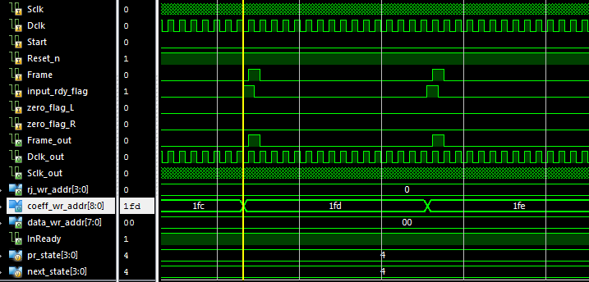

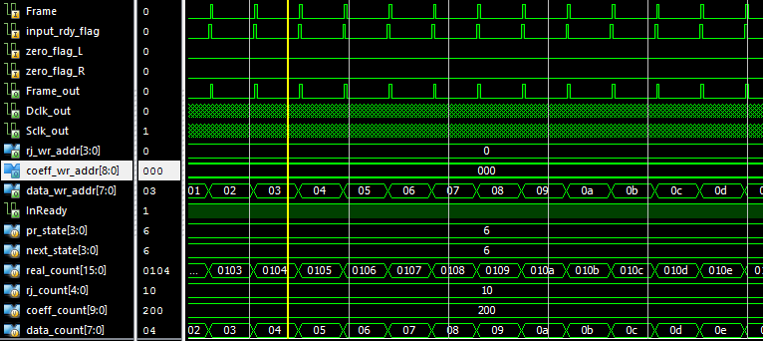

In the above two diagrams, we see the operation of the Main controller, with inputs being continuously read and written to memory. Also, compute_enable signals are issued to start the computations in the ALU.

1. **Parallel to Serial Output [P2S]:**

**Functionality:**

This functional block operates on the rising edge of the Sclk and the FRAME. Parallel data starting from the MSB of the 16bits input data is received at the arrival of frame and it is captured in the rising edge of the Sclk. Once the frame goes high, the MSB data is received on that edge and the rest 15 bits of data is received at every Sclk positive edge.

|  |  |  |
| --- | --- | --- |
| **Signal** | **Input/output** | **Description** |
| Clear | Input | Clear is synchronous with Sclk. Upon receiving clear signal from the MSDAP  Controller, data in the P2S is cleared. |
| Sclk | Input | Sclk is the timing reference for receiving the input data parallel. Data is received parallel at the positive edge of the Sclk. |
| Shifted_L,  Shifted_R | Input | Shifted_L, Shifted_R are the parallel inputs to the P2S (left and right respectively) from the shift_acc_L and shift_acc_R. These input data are captured on the positive edge of Sclk. |
| Output_L,  Output_R | Output | Output_L, output_R is the serial output from P2S left and right blocks respectively. |
| p2s_enable_L,  p2s_enable_R | Input | This is one bit from the ALU controller to the P2S left and right block respectively. This is set when the output is ready and has to be sent out serially. |

**Verilog Code:**

module PISO (Sclk, Clear, Frame, Shifted, Serial_out, p2s_enable, OutReady);

input Sclk, Clear, p2s_enable, Frame;

input [39:0] Shifted;

output reg Serial_out, OutReady;

reg [5:0] bit_count;

reg out_rdy, frame_flag;

reg [39:0] piso_reg;

always @(negedge Sclk)

begin

if(Clear == 1'b1)

begin

bit_count = 6'd40;

piso_reg = 40'd0;

out_rdy = 1'b0;

frame_flag = 1'b0;

OutReady = 1'b0;

Serial_out = 1'b0;

end

else if (p2s_enable == 1'b1)

begin

piso_reg = Shifted;

out_rdy = 1'b1;

end

else if (Frame == 1'b1 && out_rdy == 1'b1 && frame_flag == 1'b0)

begin

bit_count = bit_count - 1'b1;

Serial_out = piso_reg [bit_count];

frame_flag = 1'b1;

out_rdy = 1'b0;

OutReady = 1'b1;

end

else if (frame_flag == 1'b1)

begin

bit_count = bit_count - 1'b1;

Serial_out = piso_reg [bit_count];

OutReady = 1'b1;

if (bit_count == 6'd0)

frame_flag = 1'b0;

end

else

begin

bit_count = 6'd40;

//piso_reg = 40'd0;

//out_rdy = 1'b0;

//frame_flag = 1'b0;

Serial_out = 1'b0;

OutReady = 1'b0;

end

end

endmodule

**Simulation Results:**

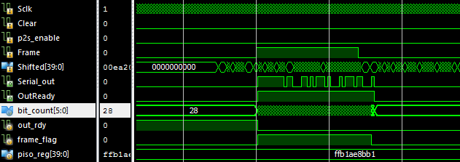

As we can see above, the data FFB1AE8BB1 is stored in the piso_reg and then is released bit by bit as soon as Frame is asserted from Serial_out and OutReady is also asserted when the serial output is going on.

**Simulation Results of State transitions**

1. **Start**

The FSM starts to function when it receives a START signal from the controller. Until the MSDAP receives this signal, FSM will be non-functional. Once the MSDAP receives the START signal, the FSM enters into state0 or FSM starts functioning. The below waveform shows the required signals to make the transition to state 0.

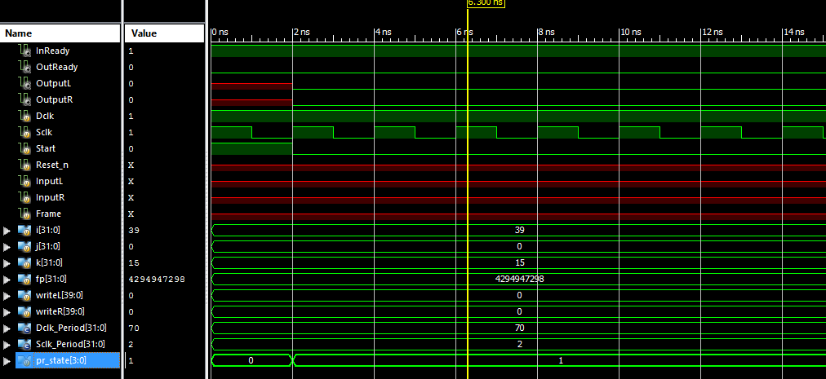

1. **Transition from State 0 to State 1**

* In state0, the ‘**InReady**’ signal is made high.
* All the required temporary registers and flags are initialized in this state. Once this is done, the FSM enters into state 1. This can be seen in the below waveform.



1. **Transition from State 1 to State 2**

* InReady signal is made high
* In the state 1, the MSDAP is waiting to receive the Rj values.
* When the Rj values for both the channels is about to receive by MSDAP, the controller send a FRAME low, signaling the start of Rj values.
* Once the FRAME is low, the FSM enters in to state 2 to receive the Rj values. Below waveform shows the state transition from 1 to 2 when the FRAME becomes low.

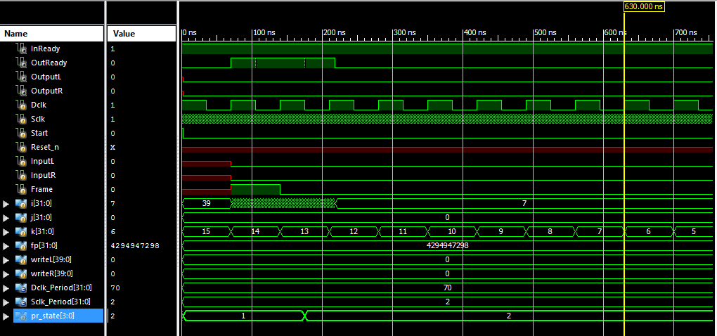

Fig 3

1. **Transition from State 2 to State 3**

* InReady signal is made high.
* Once all the Rj values are received by the FSM serially and stored in the Rj array, the FSM enters into State 3. All incoming data is through serial bus InputL and InputR from the controller.
* The Rj value is received at the start of State 2 (Fig 4) and after all Rj is received, state is changed to State3.

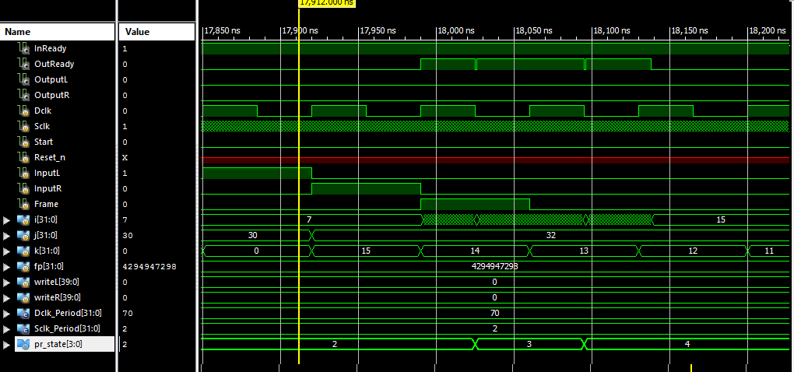

1. **Transition from State 3 to State 4**

* InReady signal is made high
* In the state 3, the MSDAP is waiting to receive the Co-efficient values.
* When the Co-efficient values for both the channels is about to receive by MSDAP, the controller send a FRAME low, signaling the start of Co-efficient values.
* Once the FRAME is low, the FSM enters in to state 4 to receive the Coefficient values. Below waveform (Fig 5) shows the state transition from 3 to 4 when the FRAME becomes low.



1. **Transition from State 4 to State 5**

* InReady signal is made high.
* In state 4, the 16 Co-efficient values, each word of length 16 bits is received serially from the controller.
* Once all the Co-efficient values are received by the FSM serially and stored in the Co-efficient array, the FSM enters into State 5.
* The Co-efficient value is received at the start of State 4 and after all Co-efficient is received, state is changed to State 5.

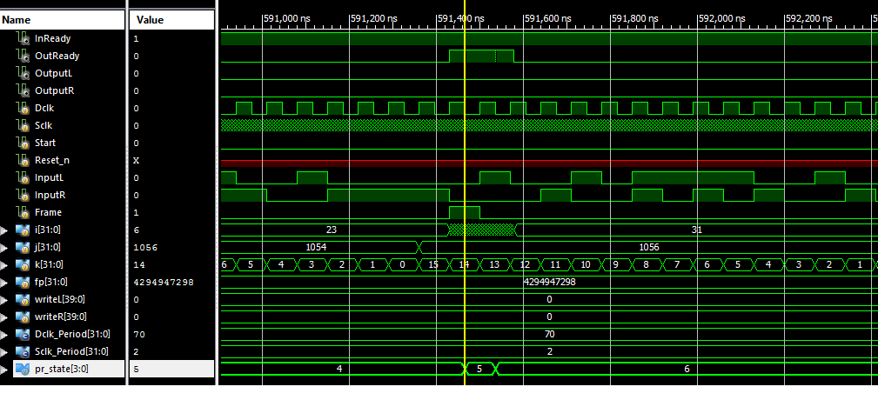

1. **Transition from State 5 to State 6**

InReady signal is made high.

In state 5, the MSDAP is waiting to receive the data values.

When the data value is about to be received by MSDAP, the controller sends a FRAME low, signaling the start of data values in both the channels.

Once the FRAME is low, the FSM enters in to state 6 to receive the data values. Below waveform shows the state transition from 5 to 6 when the FRAME becomes high.



1. **Working in State 6**

In State 6, the data is being read and the sign is extended to 16 bits and 16 zeroes are concatenated to the LSB.

* When the first frame occurs in state 6, two inputs from InputL and InputR are begin read serially. During the second frame, the computation on the first data is carried and also the second set of data is being received.
* When there is a third frame, the outputs for the first data sample from both the channels are being sent out serially and computation for the second set of data is being carried out. Also, the third set of input data samples is being received by the MSDAP.
* The OutReady goes low whenever the computation is done on the input data samples and the output is sent serially. Once, the 40 bit output sample is sent serially, the OutReady goes high again.

This operation is shown by the waveforms below:

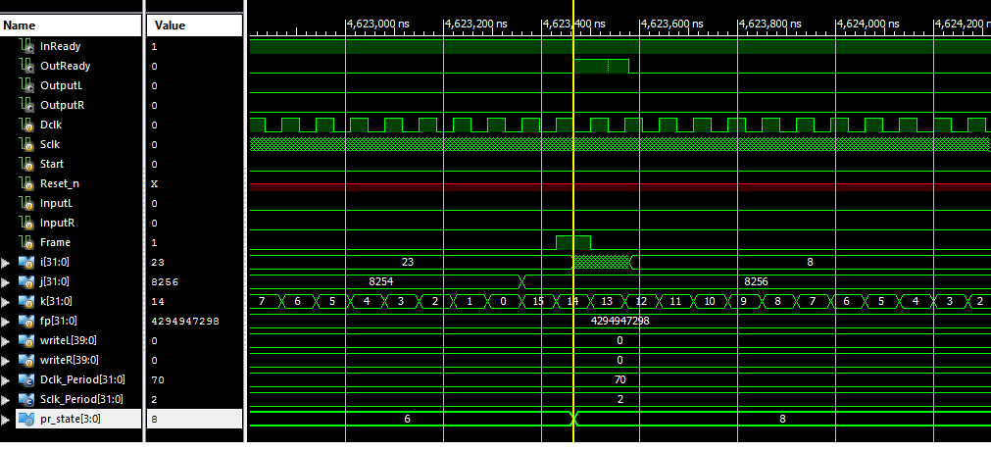

1. **Transition from State 6 to State 8**

In state 6, if the MSDAP receives 800 consecutive zeroes on both left and right input channels, then the MSDAP will go to sleep mode (State 8). In sleep mode, the OutReady signal goes high. Figure below shows this operation.



**Pin Diagram of Complete MSDAP**

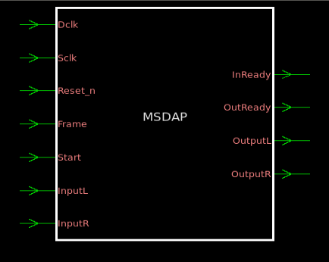

**Schematic of Complete MSDAP**

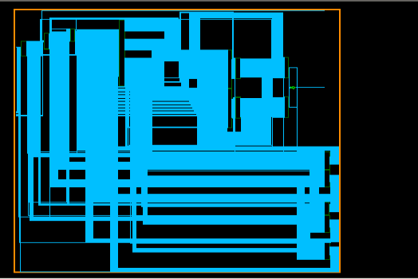

**Critical Path of Complete MSDAP**

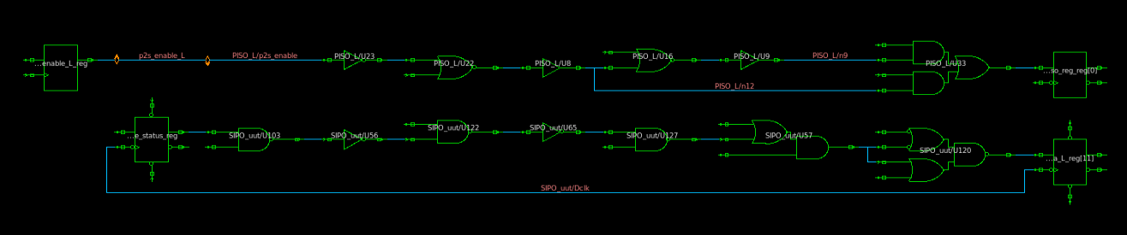

**Design Vision Reports of Gate Level Netlist**

1. **Cell Report**

****************************************

Report : cell

Design : MSDAP

Version: H-2013.03-SP4

Date : Wed Dec 16 00:54:06 2015

****************************************

Attributes:

b - black box (unknown)

h - hierarchical

n - noncombinational

r - removable

u - contains unmapped logic

Cell Reference Library Area Attributes

--------------------------------------------------------------------------------

PISO_L PISO_0 4418.937628

PISO_R PISO_1 4418.937628

SIPO_uut SIPO 3938.188885

U2 INVXLM ff_1v98_0c 6.585600

U3 INVX2M ff_1v98_0c 6.585600

U4 OR2X2M ff_1v98_0c 10.976000

add_L adder_0 5310.188868

add_R adder_1 5310.188868

alu_ctrl alu_controller 13015.340654

coeff_L coeff_memory_0 847184.757870

coeff_R coeff_memory_1 847193.538670

main_ctrl MSDAP_controller 5940.211239

rj_L rj_memory_0 26252.396887

rj_R rj_memory_1 26234.835287

shift_acc_L shift_acc_0 2840.588757

shift_acc_R shift_acc_1 2840.588757

xin_L data_memory_0 426215.642895

xin_R data_memory_1 426215.642895

--------------------------------------------------------------------------------

Total 18 cells 2647354.132984

1. **Area Report**

****************************************

Report : area

Design : MSDAP

Version: H-2013.03-SP4

Date : Wed Dec 16 00:54:05 2015

****************************************

Library(s) Used:

ff_1v98_0c (File: /home/eng/x/xxw122030/synopsys/ff_1v98_0c.db)

Number of ports: 11

Number of nets: 476

Number of cells: 18

Number of combinational cells: 3

Number of sequential cells: 0

Number of macros/black boxes: 0

Number of buf/inv: 2

Number of references: 18

Combinational area: 1360879.096340

Buf/Inv area: 105187.396791

Noncombinational area: 1286475.036644

Macro/Black Box area: 0.000000

Net Interconnect area: undefined (No wire load specified)

Total cell area: 2647354.132984

Total area: undefined

1. **QOR Report**

****************************************

Report : qor

Design : MSDAP

Version: H-2013.03-SP4

Date : Wed Dec 16 00:54:06 2015

****************************************

Timing Path Group 'Dclk'

-----------------------------------

Levels of Logic: 7.00

Critical Path Length: 0.84

Critical Path Slack: 1301.12

Critical Path Clk Period: 1302.00

Total Negative Slack: 0.00

No. of Violating Paths: 0.00

Worst Hold Violation: 0.00

Total Hold Violation: 0.00

No. of Hold Violations: 0.00

-----------------------------------

Timing Path Group 'Sclk'

-----------------------------------

Levels of Logic: 8.00

Critical Path Length: 1.02

Critical Path Slack: 0.02

Critical Path Clk Period: 37.00

Total Negative Slack: 0.00

No. of Violating Paths: 0.00

Worst Hold Violation: 0.00

Total Hold Violation: 0.00

No. of Hold Violations: 0.00

-----------------------------------

Cell Count

-----------------------------------

Hierarchical Cell Count: 33

Hierarchical Port Count: 1895

Leaf Cell Count: 83113

Buf/Inv Cell Count: 12441

Buf Cell Count: 10594

Inv Cell Count: 1847

CT Buf/Inv Cell Count: 0

Combinational Cell Count: 57617

Sequential Cell Count: 25496

Macro Count: 0

-----------------------------------

Area

-----------------------------------

Combinational Area: 1360879.096340

Noncombinational Area:

1286475.036644

Buf/Inv Area: 105187.396791

Total Buffer Area: 93023.79

Total Inverter Area: 12163.60

Macro/Black Box Area: 0.000000

Net Area: 0.000000

-----------------------------------

Cell Area: 2647354.132984

Design Area: 2647354.132984

Design Rules

-----------------------------------

Total Number of Nets: 108581

Nets With Violations: 0

Max Trans Violations: 0

Max Cap Violations: 0

-----------------------------------

Hostname: engnx12.utdallas.edu

Compile CPU Statistics

-----------------------------------------

Resource Sharing: 42.99

Logic Optimization: 143.14

Mapping Optimization: 242.70

-----------------------------------------

Overall Compile Time: 487.75

Overall Compile Wall Clock Time: 491.77

1. **Timing report**

****************************************

Report : timing

-path full

-delay max

-max_paths 1

Design : MSDAP

Version: H-2013.03-SP4

Date : Wed Dec 16 00:54:05 2015

****************************************

# A fanout number of 1000 was used for high fanout net computations.

Operating Conditions: ff_1v98_0c Library: ff_1v98_0c

Wire Load Model Mode: top

Startpoint: SIPO_uut/frame_status_reg

(falling edge-triggered flip-flop clocked by Dclk)

Endpoint: SIPO_uut/data_L_reg[11]

(falling edge-triggered flip-flop clocked by Dclk)

Path Group: Dclk

Path Type: max

Point Incr Path

--------------------------------------------------------------------------

clock Dclk (fall edge) 651.00 651.00

clock network delay (ideal) 0.00 651.00

SIPO_uut/frame_status_reg/CKN (DFFNSRHX1M) 0.00 651.00 f

SIPO_uut/frame_status_reg/Q (DFFNSRHX1M) 0.28 651.28 r

SIPO_uut/U103/Y (NAND2X2M) 0.06 651.34 f

SIPO_uut/U56/Y (INVX2M) 0.07 651.41 r

SIPO_uut/U122/Y (NAND2X2M) 0.04 651.45 f

SIPO_uut/U65/Y (INVX2M) 0.05 651.50 r

SIPO_uut/U127/Y (NAND2X2M) 0.04 651.54 f

SIPO_uut/U57/Y (OA21X1M) 0.19 651.73 f

SIPO_uut/U120/Y (OAI2BB2X1M) 0.10 651.84 f

SIPO_uut/data_L_reg[11]/D (DFFNSRHX1M) 0.00 651.84 f

data arrival time 651.84

clock Dclk (fall edge) 1953.00 1953.00

clock network delay (ideal) 0.00 1953.00

SIPO_uut/data_L_reg[11]/CKN (DFFNSRHX1M) 0.00 1953.00 f

library setup time -0.04 1952.96

data required time 1952.96

--------------------------------------------------------------------------

data required time 1952.96

data arrival time -651.84

--------------------------------------------------------------------------

slack (MET) 1301.12

Startpoint: SIPO_uut/input_rdy_flag_reg

(falling edge-triggered flip-flop clocked by Dclk)

Endpoint: main_ctrl/data_count_reg[0]

(falling edge-triggered flip-flop clocked by Sclk)

Path Group: Sclk

Path Type: max

Point Incr Path

--------------------------------------------------------------------------

clock Dclk (fall edge) 26691.00 26691.00

clock network delay (ideal) 0.00 26691.00

SIPO_uut/input_rdy_flag_reg/CKN (DFFNSRHX1M) 0.00 26691.00 f

SIPO_uut/input_rdy_flag_reg/Q (DFFNSRHX1M) 0.30 26691.30 r

SIPO_uut/input_rdy_flag (SIPO) 0.00 26691.30 r

main_ctrl/input_rdy_flag (MSDAP_controller) 0.00 26691.30 r

main_ctrl/U28/Y (NAND2XLM) 0.10 26691.40 f

main_ctrl/U5/Y (NAND2BX2M) 0.12 26691.52 f

main_ctrl/U27/Y (INVXLM) 0.08 26691.60 r

main_ctrl/U49/Y (NAND2X2M) 0.04 26691.64 f

main_ctrl/U12/Y (AOI21X1M) 0.06 26691.70 r

main_ctrl/U10/Y (BUFX2M) 0.14 26691.84 r

main_ctrl/U13/Y (AND2X2M) 0.10 26691.94 r

main_ctrl/U186/Y (OAI2BB2X1M) 0.08 26692.02 r

main_ctrl/data_count_reg[0]/D (DFFNHX2M) 0.00 26692.02 r

data arrival time 26692.02

clock Sclk (fall edge) 26692.00 26692.00

clock network delay (ideal) 0.00 26692.00

main_ctrl/data_count_reg[0]/CKN (DFFNHX2M) 0.00 26692.00 f

library setup time 0.04 26692.04

data required time 26692.04

--------------------------------------------------------------------------

data required time 26692.04

data arrival time -26692.02

--------------------------------------------------------------------------

slack (MET) 0.02

**Physical Design Flow**

**Introduction**

Physical Design flow starts right after the circuit design and logical verification of the gate level net list. Gates are converted to represent the actual layers of the component which is later used for fabrication. Gates from the net list are mapped with the equivalent layouts at the end of physical design which gives complete actual reliable information about the critical path, RC delays, power consumption, area and timing. Physical design flow is as shown in the figure below.

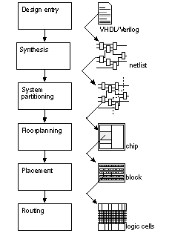

**Steps involved in Physical Design Flow**

**Step 1: Design Entry**

The first stage in physical design flow is reading in the netlist and the constraints to your tool of choice. Physical Design converts a gate level netlist into a physical layout.

Gate level netlist: .v file obtained after synthesis.

Standard cell library: This is collection of logic functions like AND, OR etc. Key information from the library such as the location of metal and input/output pins that is required by place and route tools. This standard cell libraries will contain timing information about the function such as cell delay and input pin capacitance which is used to calculated output loads.

Design Constraints: The design constraints are derived from the system specifications. The constraints file contains most designs include clock speeds for each clock in the design.

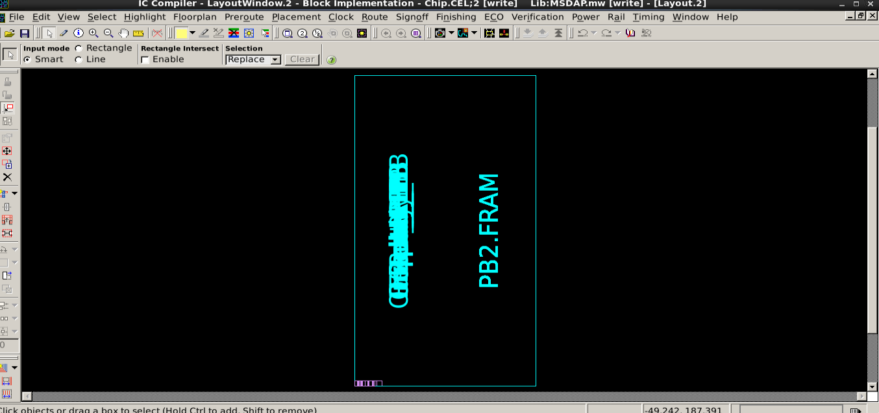

The layout window shows the layout information.

**Step 2: Partitioning**

Partitioning is the first step in the physical design flow. Each gate in the design is mapped to a node and a net is mapped as an edge and a graph is constructed. Given a net list of size ‘n’ and area ‘A’, partitioning algorithm such as simulated annealing, Kernighan Lin and F-M algorithms tries to do the bi-partition so that the resulting sizes has area approximately A/2. Partitioning is performed to make floor planning and placement much easier by reducing the number of nets that crosses the partition. This is called Cut-set reduction. Tool does a number of iterations to arrive at global minima and the final configuration is passed to the floor plan and partitioning phase.

**Step 3: Floor planning**

After circuit partitioning, floor planning and placement is done iteratively to reduce the local hotspots, critical path delay and area of the chip. There are numerous approach to obtain a global minima for the parameters mentioned above. Floor planning is done using the slicing tree approach and most commonly used approach for placement is simulated annealing, which gives the designer an advantage to choose the cost function based on the requirements.

Floor planning control parameters like aspect ratio, core utilization are defined as follows:

**Aspect Ratio= Horizontal Routing Resources / Vertical Routing Resources**

**Core Utilization= Standard Cell Area / (Row Area + Channel Area)**

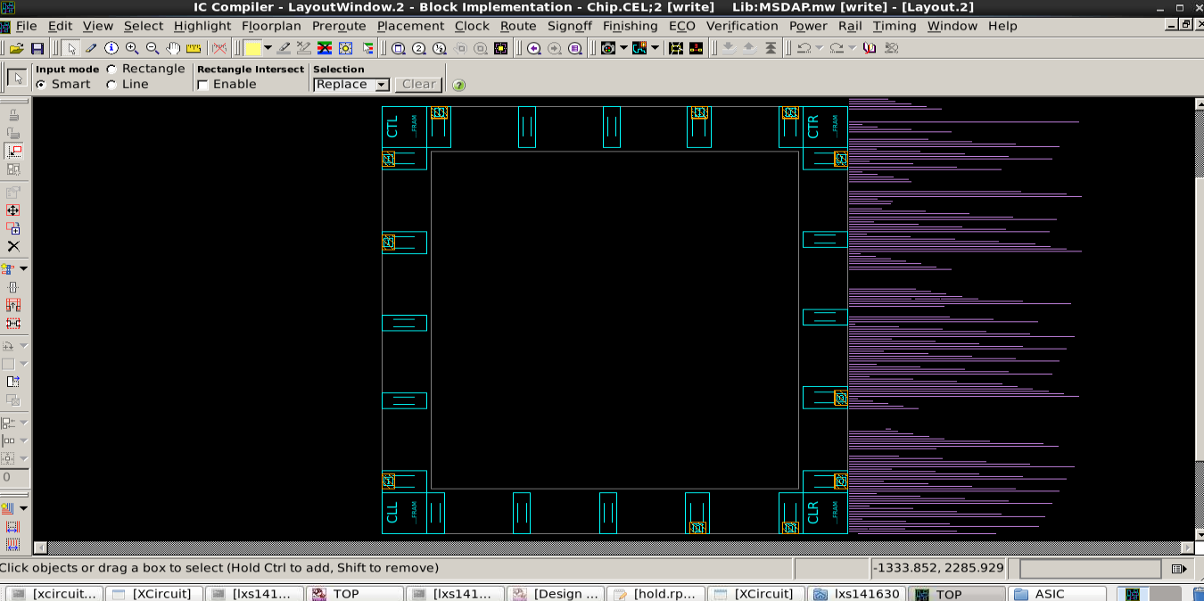

The above picture shows the floor planning for the layout.

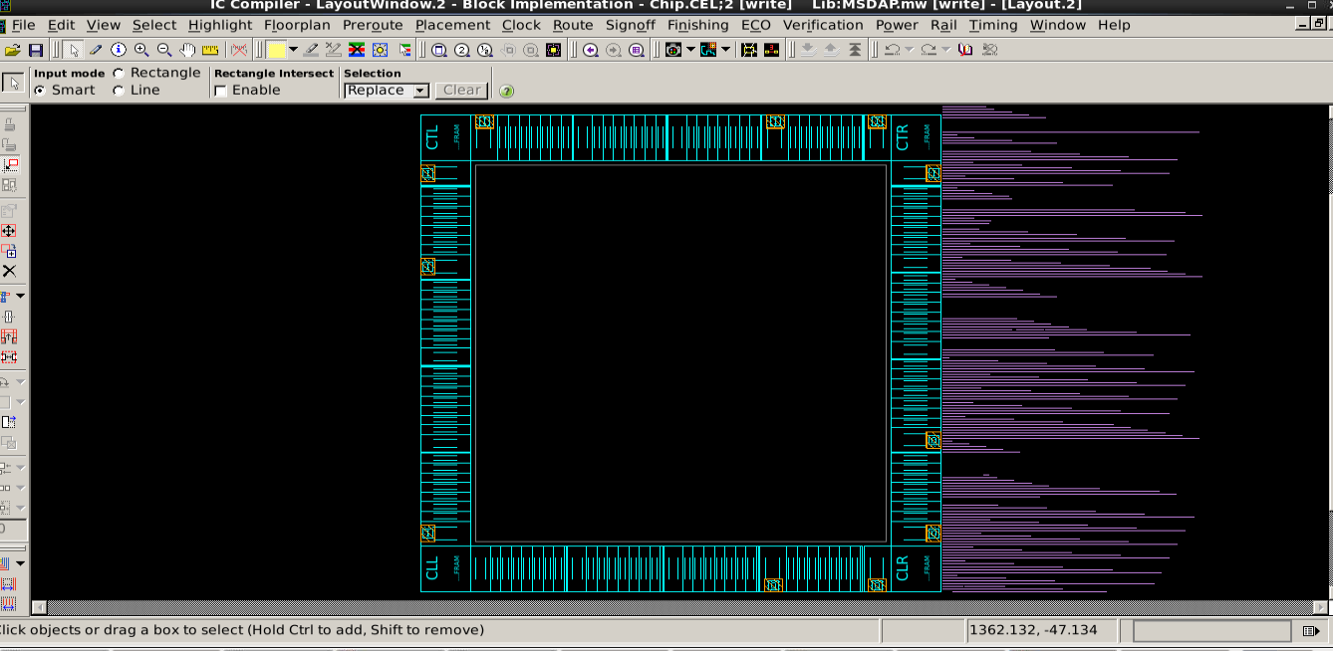

The above picture shows the insertion of pad filler.

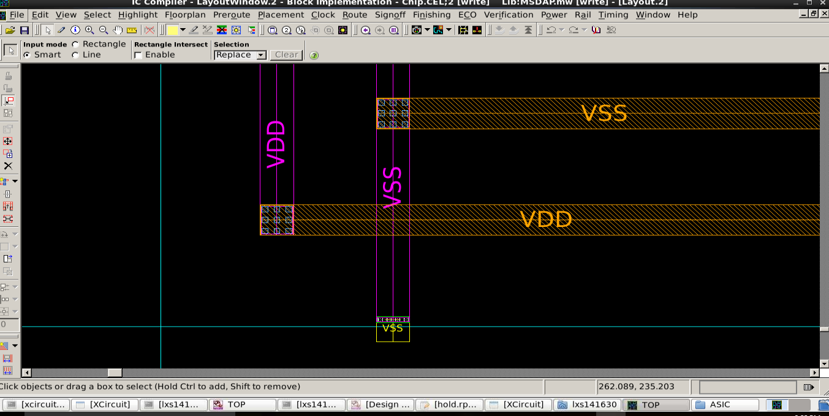

Create VDD/VSS rings.

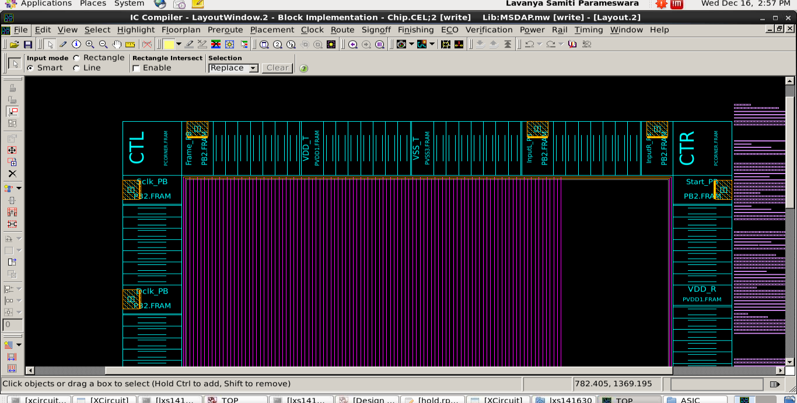

Create power strap (VDD/VSS).

**Step 4: Placement**

The process of arranging circuit components on a layout surface. After placement, we can see the accurate estimates of the capacitive loads of each standard cell must drive. The tool places these cells based on the algorithms which it uses internally.

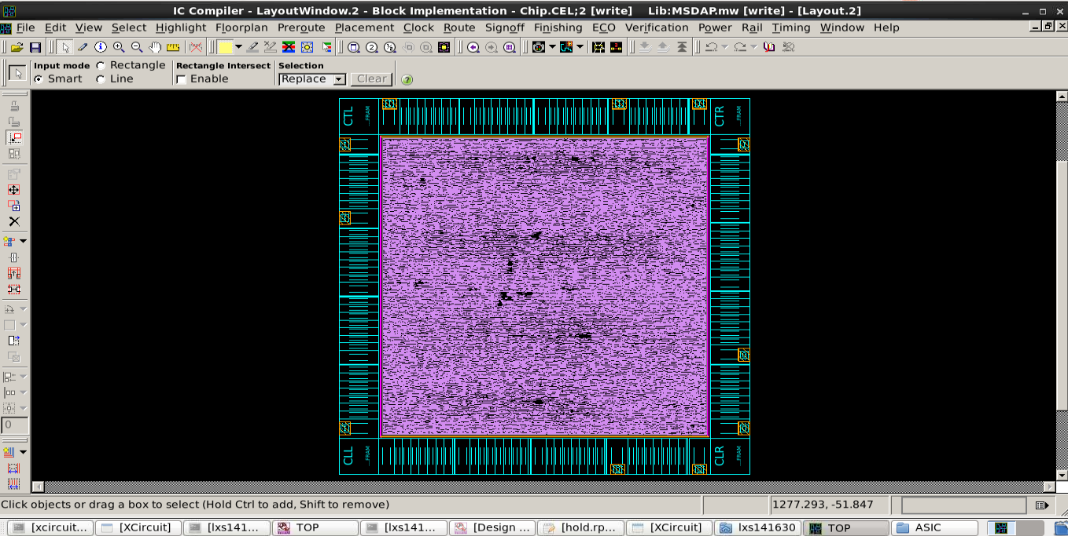

Layout after placement.

**Step 5: Clock Tree Synthesis**

Placement and routing goal is always to meet timing constraints provided by the .sdc file. If latency and uncertainty are not set for clock at front end then at backend doing clock tree synthesis (CTS) is not possible.

Cell delay and net delay are stored as look up table.

Cell delay consists of transition, timing arcs and capacitances while net delay is constituted by RCs only. Cell Delays are available in libraries.

The goal of CTS is to minimize skew and insertion delay. Clock is not propagated before CTS.

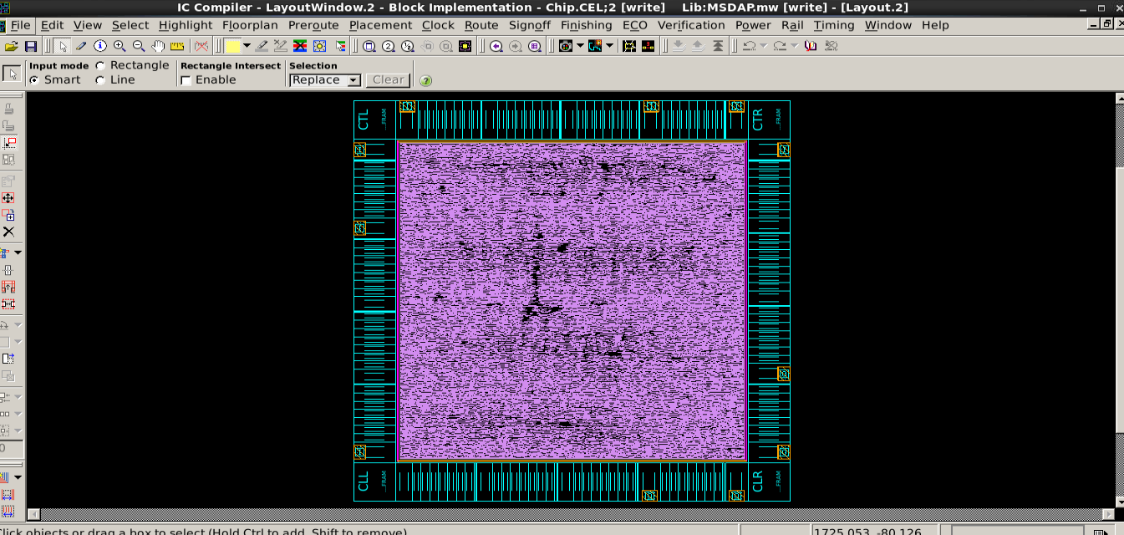

After CTS optimization.

**Step 6: Routing**

Routing is a connection of the various standard cells using wires. There are two types of routing.

Global routing : This method first partitions the routing into tiles and then decides tile-to-tile paths for all nets while attempting to optimize some of the objective functions such as circuit timing and the lengths etc.

Detailed routing: This method uses the paths obtained by global routing and assigns tracks and vias for nets.

**Physical Verification**

Spice file is generated from the layout after no DRC and LVS violations. This spice file is used for testing the chip post layout simulation. The results at this stage should match with the results expected for the design to be perfect functionally. If there is any failure or mismatch, the designer should go back to floor planning and automatic place and route step and see if there can be modifications done to get the functionally correct layout. If this cannot be fixed, then the design has to be changed in the RTL coding step and the steps from there should be repeated until the expected results are obtained. This will be the final testing on the chip before it is sent to Fabrication process. If there are any violations in the timing constraints, then the designer has to go back and see if he can fix the errors in floor planning and placement and continue the process again from that step.

1. **Steps for Design Rule Check (DRC)**

DRC errors will help the user to find if there are any errors that are against the process technology rules. In IC compiler, to check the DRC errors follow the below steps:

* Choose verification option on the menu panel.
* Select DRC.
* Tick the relevant checks required.

1. **Steps for Layout Verses Schematic Check (LVS)**

LVS errors will help the designer to know if there any shorts in the design, or any net mismatches occurred during the physical design flow.

In IC compiler, to check the LVS errors follow the below steps:

* Choose verification option on the menu panel
* Select LVS
* Tick the relevant checks required

1. **Steps for Antenna Check**

Antenna check is an advanced and complex check on every metal layer. It checks the area ratio of all the metal layers in the design and the related capacitances.

* Click on verification menu on the ICC and select the Antenna check to perform the antenna check on the design.

1. **Steps for ERC**

ERC is electrical rule check that makes sure the circuit is manufactured properly. This is done by checking the relative positions of the cells in the final layout.

* Click on verification menu on the ICC and select the ERC to perform the ERC check on the design.

**Challenges in Physical design**

* According to the Moore’s law, the number of transistors for the same area doubles every year.
* Because of this, the wiring costs increases every time the process is changed. So, a designer has to come up with a new method to have less routing wires and to reduce the total wire length in the design.
* As the number of transistors is increased, the dynamic switching power also increases which has to be handled.
* The IR drop problem also increases as the technology increases which results in more signal integrity issues.
* With all the above issues, speed and accuracy of the chip is at extreme stake.
* Hence, there should be more optimization in floor planning, placement, routing, physical verification and integration.

**Optimization**

**Layout View: For 60% utilization**

Std cell utilization: **60.59%** (1215639/(2006250-0)) (Non-fixed + Fixed)

Std cell utilization: 60.59% (1215639/(2006250-0)) (Non-fixed only)

Chip area**: 2006250** sites, bbox (258.00 258.00 2358.00 2355.20) um

Std cell area: 1215639 sites, (non-fixed:1215639 fixed:0)

77545 cells, (non-fixed:77545 fixed:0)

Lib cell count: **116**



Layout view for cell utilization 60.59%

**Layout View: For 70% utilization**

Std cell utilization: **70.14%** (1207834/(1722112-0)) (Non-fixed + Fixed)

Std cell utilization: 70.14% (1207834/(1722112-0)) (Non-fixed only)

Chip area**: 1722112** sites, bbox (258.00 258.00 2202.32 2202.32) um

Std cell area: 1207834 sites, (non-fixed:1207834 fixed:0)

77499 cells, (non-fixed:77499 fixed:0)

Lib cell count**: 126**



Layout view for cell utilization 70.14%

In comparison to 60.59% and 70.14% utilization, the chip area is reduced with the 70.14% cell utilization ratio.

Summary of the results

|  |  |  |
| --- | --- | --- |
| **Std Cell Utilization** | **60.59%** | **70.14%** |
| Chip area | 2006250 um2 | 1722112 um2 |
| Std cell area | 1215639 um2 | 1207834 um2 |
| Lib cell count | 116 | 126 |
| Total Dynamic Power | 3.5728 mW | 3.5517 mW |
| Cell Leakage Power | 106.1986 uW | 106.1446 uW |
| Frequency of Sclk | 37.2 ns | 37.2ns |
| Slack | MET | MET |

**Conclusion**

* ASIC Design flow of MSDAP is successfully completed.
* RTL Verilog code for MSDAP was written and tested using test bench.
* Timing reports was generated and slack has been met.
* Layout of the MSDAP chip has been implemented using IC compiler.
* After Physical design, the chip area was found to be 1722112 um2 after optimization.

**Appendix: Results**

1. **Utilization Report**

****************************************

Report : Chip Summary

Design : Chip

Version: D-2010.03-ICC-SP3

Date : Wed Dec 16 15:33:59 2015

****************************************

Std cell utilization: 70.14% (1207834/(1722112-0))

(Non-fixed + Fixed)

Std cell utilization: 70.14% (1207834/(1722112-0))

(Non-fixed only)

Chip area: 1722112 sites, bbox (258.00 258.00 2202.32 2202.32) um

Std cell area: 1207834 sites, (non-fixed:1207834 fixed:0)

77499 cells, (non-fixed:77499 fixed:0)

Macro cell area: 0 sites

0 cells

Placement blockages: 0 sites, (excluding fixed std cells)

0 sites, (include fixed std cells & chimney area)

0 sites, (complete p/g net blockages)

Routing blockages: 0 sites, (partial p/g net blockages)

0 sites, (routing blockages and signal pre-route)

Lib cell count: 126

Avg. std cell width: 5.65 um

Site array: unit (width: 0.56 um, height: 3.92 um, rows: 496)

Physical DB scale: 1000 db_unit = 1 um

****************************************

Report : pnet options

Design : Chip

Version: D-2010.03-ICC-SP3

Date : Wed Dec 16 15:33:59 2015

****************************************

--------------------------------------------------------------------

Layer Blockage Min_width Min_height Via_additive Density

--------------------------------------------------------------------

METAL1 none --- --- via additive ---

METAL2 none --- --- via additive ---

METAL3 none --- --- via additive ---

METAL4 none --- --- via additive ---

METAL5 none --- --- via additive ---

METAL6 none --- --- via additive ---

**********************************

Sub-Region Utilization

**********************************

Number of regions with placement utilization 0 - 0.125 is 1 (0.01%)

Number of regions with placement utilization 0.125 - 0.25 is 0 (0.00%)

Number of regions with placement utilization 0.25 - 0.375 is 6 (0.06%)

Number of regions with placement utilization 0.375 - 0.5 is 406 (4.06%)

Number of regions with placement utilization 0.5 - 0.625 is 1682 (16.82%)

Number of regions with placement utilization 0.625 - 0.75 is 4420 (44.20%)

Number of regions with placement utilization 0.75 - 0.875 is 3339 (33.39%)

Number of regions with placement utilization 0.875 - 1 is 146 (1.46%)

1. **Power report**

****************************************

Report : power

-analysis_effort low

Design : Chip

Version: D-2010.03-ICC-SP3

Date : Wed Dec 16 16:04:54 2015

****************************************

Library(s) Used:

SP018EE_V0p5_max (File: /home/eng/x/xxw122030/synopsys/io_max.db)

ss_1v62_125c (File: /home/eng/x/xxw122030/synopsys/ss_1v62_125c.db)

Operating Conditions: ss_1v62_125c Library: ss_1v62_125c

Wire Load Model Mode: top

Global Operating Voltage = 1.62

Power-specific unit information :

Voltage Units = 1V

Capacitance Units = 1.000000pf

Time Units = 1ns

Dynamic Power Units = 1mW (derived from V,C,T units)

Leakage Power Units = 1pW

Cell Internal Power = 2.7014 mW (76%)

Net Switching Power = 850.3647 uW (24%)

---------

Total Dynamic Power = 3.5517 mW (100%)

Cell Leakage Power = 106.1446 uW

1. **Hold time Report**

****************************************

Report : timing

-path full

-delay min

-max_paths 20

Design : Chip

Version: D-2010.03-ICC-SP3

Date : Wed Dec 16 15:50:47 2015

****************************************

* Some/all delay information is back-annotated.

Operating Conditions: ff_1v98_0c Library: ff_1v98_0c

Parasitic source : LPE

Parasitic mode : RealRC

Extraction mode : MIN_MAX

Extraction derating : 125/125/125

Startpoint: P_MSDAP/main_ctrl/next_state_reg[0]

(falling edge-triggered flip-flop clocked by Dclk)

Endpoint: P_MSDAP/main_ctrl/pr_state_reg[0]

(falling edge-triggered flip-flop clocked by Dclk)

Path Group: Dclk

Path Type: min

Point Incr Path

--------------------------------------------------------------------------

clock Dclk (fall edge) 651.00 651.00

clock network delay (propagated) 2.40 653.40

P_MSDAP/main_ctrl/next_state_reg[0]/CKN (DFFNSRHX1M)

0.00 653.40 f

P_MSDAP/main_ctrl/next_state_reg[0]/Q (DFFNSRHX1M) 0.73 654.12 r

P_MSDAP/main_ctrl/pr_state_reg[0]/D (DFFNSRHX1M) 0.00 * 654.12 r

data arrival time 654.12

clock Dclk (fall edge) 651.00 651.00

clock network delay (propagated) 2.45 653.45

P_MSDAP/main_ctrl/pr_state_reg[0]/CKN (DFFNSRHX1M) 0.00 653.45 f

library hold time 0.21 653.67

data required time 653.67

--------------------------------------------------------------------------

data required time 653.67

data arrival time -654.12

--------------------------------------------------------------------------

slack (MET) 0.46

Startpoint: P_MSDAP/main_ctrl/coeff_count_reg[0]

(falling edge-triggered flip-flop clocked by Dclk)

Endpoint: P_MSDAP/main_ctrl/coeff_count_reg[0]

(falling edge-triggered flip-flop clocked by Dclk)

Path Group: Dclk

Path Type: min

Point Incr Path

--------------------------------------------------------------------------

clock Dclk (fall edge) 651.00 651.00

clock network delay (propagated) 2.45 653.45

P_MSDAP/main_ctrl/coeff_count_reg[0]/CKN (DFFNHX2M) 0.00 653.45 f

P_MSDAP/main_ctrl/coeff_count_reg[0]/Q (DFFNHX2M) 0.57 654.02 f

P_MSDAP/main_ctrl/U77/Y (OAI22X1M) 0.22 * 654.24 r

P_MSDAP/main_ctrl/coeff_count_reg[0]/D (DFFNHX2M) 0.00 * 654.24 r

data arrival time 654.24

clock Dclk (fall edge) 651.00 651.00

clock network delay (propagated) 2.45 653.45

P_MSDAP/main_ctrl/coeff_count_reg[0]/CKN (DFFNHX2M) 0.00 653.45 f

library hold time 0.25 653.70

data required time 653.70

--------------------------------------------------------------------------

data required time 653.70

data arrival time -654.24

--------------------------------------------------------------------------

slack (MET) 0.54

Startpoint: P_MSDAP/PISO_L/piso_reg_reg[3]

(falling edge-triggered flip-flop clocked by Dclk)

Endpoint: P_MSDAP/PISO_L/piso_reg_reg[3]

(falling edge-triggered flip-flop clocked by Dclk)

Path Group: Dclk

Path Type: min

Point Incr Path

--------------------------------------------------------------------------

clock Dclk (fall edge) 651.00 651.00

clock network delay (propagated) 2.33 653.33

P_MSDAP/PISO_L/piso_reg_reg[3]/CKN (DFFNHX2M) 0.00 653.33 f

P_MSDAP/PISO_L/piso_reg_reg[3]/Q (DFFNHX2M) 0.59 653.92 r

P_MSDAP/PISO_L/U71/Y (AO22X2M) 0.19 * 654.11 r

P_MSDAP/PISO_L/piso_reg_reg[3]/D (DFFNHX2M) 0.00 * 654.11 r

data arrival time 654.11

clock Dclk (fall edge) 651.00 651.00

clock network delay (propagated) 2.33 653.33

P_MSDAP/PISO_L/piso_reg_reg[3]/CKN (DFFNHX2M) 0.00 653.33 f

library hold time 0.24 653.57

data required time 653.57

--------------------------------------------------------------------------

data required time 653.57

data arrival time -654.11

--------------------------------------------------------------------------

slack (MET) 0.55

Startpoint: P_MSDAP/PISO_R/piso_reg_reg[37]

(falling edge-triggered flip-flop clocked by Dclk)

Endpoint: P_MSDAP/PISO_R/piso_reg_reg[37]

(falling edge-triggered flip-flop clocked by Dclk)

Path Group: Dclk

Path Type: min

Point Incr Path

--------------------------------------------------------------------------

clock Dclk (fall edge) 651.00 651.00

clock network delay (propagated) 2.45 653.45

P_MSDAP/PISO_R/piso_reg_reg[37]/CKN (DFFNHX2M) 0.00 653.45 f

P_MSDAP/PISO_R/piso_reg_reg[37]/Q (DFFNHX2M) 0.60 654.05 r

P_MSDAP/PISO_R/U65/Y (AO22X2M) 0.19 * 654.24 r

P_MSDAP/PISO_R/piso_reg_reg[37]/D (DFFNHX2M) 0.00 * 654.24 r

data arrival time 654.24

clock Dclk (fall edge) 651.00 651.00

clock network delay (propagated) 2.45 653.45

P_MSDAP/PISO_R/piso_reg_reg[37]/CKN (DFFNHX2M) 0.00 653.45 f

library hold time 0.22 653.67

data required time 653.67

--------------------------------------------------------------------------

data required time 653.67

data arrival time -654.24

--------------------------------------------------------------------------

slack (MET) 0.57

Startpoint: P_MSDAP/PISO_R/piso_reg_reg[3]

(falling edge-triggered flip-flop clocked by Dclk)

Endpoint: P_MSDAP/PISO_R/piso_reg_reg[3]

(falling edge-triggered flip-flop clocked by Dclk)

Path Group: Dclk

Path Type: min

Point Incr Path

--------------------------------------------------------------------------

clock Dclk (fall edge) 651.00 651.00

clock network delay (propagated) 2.45 653.45

P_MSDAP/PISO_R/piso_reg_reg[3]/CKN (DFFNHX2M) 0.00 653.45 f

P_MSDAP/PISO_R/piso_reg_reg[3]/Q (DFFNHX2M) 0.59 654.04 r

P_MSDAP/PISO_R/U71/Y (AO22X2M) 0.20 * 654.24 r

P_MSDAP/PISO_R/piso_reg_reg[3]/D (DFFNHX2M) 0.00 * 654.24 r

data arrival time 654.24

clock Dclk (fall edge) 651.00 651.00

clock network delay (propagated) 2.45 653.45

P_MSDAP/PISO_R/piso_reg_reg[3]/CKN (DFFNHX2M) 0.00 653.45 f

library hold time 0.22 653.67

data required time 653.67

--------------------------------------------------------------------------

data required time 653.67

data arrival time -654.24

--------------------------------------------------------------------------

slack (MET) 0.57

Startpoint: P_MSDAP/PISO_R/piso_reg_reg[0]

(falling edge-triggered flip-flop clocked by Dclk)

Endpoint: P_MSDAP/PISO_R/piso_reg_reg[0]

(falling edge-triggered flip-flop clocked by Dclk)

Path Group: Dclk

Path Type: min

Point Incr Path

--------------------------------------------------------------------------

clock Dclk (fall edge) 651.00 651.00

clock network delay (propagated) 2.45 653.45

P_MSDAP/PISO_R/piso_reg_reg[0]/CKN (DFFNHX2M) 0.00 653.45 f

P_MSDAP/PISO_R/piso_reg_reg[0]/Q (DFFNHX2M) 0.60 654.05 r

P_MSDAP/PISO_R/U33/Y (AO22X2M) 0.19 * 654.24 r

P_MSDAP/PISO_R/piso_reg_reg[0]/D (DFFNHX2M) 0.00 * 654.24 r

data arrival time 654.24

clock Dclk (fall edge) 651.00 651.00

clock network delay (propagated) 2.45 653.45

P_MSDAP/PISO_R/piso_reg_reg[0]/CKN (DFFNHX2M) 0.00 653.45 f

library hold time 0.22 653.67

data required time 653.67

--------------------------------------------------------------------------

data required time 653.67

data arrival time -654.24

--------------------------------------------------------------------------

slack (MET) 0.57

Startpoint: P_MSDAP/PISO_L/piso_reg_reg[29]

(falling edge-triggered flip-flop clocked by Dclk)

Endpoint: P_MSDAP/PISO_L/piso_reg_reg[29]

(falling edge-triggered flip-flop clocked by Dclk)

Path Group: Dclk

Path Type: min

Point Incr Path

--------------------------------------------------------------------------

clock Dclk (fall edge) 651.00 651.00

clock network delay (propagated) 2.32 653.32

P_MSDAP/PISO_L/piso_reg_reg[29]/CKN (DFFNHX2M) 0.00 653.32 f

P_MSDAP/PISO_L/piso_reg_reg[29]/Q (DFFNHX2M) 0.61 653.93 r

P_MSDAP/PISO_L/U57/Y (AO22X2M) 0.19 * 654.12 r

P_MSDAP/PISO_L/piso_reg_reg[29]/D (DFFNHX2M) 0.00 * 654.12 r

data arrival time 654.12

clock Dclk (fall edge) 651.00 651.00

clock network delay (propagated) 2.32 653.32

P_MSDAP/PISO_L/piso_reg_reg[29]/CKN (DFFNHX2M) 0.00 653.32 f

library hold time 0.23 653.55

data required time 653.55

--------------------------------------------------------------------------

data required time 653.55

data arrival time -654.12

--------------------------------------------------------------------------

slack (MET) 0.57

Startpoint: P_MSDAP/main_ctrl/data_count_reg[0]

(falling edge-triggered flip-flop clocked by Dclk)

Endpoint: P_MSDAP/main_ctrl/data_count_reg[0]

(falling edge-triggered flip-flop clocked by Dclk)

Path Group: Dclk

Path Type: min

Point Incr Path

--------------------------------------------------------------------------

clock Dclk (fall edge) 651.00 651.00

clock network delay (propagated) 2.47 653.47

P_MSDAP/main_ctrl/data_count_reg[0]/CKN (DFFNHX2M) 0.00 653.47 f

P_MSDAP/main_ctrl/data_count_reg[0]/Q (DFFNHX2M) 0.55 654.03 f

P_MSDAP/main_ctrl/r100/A[0] (MSDAP_controller_DW01_inc_2)

0.00 654.03 f

P_MSDAP/main_ctrl/r100/U1/Y (INVX2M) 0.06 * 654.09 r

P_MSDAP/main_ctrl/r100/SUM[0] (MSDAP_controller_DW01_inc_2)

0.00 654.09 r

P_MSDAP/main_ctrl/U120/Y (OAI2BB2X1M) 0.21 * 654.30 r

P_MSDAP/main_ctrl/data_count_reg[0]/D (DFFNHX2M) 0.00 * 654.30 r

data arrival time 654.30

clock Dclk (fall edge) 651.00 651.00

clock network delay (propagated) 2.47 653.47

P_MSDAP/main_ctrl/data_count_reg[0]/CKN (DFFNHX2M) 0.00 653.47 f

library hold time 0.25 653.73

data required time 653.73

--------------------------------------------------------------------------

data required time 653.73

data arrival time -654.30

--------------------------------------------------------------------------

slack (MET) 0.57

Startpoint: P_MSDAP/PISO_L/piso_reg_reg[13]

(falling edge-triggered flip-flop clocked by Dclk)

Endpoint: P_MSDAP/PISO_L/piso_reg_reg[13]

(falling edge-triggered flip-flop clocked by Dclk)

Path Group: Dclk

Path Type: min

Point Incr Path

--------------------------------------------------------------------------

clock Dclk (fall edge) 651.00 651.00

clock network delay (propagated) 2.33 653.33

P_MSDAP/PISO_L/piso_reg_reg[13]/CKN (DFFNHX2M) 0.00 653.33 f

P_MSDAP/PISO_L/piso_reg_reg[13]/Q (DFFNHX2M) 0.62 653.95 r

P_MSDAP/PISO_L/U41/Y (AO22X2M) 0.19 * 654.14 r

P_MSDAP/PISO_L/piso_reg_reg[13]/D (DFFNHX2M) 0.00 * 654.14 r

data arrival time 654.14

clock Dclk (fall edge) 651.00 651.00

clock network delay (propagated) 2.33 653.33

P_MSDAP/PISO_L/piso_reg_reg[13]/CKN (DFFNHX2M) 0.00 653.33 f

library hold time 0.24 653.57

data required time 653.57

--------------------------------------------------------------------------

data required time 653.57

data arrival time -654.14

--------------------------------------------------------------------------

slack (MET) 0.57

Startpoint: P_MSDAP/PISO_R/piso_reg_reg[11]

(falling edge-triggered flip-flop clocked by Dclk)

Endpoint: P_MSDAP/PISO_R/piso_reg_reg[11]

(falling edge-triggered flip-flop clocked by Dclk)

Path Group: Dclk

Path Type: min

Point Incr Path

--------------------------------------------------------------------------

clock Dclk (fall edge) 651.00 651.00

clock network delay (propagated) 2.45 653.45

P_MSDAP/PISO_R/piso_reg_reg[11]/CKN (DFFNHX2M) 0.00 653.45 f

P_MSDAP/PISO_R/piso_reg_reg[11]/Q (DFFNHX2M) 0.60 654.05 r

P_MSDAP/PISO_R/U39/Y (AO22X2M) 0.20 * 654.25 r

P_MSDAP/PISO_R/piso_reg_reg[11]/D (DFFNHX2M) 0.00 * 654.25 r

data arrival time 654.25

clock Dclk (fall edge) 651.00 651.00

clock network delay (propagated) 2.45 653.45

P_MSDAP/PISO_R/piso_reg_reg[11]/CKN (DFFNHX2M) 0.00 653.45 f

library hold time 0.22 653.67

data required time 653.67

--------------------------------------------------------------------------

data required time 653.67

data arrival time -654.25

--------------------------------------------------------------------------

slack (MET) 0.57

Startpoint: P_MSDAP/PISO_L/piso_reg_reg[8]

(falling edge-triggered flip-flop clocked by Dclk)

Endpoint: P_MSDAP/PISO_L/piso_reg_reg[8]

(falling edge-triggered flip-flop clocked by Dclk)

Path Group: Dclk

Path Type: min

Point Incr Path

--------------------------------------------------------------------------

clock Dclk (fall edge) 651.00 651.00

clock network delay (propagated) 2.33 653.33

P_MSDAP/PISO_L/piso_reg_reg[8]/CKN (DFFNHX2M) 0.00 653.33 f

P_MSDAP/PISO_L/piso_reg_reg[8]/Q (DFFNHX2M) 0.62 653.95 r

P_MSDAP/PISO_L/U36/Y (AO22X2M) 0.19 * 654.14 r

P_MSDAP/PISO_L/piso_reg_reg[8]/D (DFFNHX2M) 0.00 * 654.14 r

data arrival time 654.14

clock Dclk (fall edge) 651.00 651.00

clock network delay (propagated) 2.33 653.33

P_MSDAP/PISO_L/piso_reg_reg[8]/CKN (DFFNHX2M) 0.00 653.33 f

library hold time 0.24 653.57

data required time 653.57

--------------------------------------------------------------------------

data required time 653.57

data arrival time -654.14

--------------------------------------------------------------------------

slack (MET) 0.57

Startpoint: P_MSDAP/PISO_L/piso_reg_reg[37]

(falling edge-triggered flip-flop clocked by Dclk)

Endpoint: P_MSDAP/PISO_L/piso_reg_reg[37]

(falling edge-triggered flip-flop clocked by Dclk)

Path Group: Dclk

Path Type: min

Point Incr Path

--------------------------------------------------------------------------

clock Dclk (fall edge) 651.00 651.00

clock network delay (propagated) 2.33 653.33

P_MSDAP/PISO_L/piso_reg_reg[37]/CKN (DFFNHX2M) 0.00 653.33 f

P_MSDAP/PISO_L/piso_reg_reg[37]/Q (DFFNHX2M) 0.62 653.95 r

P_MSDAP/PISO_L/U65/Y (AO22X2M) 0.20 * 654.14 r

P_MSDAP/PISO_L/piso_reg_reg[37]/D (DFFNHX2M) 0.00 * 654.14 r

data arrival time 654.14

clock Dclk (fall edge) 651.00 651.00

clock network delay (propagated) 2.33 653.33

P_MSDAP/PISO_L/piso_reg_reg[37]/CKN (DFFNHX2M) 0.00 653.33 f

library hold time 0.24 653.57

data required time 653.57

--------------------------------------------------------------------------

data required time 653.57

data arrival time -654.14

--------------------------------------------------------------------------

slack (MET) 0.57

Startpoint: P_MSDAP/PISO_L/piso_reg_reg[16]

(falling edge-triggered flip-flop clocked by Dclk)

Endpoint: P_MSDAP/PISO_L/piso_reg_reg[16]

(falling edge-triggered flip-flop clocked by Dclk)

Path Group: Dclk

Path Type: min

Point Incr Path

--------------------------------------------------------------------------

clock Dclk (fall edge) 651.00 651.00

clock network delay (propagated) 2.32 653.32

P_MSDAP/PISO_L/piso_reg_reg[16]/CKN (DFFNHX2M) 0.00 653.32 f

P_MSDAP/PISO_L/piso_reg_reg[16]/Q (DFFNHX2M) 0.61 653.93 r

P_MSDAP/PISO_L/U44/Y (AO22X2M) 0.20 * 654.12 r

P_MSDAP/PISO_L/piso_reg_reg[16]/D (DFFNHX2M) 0.00 * 654.12 r

data arrival time 654.12

clock Dclk (fall edge) 651.00 651.00

clock network delay (propagated) 2.32 653.32

P_MSDAP/PISO_L/piso_reg_reg[16]/CKN (DFFNHX2M) 0.00 653.32 f

library hold time 0.23 653.55

data required time 653.55

--------------------------------------------------------------------------

data required time 653.55

data arrival time -654.12

--------------------------------------------------------------------------

slack (MET) 0.57

Startpoint: P_MSDAP/PISO_L/piso_reg_reg[22]

(falling edge-triggered flip-flop clocked by Dclk)

Endpoint: P_MSDAP/PISO_L/piso_reg_reg[22]

(falling edge-triggered flip-flop clocked by Dclk)

Path Group: Dclk

Path Type: min

Point Incr Path

--------------------------------------------------------------------------

clock Dclk (fall edge) 651.00 651.00

clock network delay (propagated) 2.32 653.32

P_MSDAP/PISO_L/piso_reg_reg[22]/CKN (DFFNHX2M) 0.00 653.32 f

P_MSDAP/PISO_L/piso_reg_reg[22]/Q (DFFNHX2M) 0.61 653.93 r

P_MSDAP/PISO_L/U50/Y (AO22X2M) 0.19 * 654.13 r

P_MSDAP/PISO_L/piso_reg_reg[22]/D (DFFNHX2M) 0.00 * 654.13 r

data arrival time 654.13

clock Dclk (fall edge) 651.00 651.00

clock network delay (propagated) 2.32 653.32

P_MSDAP/PISO_L/piso_reg_reg[22]/CKN (DFFNHX2M) 0.00 653.32 f

library hold time 0.23 653.55

data required time 653.55

--------------------------------------------------------------------------

data required time 653.55

data arrival time -654.13

--------------------------------------------------------------------------

slack (MET) 0.57

Startpoint: P_MSDAP/PISO_R/piso_reg_reg[14]

(falling edge-triggered flip-flop clocked by Dclk)

Endpoint: P_MSDAP/PISO_R/piso_reg_reg[14]

(falling edge-triggered flip-flop clocked by Dclk)

Path Group: Dclk

Path Type: min

Point Incr Path

--------------------------------------------------------------------------

clock Dclk (fall edge) 651.00 651.00

clock network delay (propagated) 2.45 653.45

P_MSDAP/PISO_R/piso_reg_reg[14]/CKN (DFFNHX2M) 0.00 653.45 f

P_MSDAP/PISO_R/piso_reg_reg[14]/Q (DFFNHX2M) 0.60 654.06 r

P_MSDAP/PISO_R/U42/Y (AO22X2M) 0.19 * 654.25 r

P_MSDAP/PISO_R/piso_reg_reg[14]/D (DFFNHX2M) 0.00 * 654.25 r

data arrival time 654.25

clock Dclk (fall edge) 651.00 651.00

clock network delay (propagated) 2.45 653.45

P_MSDAP/PISO_R/piso_reg_reg[14]/CKN (DFFNHX2M) 0.00 653.45 f

library hold time 0.22 653.67

data required time 653.67

--------------------------------------------------------------------------

data required time 653.67

data arrival time -654.25

--------------------------------------------------------------------------

slack (MET) 0.57

Startpoint: P_MSDAP/PISO_R/piso_reg_reg[8]

(falling edge-triggered flip-flop clocked by Dclk)

Endpoint: P_MSDAP/PISO_R/piso_reg_reg[8]

(falling edge-triggered flip-flop clocked by Dclk)

Path Group: Dclk

Path Type: min

Point Incr Path

--------------------------------------------------------------------------

clock Dclk (fall edge) 651.00 651.00

clock network delay (propagated) 2.45 653.45

P_MSDAP/PISO_R/piso_reg_reg[8]/CKN (DFFNHX2M) 0.00 653.45 f

P_MSDAP/PISO_R/piso_reg_reg[8]/Q (DFFNHX2M) 0.60 654.06 r

P_MSDAP/PISO_R/U36/Y (AO22X2M) 0.19 * 654.25 r

P_MSDAP/PISO_R/piso_reg_reg[8]/D (DFFNHX2M) 0.00 * 654.25 r

data arrival time 654.25

clock Dclk (fall edge) 651.00 651.00

clock network delay (propagated) 2.45 653.45

P_MSDAP/PISO_R/piso_reg_reg[8]/CKN (DFFNHX2M) 0.00 653.45 f

library hold time 0.22 653.68

data required time 653.68

--------------------------------------------------------------------------

data required time 653.68

data arrival time -654.25

--------------------------------------------------------------------------

slack (MET) 0.57

Startpoint: P_MSDAP/PISO_L/piso_reg_reg[21]

(falling edge-triggered flip-flop clocked by Dclk)

Endpoint: P_MSDAP/PISO_L/piso_reg_reg[21]

(falling edge-triggered flip-flop clocked by Dclk)

Path Group: Dclk

Path Type: min

Point Incr Path

--------------------------------------------------------------------------

clock Dclk (fall edge) 651.00 651.00

clock network delay (propagated) 2.32 653.32

P_MSDAP/PISO_L/piso_reg_reg[21]/CKN (DFFNHX2M) 0.00 653.32 f

P_MSDAP/PISO_L/piso_reg_reg[21]/Q (DFFNHX2M) 0.61 653.93 r

P_MSDAP/PISO_L/U49/Y (AO22X2M) 0.19 * 654.13 r

P_MSDAP/PISO_L/piso_reg_reg[21]/D (DFFNHX2M) 0.00 * 654.13 r

data arrival time 654.13

clock Dclk (fall edge) 651.00 651.00

clock network delay (propagated) 2.32 653.32

P_MSDAP/PISO_L/piso_reg_reg[21]/CKN (DFFNHX2M) 0.00 653.32 f

library hold time 0.23 653.55

data required time 653.55

--------------------------------------------------------------------------

data required time 653.55

data arrival time -654.13

--------------------------------------------------------------------------

slack (MET) 0.57

Startpoint: P_MSDAP/PISO_L/piso_reg_reg[19]

(falling edge-triggered flip-flop clocked by Dclk)

Endpoint: P_MSDAP/PISO_L/piso_reg_reg[19]

(falling edge-triggered flip-flop clocked by Dclk)

Path Group: Dclk

Path Type: min

Point Incr Path

--------------------------------------------------------------------------

clock Dclk (fall edge) 651.00 651.00

clock network delay (propagated) 2.32 653.32

P_MSDAP/PISO_L/piso_reg_reg[19]/CKN (DFFNHX2M) 0.00 653.32 f

P_MSDAP/PISO_L/piso_reg_reg[19]/Q (DFFNHX2M) 0.61 653.93 r

P_MSDAP/PISO_L/U47/Y (AO22X2M) 0.19 * 654.13 r

P_MSDAP/PISO_L/piso_reg_reg[19]/D (DFFNHX2M) 0.00 * 654.13 r

data arrival time 654.13

clock Dclk (fall edge) 651.00 651.00

clock network delay (propagated) 2.32 653.32

P_MSDAP/PISO_L/piso_reg_reg[19]/CKN (DFFNHX2M) 0.00 653.32 f

library hold time 0.23 653.55

data required time 653.55

--------------------------------------------------------------------------

data required time 653.55

data arrival time -654.13

--------------------------------------------------------------------------

slack (MET) 0.57

Startpoint: P_MSDAP/PISO_L/piso_reg_reg[25]

(falling edge-triggered flip-flop clocked by Dclk)

Endpoint: P_MSDAP/PISO_L/piso_reg_reg[25]

(falling edge-triggered flip-flop clocked by Dclk)

Path Group: Dclk

Path Type: min

Point Incr Path

--------------------------------------------------------------------------

clock Dclk (fall edge) 651.00 651.00

clock network delay (propagated) 2.32 653.32

P_MSDAP/PISO_L/piso_reg_reg[25]/CKN (DFFNHX2M) 0.00 653.32 f

P_MSDAP/PISO_L/piso_reg_reg[25]/Q (DFFNHX2M) 0.61 653.94 r

P_MSDAP/PISO_L/U53/Y (AO22X2M) 0.19 * 654.13 r

P_MSDAP/PISO_L/piso_reg_reg[25]/D (DFFNHX2M) 0.00 * 654.13 r

data arrival time 654.13

clock Dclk (fall edge) 651.00 651.00

clock network delay (propagated) 2.32 653.32

P_MSDAP/PISO_L/piso_reg_reg[25]/CKN (DFFNHX2M) 0.00 653.32 f

library hold time 0.23 653.55

data required time 653.55

--------------------------------------------------------------------------

data required time 653.55

data arrival time -654.13

--------------------------------------------------------------------------

slack (MET) 0.57

Startpoint: P_MSDAP/PISO_R/piso_reg_reg[10]

(falling edge-triggered flip-flop clocked by Dclk)

Endpoint: P_MSDAP/PISO_R/piso_reg_reg[10]

(falling edge-triggered flip-flop clocked by Dclk)

Path Group: Dclk

Path Type: min

Point Incr Path

--------------------------------------------------------------------------

clock Dclk (fall edge) 651.00 651.00

clock network delay (propagated) 2.45 653.45

P_MSDAP/PISO_R/piso_reg_reg[10]/CKN (DFFNHX2M) 0.00 653.45 f

P_MSDAP/PISO_R/piso_reg_reg[10]/Q (DFFNHX2M) 0.60 654.06 r

P_MSDAP/PISO_R/U38/Y (AO22X2M) 0.19 * 654.25 r

P_MSDAP/PISO_R/piso_reg_reg[10]/D (DFFNHX2M) 0.00 * 654.25 r

data arrival time 654.25

clock Dclk (fall edge) 651.00 651.00

clock network delay (propagated) 2.45 653.45

P_MSDAP/PISO_R/piso_reg_reg[10]/CKN (DFFNHX2M) 0.00 653.45 f

library hold time 0.22 653.67

data required time 653.67

--------------------------------------------------------------------------

data required time 653.67

data arrival time -654.25

--------------------------------------------------------------------------

slack (MET) 0.58

Startpoint: P_MSDAP/SIPO_uut/bit_count_reg[0]

(falling edge-triggered flip-flop clocked by Sclk)

Endpoint: P_MSDAP/SIPO_uut/bit_count_reg[0]

(falling edge-triggered flip-flop clocked by Sclk)

Path Group: Sclk

Path Type: min

Point Incr Path

--------------------------------------------------------------------------

clock Sclk (fall edge) 15.00 15.00

clock network delay (propagated) 1.33 16.33

P_MSDAP/SIPO_uut/bit_count_reg[0]/CKN (DFFNSRHX1M) 0.00 16.33 f

P_MSDAP/SIPO_uut/bit_count_reg[0]/Q (DFFNSRHX1M) 0.83 17.16 f

P_MSDAP/SIPO_uut/U105/Y (NAND2X2M) 0.15 * 17.31 r

P_MSDAP/SIPO_uut/bit_count_reg[0]/D (DFFNSRHX1M) 0.00 * 17.31 r

data arrival time 17.31

clock Sclk (fall edge) 15.00 15.00

clock network delay (propagated) 1.33 16.33

P_MSDAP/SIPO_uut/bit_count_reg[0]/CKN (DFFNSRHX1M) 0.00 16.33 f

library hold time 0.17 16.50

data required time 16.50

--------------------------------------------------------------------------

data required time 16.50

data arrival time -17.31

--------------------------------------------------------------------------

slack (MET) 0.82

Startpoint: P_MSDAP/SIPO_uut/data_L_reg[4]

(falling edge-triggered flip-flop clocked by Sclk)

Endpoint: P_MSDAP/SIPO_uut/data_L_reg[4]

(falling edge-triggered flip-flop clocked by Sclk)

Path Group: Sclk

Path Type: min

Point Incr Path

--------------------------------------------------------------------------

clock Sclk (fall edge) 15.00 15.00

clock network delay (propagated) 1.33 16.33

P_MSDAP/SIPO_uut/data_L_reg[4]/CKN (DFFNSRHX1M) 0.00 16.33 f

P_MSDAP/SIPO_uut/data_L_reg[4]/Q (DFFNSRHX1M) 0.80 17.13 r

P_MSDAP/SIPO_uut/U110/Y (OAI2BB2X1M) 0.22 * 17.35 r

P_MSDAP/SIPO_uut/data_L_reg[4]/D (DFFNSRHX1M) 0.00 * 17.35 r

data arrival time 17.35

clock Sclk (fall edge) 15.00 15.00

clock network delay (propagated) 1.33 16.33

P_MSDAP/SIPO_uut/data_L_reg[4]/CKN (DFFNSRHX1M) 0.00 16.33 f

library hold time 0.17 16.50

data required time 16.50

--------------------------------------------------------------------------

data required time 16.50

data arrival time -17.35

--------------------------------------------------------------------------

slack (MET) 0.85

Startpoint: P_MSDAP/SIPO_uut/data_L_reg[0]

(falling edge-triggered flip-flop clocked by Sclk)

Endpoint: P_MSDAP/SIPO_uut/data_L_reg[0]

(falling edge-triggered flip-flop clocked by Sclk)

Path Group: Sclk

Path Type: min

Point Incr Path

--------------------------------------------------------------------------

clock Sclk (fall edge) 15.00 15.00

clock network delay (propagated) 1.34 16.34

P_MSDAP/SIPO_uut/data_L_reg[0]/CKN (DFFNSRHX1M) 0.00 16.34 f

P_MSDAP/SIPO_uut/data_L_reg[0]/Q (DFFNSRHX1M) 0.79 17.13 r

P_MSDAP/SIPO_uut/U85/Y (OAI2BB2X1M) 0.23 * 17.36 r

P_MSDAP/SIPO_uut/data_L_reg[0]/D (DFFNSRHX1M) 0.00 * 17.36 r

data arrival time 17.36

clock Sclk (fall edge) 15.00 15.00

clock network delay (propagated) 1.34 16.34

P_MSDAP/SIPO_uut/data_L_reg[0]/CKN (DFFNSRHX1M) 0.00 16.34 f

library hold time 0.17 16.50

data required time 16.50

--------------------------------------------------------------------------

data required time 16.50

data arrival time -17.36

--------------------------------------------------------------------------

slack (MET) 0.86

Startpoint: P_MSDAP/SIPO_uut/data_L_reg[9]

(falling edge-triggered flip-flop clocked by Sclk)

Endpoint: P_MSDAP/SIPO_uut/data_L_reg[9]

(falling edge-triggered flip-flop clocked by Sclk)

Path Group: Sclk

Path Type: min

Point Incr Path

--------------------------------------------------------------------------

clock Sclk (fall edge) 15.00 15.00

clock network delay (propagated) 1.34 16.34

P_MSDAP/SIPO_uut/data_L_reg[9]/CKN (DFFNSRHX1M) 0.00 16.34 f

P_MSDAP/SIPO_uut/data_L_reg[9]/Q (DFFNSRHX1M) 0.80 17.14 r

P_MSDAP/SIPO_uut/U94/Y (OAI2BB2X1M) 0.23 * 17.37 r

P_MSDAP/SIPO_uut/data_L_reg[9]/D (DFFNSRHX1M) 0.00 * 17.37 r

data arrival time 17.37

clock Sclk (fall edge) 15.00 15.00

clock network delay (propagated) 1.34 16.34

P_MSDAP/SIPO_uut/data_L_reg[9]/CKN (DFFNSRHX1M) 0.00 16.34 f

library hold time 0.17 16.50

data required time 16.50

--------------------------------------------------------------------------

data required time 16.50

data arrival time -17.37

--------------------------------------------------------------------------

slack (MET) 0.86

Startpoint: P_MSDAP/SIPO_uut/data_L_reg[5]

(falling edge-triggered flip-flop clocked by Sclk)

Endpoint: P_MSDAP/SIPO_uut/data_L_reg[5]

(falling edge-triggered flip-flop clocked by Sclk)

Path Group: Sclk

Path Type: min

Point Incr Path

--------------------------------------------------------------------------

clock Sclk (fall edge) 15.00 15.00

clock network delay (propagated) 1.33 16.33

P_MSDAP/SIPO_uut/data_L_reg[5]/CKN (DFFNSRHX1M) 0.00 16.33 f

P_MSDAP/SIPO_uut/data_L_reg[5]/Q (DFFNSRHX1M) 0.80 17.14 r

P_MSDAP/SIPO_uut/U119/Y (OAI2BB2X1M) 0.23 * 17.37 r

P_MSDAP/SIPO_uut/data_L_reg[5]/D (DFFNSRHX1M) 0.00 * 17.37 r

data arrival time 17.37

clock Sclk (fall edge) 15.00 15.00

clock network delay (propagated) 1.33 16.33

P_MSDAP/SIPO_uut/data_L_reg[5]/CKN (DFFNSRHX1M) 0.00 16.33 f

library hold time 0.17 16.50

data required time 16.50

--------------------------------------------------------------------------

data required time 16.50

data arrival time -17.37

--------------------------------------------------------------------------

slack (MET) 0.87

Startpoint: P_MSDAP/SIPO_uut/data_L_reg[1]

(falling edge-triggered flip-flop clocked by Sclk)

Endpoint: P_MSDAP/SIPO_uut/data_L_reg[1]

(falling edge-triggered flip-flop clocked by Sclk)

Path Group: Sclk

Path Type: min

Point Incr Path

--------------------------------------------------------------------------

clock Sclk (fall edge) 15.00 15.00

clock network delay (propagated) 1.34 16.34

P_MSDAP/SIPO_uut/data_L_reg[1]/CKN (DFFNSRHX1M) 0.00 16.34 f

P_MSDAP/SIPO_uut/data_L_reg[1]/Q (DFFNSRHX1M) 0.80 17.13 r

P_MSDAP/SIPO_uut/U92/Y (OAI2BB2X1M) 0.24 * 17.37 r

P_MSDAP/SIPO_uut/data_L_reg[1]/D (DFFNSRHX1M) 0.00 * 17.37 r

data arrival time 17.37

clock Sclk (fall edge) 15.00 15.00

clock network delay (propagated) 1.34 16.34

P_MSDAP/SIPO_uut/data_L_reg[1]/CKN (DFFNSRHX1M) 0.00 16.34 f

library hold time 0.17 16.50

data required time 16.50

--------------------------------------------------------------------------

data required time 16.50

data arrival time -17.37

--------------------------------------------------------------------------

slack (MET) 0.87

Startpoint: P_MSDAP/SIPO_uut/data_L_reg[11]

(falling edge-triggered flip-flop clocked by Sclk)

Endpoint: P_MSDAP/SIPO_uut/data_L_reg[11]

(falling edge-triggered flip-flop clocked by Sclk)

Path Group: Sclk

Path Type: min

Point Incr Path

--------------------------------------------------------------------------

clock Sclk (fall edge) 15.00 15.00

clock network delay (propagated) 1.34 16.34

P_MSDAP/SIPO_uut/data_L_reg[11]/CKN (DFFNSRHX1M) 0.00 16.34 f

P_MSDAP/SIPO_uut/data_L_reg[11]/Q (DFFNSRHX1M) 0.80 17.14 r

P_MSDAP/SIPO_uut/U120/Y (OAI2BB2X1M) 0.24 * 17.38 r

P_MSDAP/SIPO_uut/data_L_reg[11]/D (DFFNSRHX1M) 0.00 * 17.38 r

data arrival time 17.38

clock Sclk (fall edge) 15.00 15.00

clock network delay (propagated) 1.34 16.34

P_MSDAP/SIPO_uut/data_L_reg[11]/CKN (DFFNSRHX1M) 0.00 16.34 f

library hold time 0.17 16.50

data required time 16.50

--------------------------------------------------------------------------

data required time 16.50

data arrival time -17.38

--------------------------------------------------------------------------

slack (MET) 0.87

Startpoint: P_MSDAP/SIPO_uut/data_R_reg[9]

(falling edge-triggered flip-flop clocked by Sclk)

Endpoint: P_MSDAP/SIPO_uut/data_R_reg[9]

(falling edge-triggered flip-flop clocked by Sclk)

Path Group: Sclk

Path Type: min

Point Incr Path

--------------------------------------------------------------------------

clock Sclk (fall edge) 15.00 15.00

clock network delay (propagated) 1.33 16.33

P_MSDAP/SIPO_uut/data_R_reg[9]/CKN (DFFNSRHX1M) 0.00 16.33 f

P_MSDAP/SIPO_uut/data_R_reg[9]/Q (DFFNSRHX1M) 0.81 17.15 r

P_MSDAP/SIPO_uut/U91/Y (OAI2BB2X1M) 0.23 * 17.37 r

P_MSDAP/SIPO_uut/data_R_reg[9]/D (DFFNSRHX1M) 0.00 * 17.37 r

data arrival time 17.37

clock Sclk (fall edge) 15.00 15.00

clock network delay (propagated) 1.33 16.33

P_MSDAP/SIPO_uut/data_R_reg[9]/CKN (DFFNSRHX1M) 0.00 16.33 f

library hold time 0.17 16.50

data required time 16.50

--------------------------------------------------------------------------

data required time 16.50

data arrival time -17.37

--------------------------------------------------------------------------

slack (MET) 0.88

Startpoint: P_MSDAP/SIPO_uut/data_L_reg[13]

(falling edge-triggered flip-flop clocked by Sclk)

Endpoint: P_MSDAP/SIPO_uut/data_L_reg[13]

(falling edge-triggered flip-flop clocked by Sclk)

Path Group: Sclk

Path Type: min

Point Incr Path

--------------------------------------------------------------------------

clock Sclk (fall edge) 15.00 15.00

clock network delay (propagated) 1.33 16.33

P_MSDAP/SIPO_uut/data_L_reg[13]/CKN (DFFNSRHX1M) 0.00 16.33 f

P_MSDAP/SIPO_uut/data_L_reg[13]/Q (DFFNSRHX1M) 0.82 17.15 r

P_MSDAP/SIPO_uut/U121/Y (OAI2BB2X1M) 0.23 * 17.38 r

P_MSDAP/SIPO_uut/data_L_reg[13]/D (DFFNSRHX1M) 0.00 * 17.38 r

data arrival time 17.38

clock Sclk (fall edge) 15.00 15.00

clock network delay (propagated) 1.33 16.33

P_MSDAP/SIPO_uut/data_L_reg[13]/CKN (DFFNSRHX1M) 0.00 16.33 f

library hold time 0.17 16.50

data required time 16.50

--------------------------------------------------------------------------

data required time 16.50

data arrival time -17.38

--------------------------------------------------------------------------

slack (MET) 0.88

Startpoint: P_MSDAP/SIPO_uut/data_L_reg[7]

(falling edge-triggered flip-flop clocked by Sclk)

Endpoint: P_MSDAP/SIPO_uut/data_L_reg[7]

(falling edge-triggered flip-flop clocked by Sclk)

Path Group: Sclk

Path Type: min

Point Incr Path

--------------------------------------------------------------------------

clock Sclk (fall edge) 15.00 15.00

clock network delay (propagated) 1.34 16.34

P_MSDAP/SIPO_uut/data_L_reg[7]/CKN (DFFNSRHX1M) 0.00 16.34 f

P_MSDAP/SIPO_uut/data_L_reg[7]/Q (DFFNSRHX1M) 0.81 17.15 r

P_MSDAP/SIPO_uut/U93/Y (OAI2BB2X1M) 0.23 * 17.38 r

P_MSDAP/SIPO_uut/data_L_reg[7]/D (DFFNSRHX1M) 0.00 * 17.38 r

data arrival time 17.38

clock Sclk (fall edge) 15.00 15.00

clock network delay (propagated) 1.34 16.34

P_MSDAP/SIPO_uut/data_L_reg[7]/CKN (DFFNSRHX1M) 0.00 16.34 f

library hold time 0.17 16.50

data required time 16.50

--------------------------------------------------------------------------

data required time 16.50

data arrival time -17.38

--------------------------------------------------------------------------

slack (MET) 0.88

Startpoint: P_MSDAP/SIPO_uut/data_R_reg[0]

(falling edge-triggered flip-flop clocked by Sclk)

Endpoint: P_MSDAP/SIPO_uut/data_R_reg[0]

(falling edge-triggered flip-flop clocked by Sclk)

Path Group: Sclk

Path Type: min

Point Incr Path

--------------------------------------------------------------------------

clock Sclk (fall edge) 15.00 15.00

clock network delay (propagated) 1.33 16.33

P_MSDAP/SIPO_uut/data_R_reg[0]/CKN (DFFNSRHX1M) 0.00 16.33 f

P_MSDAP/SIPO_uut/data_R_reg[0]/Q (DFFNSRHX1M) 0.82 17.15 r

P_MSDAP/SIPO_uut/U81/Y (OAI2BB2X1M) 0.23 * 17.38 r

P_MSDAP/SIPO_uut/data_R_reg[0]/D (DFFNSRHX1M) 0.00 * 17.38 r

data arrival time 17.38

clock Sclk (fall edge) 15.00 15.00

clock network delay (propagated) 1.33 16.33

P_MSDAP/SIPO_uut/data_R_reg[0]/CKN (DFFNSRHX1M) 0.00 16.33 f

library hold time 0.17 16.50

data required time 16.50

--------------------------------------------------------------------------

data required time 16.50

data arrival time -17.38

--------------------------------------------------------------------------

slack (MET) 0.88

Startpoint: P_MSDAP/SIPO_uut/data_L_reg[3]

(falling edge-triggered flip-flop clocked by Sclk)

Endpoint: P_MSDAP/SIPO_uut/data_L_reg[3]

(falling edge-triggered flip-flop clocked by Sclk)

Path Group: Sclk

Path Type: min

Point Incr Path

--------------------------------------------------------------------------

clock Sclk (fall edge) 15.00 15.00

clock network delay (propagated) 1.33 16.33

P_MSDAP/SIPO_uut/data_L_reg[3]/CKN (DFFNSRHX1M) 0.00 16.33 f

P_MSDAP/SIPO_uut/data_L_reg[3]/Q (DFFNSRHX1M) 0.81 17.14 r

P_MSDAP/SIPO_uut/U118/Y (OAI2BB2X1M) 0.24 * 17.38 r

P_MSDAP/SIPO_uut/data_L_reg[3]/D (DFFNSRHX1M) 0.00 * 17.38 r

data arrival time 17.38

clock Sclk (fall edge) 15.00 15.00

clock network delay (propagated) 1.33 16.33

P_MSDAP/SIPO_uut/data_L_reg[3]/CKN (DFFNSRHX1M) 0.00 16.33 f

library hold time 0.17 16.50

data required time 16.50

--------------------------------------------------------------------------

data required time 16.50

data arrival time -17.38

--------------------------------------------------------------------------

slack (MET) 0.88

Startpoint: P_MSDAP/SIPO_uut/data_R_reg[5]

(falling edge-triggered flip-flop clocked by Sclk)

Endpoint: P_MSDAP/SIPO_uut/data_R_reg[5]

(falling edge-triggered flip-flop clocked by Sclk)

Path Group: Sclk

Path Type: min

Point Incr Path

--------------------------------------------------------------------------

clock Sclk (fall edge) 15.00 15.00

clock network delay (propagated) 1.33 16.33

P_MSDAP/SIPO_uut/data_R_reg[5]/CKN (DFFNSRHX1M) 0.00 16.33 f

P_MSDAP/SIPO_uut/data_R_reg[5]/Q (DFFNSRHX1M) 0.81 17.14 r

P_MSDAP/SIPO_uut/U115/Y (OAI2BB2X1M) 0.24 * 17.39 r

P_MSDAP/SIPO_uut/data_R_reg[5]/D (DFFNSRHX1M) 0.00 * 17.39 r

data arrival time 17.39

clock Sclk (fall edge) 15.00 15.00

clock network delay (propagated) 1.33 16.33

P_MSDAP/SIPO_uut/data_R_reg[5]/CKN (DFFNSRHX1M) 0.00 16.33 f

library hold time 0.17 16.50

data required time 16.50

--------------------------------------------------------------------------

data required time 16.50

data arrival time -17.39

--------------------------------------------------------------------------

slack (MET) 0.89

Startpoint: P_MSDAP/SIPO_uut/data_L_reg[2]

(falling edge-triggered flip-flop clocked by Sclk)

Endpoint: P_MSDAP/SIPO_uut/data_L_reg[2]

(falling edge-triggered flip-flop clocked by Sclk)

Path Group: Sclk

Path Type: min

Point Incr Path

--------------------------------------------------------------------------

clock Sclk (fall edge) 15.00 15.00

clock network delay (propagated) 1.33 16.33

P_MSDAP/SIPO_uut/data_L_reg[2]/CKN (DFFNSRHX1M) 0.00 16.33 f

P_MSDAP/SIPO_uut/data_L_reg[2]/Q (DFFNSRHX1M) 0.82 17.16 r

P_MSDAP/SIPO_uut/U86/Y (OAI2BB2X1M) 0.23 * 17.39 r

P_MSDAP/SIPO_uut/data_L_reg[2]/D (DFFNSRHX1M) 0.00 * 17.39 r

data arrival time 17.39

clock Sclk (fall edge) 15.00 15.00

clock network delay (propagated) 1.33 16.33

P_MSDAP/SIPO_uut/data_L_reg[2]/CKN (DFFNSRHX1M) 0.00 16.33 f

library hold time 0.17 16.50

data required time 16.50

--------------------------------------------------------------------------

data required time 16.50

data arrival time -17.39

--------------------------------------------------------------------------

slack (MET) 0.89

Startpoint: P_MSDAP/SIPO_uut/data_L_reg[6]

(falling edge-triggered flip-flop clocked by Sclk)

Endpoint: P_MSDAP/SIPO_uut/data_L_reg[6]

(falling edge-triggered flip-flop clocked by Sclk)

Path Group: Sclk

Path Type: min

Point Incr Path

--------------------------------------------------------------------------

clock Sclk (fall edge) 15.00 15.00

clock network delay (propagated) 1.34 16.34

P_MSDAP/SIPO_uut/data_L_reg[6]/CKN (DFFNSRHX1M) 0.00 16.34 f

P_MSDAP/SIPO_uut/data_L_reg[6]/Q (DFFNSRHX1M) 0.83 17.16 r

P_MSDAP/SIPO_uut/U111/Y (OAI2BB2X1M) 0.23 * 17.40 r

P_MSDAP/SIPO_uut/data_L_reg[6]/D (DFFNSRHX1M) 0.00 * 17.40 r

data arrival time 17.40

clock Sclk (fall edge) 15.00 15.00

clock network delay (propagated) 1.34 16.34

P_MSDAP/SIPO_uut/data_L_reg[6]/CKN (DFFNSRHX1M) 0.00 16.34 f

library hold time 0.17 16.50

data required time 16.50

--------------------------------------------------------------------------

data required time 16.50

data arrival time -17.40

--------------------------------------------------------------------------

slack (MET) 0.89

Startpoint: P_MSDAP/SIPO_uut/bit_count_reg[3]

(falling edge-triggered flip-flop clocked by Sclk)

Endpoint: P_MSDAP/SIPO_uut/bit_count_reg[3]

(falling edge-triggered flip-flop clocked by Sclk)

Path Group: Sclk

Path Type: min

Point Incr Path

--------------------------------------------------------------------------

clock Sclk (fall edge) 15.00 15.00

clock network delay (propagated) 1.33 16.33

P_MSDAP/SIPO_uut/bit_count_reg[3]/CKN (DFFNSRHX1M) 0.00 16.33 f

P_MSDAP/SIPO_uut/bit_count_reg[3]/Q (DFFNSRHX1M) 0.77 17.10 r

P_MSDAP/SIPO_uut/U75/Y (XOR2X2M) 0.19 * 17.29 f

P_MSDAP/SIPO_uut/U51/Y (NAND2X2M) 0.10 * 17.39 r

P_MSDAP/SIPO_uut/bit_count_reg[3]/D (DFFNSRHX1M) 0.00 * 17.39 r

data arrival time 17.39

clock Sclk (fall edge) 15.00 15.00

clock network delay (propagated) 1.33 16.33

P_MSDAP/SIPO_uut/bit_count_reg[3]/CKN (DFFNSRHX1M) 0.00 16.33 f

library hold time 0.17 16.50

data required time 16.50

--------------------------------------------------------------------------

data required time 16.50

data arrival time -17.39

--------------------------------------------------------------------------

slack (MET) 0.90

Startpoint: P_MSDAP/SIPO_uut/data_R_reg[15]

(falling edge-triggered flip-flop clocked by Sclk)

Endpoint: P_MSDAP/SIPO_uut/data_R_reg[15]

(falling edge-triggered flip-flop clocked by Sclk)

Path Group: Sclk

Path Type: min

Point Incr Path

--------------------------------------------------------------------------

clock Sclk (fall edge) 15.00 15.00

clock network delay (propagated) 1.33 16.33

P_MSDAP/SIPO_uut/data_R_reg[15]/CKN (DFFNSRHX1M) 0.00 16.33 f

P_MSDAP/SIPO_uut/data_R_reg[15]/Q (DFFNSRHX1M) 0.83 17.16 r

P_MSDAP/SIPO_uut/U95/Y (OAI2BB2X1M) 0.24 * 17.40 r

P_MSDAP/SIPO_uut/data_R_reg[15]/D (DFFNSRHX1M) 0.00 * 17.40 r

data arrival time 17.40

clock Sclk (fall edge) 15.00 15.00

clock network delay (propagated) 1.33 16.33

P_MSDAP/SIPO_uut/data_R_reg[15]/CKN (DFFNSRHX1M) 0.00 16.33 f

library hold time 0.17 16.50

data required time 16.50

--------------------------------------------------------------------------

data required time 16.50

data arrival time -17.40

--------------------------------------------------------------------------

slack (MET) 0.90

Startpoint: P_MSDAP/SIPO_uut/data_R_reg[13]

(falling edge-triggered flip-flop clocked by Sclk)

Endpoint: P_MSDAP/SIPO_uut/data_R_reg[13]

(falling edge-triggered flip-flop clocked by Sclk)

Path Group: Sclk

Path Type: min

Point Incr Path

--------------------------------------------------------------------------

clock Sclk (fall edge) 15.00 15.00

clock network delay (propagated) 1.33 16.33

P_MSDAP/SIPO_uut/data_R_reg[13]/CKN (DFFNSRHX1M) 0.00 16.33 f

P_MSDAP/SIPO_uut/data_R_reg[13]/Q (DFFNSRHX1M) 0.84 17.17 r

P_MSDAP/SIPO_uut/U117/Y (OAI2BB2X1M) 0.23 * 17.41 r

P_MSDAP/SIPO_uut/data_R_reg[13]/D (DFFNSRHX1M) 0.00 * 17.41 r

data arrival time 17.41

clock Sclk (fall edge) 15.00 15.00

clock network delay (propagated) 1.33 16.33

P_MSDAP/SIPO_uut/data_R_reg[13]/CKN (DFFNSRHX1M) 0.00 16.33 f

library hold time 0.17 16.50

data required time 16.50

--------------------------------------------------------------------------

data required time 16.50

data arrival time -17.41

--------------------------------------------------------------------------

slack (MET) 0.91

Startpoint: P_MSDAP/SIPO_uut/data_R_reg[1]

(falling edge-triggered flip-flop clocked by Sclk)

Endpoint: P_MSDAP/SIPO_uut/data_R_reg[1]

(falling edge-triggered flip-flop clocked by Sclk)

Path Group: Sclk

Path Type: min

Point Incr Path

--------------------------------------------------------------------------

clock Sclk (fall edge) 15.00 15.00

clock network delay (propagated) 1.33 16.33

P_MSDAP/SIPO_uut/data_R_reg[1]/CKN (DFFNSRHX1M) 0.00 16.33 f

P_MSDAP/SIPO_uut/data_R_reg[1]/Q (DFFNSRHX1M) 0.84 17.17 r

P_MSDAP/SIPO_uut/U89/Y (OAI2BB2X1M) 0.24 * 17.41 r

P_MSDAP/SIPO_uut/data_R_reg[1]/D (DFFNSRHX1M) 0.00 * 17.41 r

data arrival time 17.41

clock Sclk (fall edge) 15.00 15.00

clock network delay (propagated) 1.33 16.33

P_MSDAP/SIPO_uut/data_R_reg[1]/CKN (DFFNSRHX1M) 0.00 16.33 f

library hold time 0.17 16.50

data required time 16.50

--------------------------------------------------------------------------

data required time 16.50

data arrival time -17.41

--------------------------------------------------------------------------

slack (MET) 0.91

Startpoint: P_MSDAP/SIPO_uut/data_L_reg[12]

(falling edge-triggered flip-flop clocked by Sclk)

Endpoint: P_MSDAP/SIPO_uut/data_L_reg[12]

(falling edge-triggered flip-flop clocked by Sclk)

Path Group: Sclk

Path Type: min

Point Incr Path

--------------------------------------------------------------------------

clock Sclk (fall edge) 15.00 15.00

clock network delay (propagated) 1.34 16.34

P_MSDAP/SIPO_uut/data_L_reg[12]/CKN (DFFNSRHX1M) 0.00 16.34 f

P_MSDAP/SIPO_uut/data_L_reg[12]/Q (DFFNSRHX1M) 0.84 17.18 r

P_MSDAP/SIPO_uut/U112/Y (OAI2BB2X1M) 0.24 * 17.41 r

P_MSDAP/SIPO_uut/data_L_reg[12]/D (DFFNSRHX1M) 0.00 * 17.41 r

data arrival time 17.41

clock Sclk (fall edge) 15.00 15.00

clock network delay (propagated) 1.34 16.34

P_MSDAP/SIPO_uut/data_L_reg[12]/CKN (DFFNSRHX1M) 0.00 16.34 f

library hold time 0.17 16.50

data required time 16.50

--------------------------------------------------------------------------

data required time 16.50

data arrival time -17.41

--------------------------------------------------------------------------

slack (MET) 0.91

1. **Setup time Report**

****************************************

Report : timing

-path full

-delay min

-max_paths 20

Design : Chip

Version: D-2010.03-ICC-SP3

Date : Wed Dec 16 15:50:47 2015

****************************************

* Some/all delay information is back-annotated.

Operating Conditions: ff_1v98_0c Library: ff_1v98_0c

Parasitic source : LPE

Parasitic mode : RealRC

Extraction mode : MIN_MAX

Extraction derating : 125/125/125

Startpoint: P_MSDAP/main_ctrl/next_state_reg[0]

(falling edge-triggered flip-flop clocked by Dclk)

Endpoint: P_MSDAP/main_ctrl/pr_state_reg[0]

(falling edge-triggered flip-flop clocked by Dclk)

Path Group: Dclk

Path Type: min

Point Incr Path

--------------------------------------------------------------------------

clock Dclk (fall edge) 651.00 651.00

clock network delay (propagated) 2.40 653.40

P_MSDAP/main_ctrl/next_state_reg[0]/CKN (DFFNSRHX1M)

0.00 653.40 f

P_MSDAP/main_ctrl/next_state_reg[0]/Q (DFFNSRHX1M) 0.73 654.12 r

P_MSDAP/main_ctrl/pr_state_reg[0]/D (DFFNSRHX1M) 0.00 * 654.12 r

data arrival time 654.12

clock Dclk (fall edge) 651.00 651.00

clock network delay (propagated) 2.45 653.45

P_MSDAP/main_ctrl/pr_state_reg[0]/CKN (DFFNSRHX1M) 0.00 653.45 f

library hold time 0.21 653.67

data required time 653.67

--------------------------------------------------------------------------

data required time 653.67

data arrival time -654.12

--------------------------------------------------------------------------

slack (MET) 0.46

Startpoint: P_MSDAP/main_ctrl/coeff_count_reg[0]

(falling edge-triggered flip-flop clocked by Dclk)

Endpoint: P_MSDAP/main_ctrl/coeff_count_reg[0]

(falling edge-triggered flip-flop clocked by Dclk)

Path Group: Dclk

Path Type: min

Point Incr Path

--------------------------------------------------------------------------

clock Dclk (fall edge) 651.00 651.00

clock network delay (propagated) 2.45 653.45

P_MSDAP/main_ctrl/coeff_count_reg[0]/CKN (DFFNHX2M) 0.00 653.45 f

P_MSDAP/main_ctrl/coeff_count_reg[0]/Q (DFFNHX2M) 0.57 654.02 f

P_MSDAP/main_ctrl/U77/Y (OAI22X1M) 0.22 * 654.24 r

P_MSDAP/main_ctrl/coeff_count_reg[0]/D (DFFNHX2M) 0.00 * 654.24 r

data arrival time 654.24

clock Dclk (fall edge) 651.00 651.00

clock network delay (propagated) 2.45 653.45

P_MSDAP/main_ctrl/coeff_count_reg[0]/CKN (DFFNHX2M) 0.00 653.45 f

library hold time 0.25 653.70

data required time 653.70

--------------------------------------------------------------------------

data required time 653.70

data arrival time -654.24

--------------------------------------------------------------------------

slack (MET) 0.54

Startpoint: P_MSDAP/PISO_L/piso_reg_reg[3]

(falling edge-triggered flip-flop clocked by Dclk)

Endpoint: P_MSDAP/PISO_L/piso_reg_reg[3]

(falling edge-triggered flip-flop clocked by Dclk)

Path Group: Dclk

Path Type: min

Point Incr Path

--------------------------------------------------------------------------

clock Dclk (fall edge) 651.00 651.00

clock network delay (propagated) 2.33 653.33

P_MSDAP/PISO_L/piso_reg_reg[3]/CKN (DFFNHX2M) 0.00 653.33 f

P_MSDAP/PISO_L/piso_reg_reg[3]/Q (DFFNHX2M) 0.59 653.92 r

P_MSDAP/PISO_L/U71/Y (AO22X2M) 0.19 * 654.11 r

P_MSDAP/PISO_L/piso_reg_reg[3]/D (DFFNHX2M) 0.00 * 654.11 r

data arrival time 654.11

clock Dclk (fall edge) 651.00 651.00

clock network delay (propagated) 2.33 653.33

P_MSDAP/PISO_L/piso_reg_reg[3]/CKN (DFFNHX2M) 0.00 653.33 f

library hold time 0.24 653.57

data required time 653.57

--------------------------------------------------------------------------

data required time 653.57

data arrival time -654.11

--------------------------------------------------------------------------

slack (MET) 0.55

Startpoint: P_MSDAP/PISO_R/piso_reg_reg[37]

(falling edge-triggered flip-flop clocked by Dclk)

Endpoint: P_MSDAP/PISO_R/piso_reg_reg[37]

(falling edge-triggered flip-flop clocked by Dclk)

Path Group: Dclk

Path Type: min

Point Incr Path

--------------------------------------------------------------------------

clock Dclk (fall edge) 651.00 651.00

clock network delay (propagated) 2.45 653.45

P_MSDAP/PISO_R/piso_reg_reg[37]/CKN (DFFNHX2M) 0.00 653.45 f

P_MSDAP/PISO_R/piso_reg_reg[37]/Q (DFFNHX2M) 0.60 654.05 r

P_MSDAP/PISO_R/U65/Y (AO22X2M) 0.19 * 654.24 r

P_MSDAP/PISO_R/piso_reg_reg[37]/D (DFFNHX2M) 0.00 * 654.24 r

data arrival time 654.24

clock Dclk (fall edge) 651.00 651.00

clock network delay (propagated) 2.45 653.45

P_MSDAP/PISO_R/piso_reg_reg[37]/CKN (DFFNHX2M) 0.00 653.45 f

library hold time 0.22 653.67

data required time 653.67

--------------------------------------------------------------------------

data required time 653.67

data arrival time -654.24

--------------------------------------------------------------------------

slack (MET) 0.57

Startpoint: P_MSDAP/PISO_R/piso_reg_reg[3]

(falling edge-triggered flip-flop clocked by Dclk)

Endpoint: P_MSDAP/PISO_R/piso_reg_reg[3]

(falling edge-triggered flip-flop clocked by Dclk)

Path Group: Dclk

Path Type: min

Point Incr Path

--------------------------------------------------------------------------

clock Dclk (fall edge) 651.00 651.00

clock network delay (propagated) 2.45 653.45

P_MSDAP/PISO_R/piso_reg_reg[3]/CKN (DFFNHX2M) 0.00 653.45 f

P_MSDAP/PISO_R/piso_reg_reg[3]/Q (DFFNHX2M) 0.59 654.04 r

P_MSDAP/PISO_R/U71/Y (AO22X2M) 0.20 * 654.24 r

P_MSDAP/PISO_R/piso_reg_reg[3]/D (DFFNHX2M) 0.00 * 654.24 r

data arrival time 654.24

clock Dclk (fall edge) 651.00 651.00

clock network delay (propagated) 2.45 653.45

P_MSDAP/PISO_R/piso_reg_reg[3]/CKN (DFFNHX2M) 0.00 653.45 f

library hold time 0.22 653.67

data required time 653.67

--------------------------------------------------------------------------

data required time 653.67

data arrival time -654.24

--------------------------------------------------------------------------

slack (MET) 0.57

Startpoint: P_MSDAP/PISO_R/piso_reg_reg[0]

(falling edge-triggered flip-flop clocked by Dclk)

Endpoint: P_MSDAP/PISO_R/piso_reg_reg[0]

(falling edge-triggered flip-flop clocked by Dclk)

Path Group: Dclk

Path Type: min

Point Incr Path

--------------------------------------------------------------------------

clock Dclk (fall edge) 651.00 651.00

clock network delay (propagated) 2.45 653.45

P_MSDAP/PISO_R/piso_reg_reg[0]/CKN (DFFNHX2M) 0.00 653.45 f

P_MSDAP/PISO_R/piso_reg_reg[0]/Q (DFFNHX2M) 0.60 654.05 r

P_MSDAP/PISO_R/U33/Y (AO22X2M) 0.19 * 654.24 r

P_MSDAP/PISO_R/piso_reg_reg[0]/D (DFFNHX2M) 0.00 * 654.24 r

data arrival time 654.24

clock Dclk (fall edge) 651.00 651.00

clock network delay (propagated) 2.45 653.45

P_MSDAP/PISO_R/piso_reg_reg[0]/CKN (DFFNHX2M) 0.00 653.45 f

library hold time 0.22 653.67

data required time 653.67

--------------------------------------------------------------------------

data required time 653.67

data arrival time -654.24

--------------------------------------------------------------------------

slack (MET) 0.57

Startpoint: P_MSDAP/PISO_L/piso_reg_reg[29]

(falling edge-triggered flip-flop clocked by Dclk)

Endpoint: P_MSDAP/PISO_L/piso_reg_reg[29]

(falling edge-triggered flip-flop clocked by Dclk)

Path Group: Dclk

Path Type: min

Point Incr Path

--------------------------------------------------------------------------

clock Dclk (fall edge) 651.00 651.00

clock network delay (propagated) 2.32 653.32

P_MSDAP/PISO_L/piso_reg_reg[29]/CKN (DFFNHX2M) 0.00 653.32 f

P_MSDAP/PISO_L/piso_reg_reg[29]/Q (DFFNHX2M) 0.61 653.93 r

P_MSDAP/PISO_L/U57/Y (AO22X2M) 0.19 * 654.12 r

P_MSDAP/PISO_L/piso_reg_reg[29]/D (DFFNHX2M) 0.00 * 654.12 r

data arrival time 654.12

clock Dclk (fall edge) 651.00 651.00

clock network delay (propagated) 2.32 653.32

P_MSDAP/PISO_L/piso_reg_reg[29]/CKN (DFFNHX2M) 0.00 653.32 f

library hold time 0.23 653.55

data required time 653.55

--------------------------------------------------------------------------

data required time 653.55

data arrival time -654.12

--------------------------------------------------------------------------

slack (MET) 0.57

Startpoint: P_MSDAP/main_ctrl/data_count_reg[0]

(falling edge-triggered flip-flop clocked by Dclk)

Endpoint: P_MSDAP/main_ctrl/data_count_reg[0]

(falling edge-triggered flip-flop clocked by Dclk)

Path Group: Dclk

Path Type: min

Point Incr Path

--------------------------------------------------------------------------

clock Dclk (fall edge) 651.00 651.00

clock network delay (propagated) 2.47 653.47

P_MSDAP/main_ctrl/data_count_reg[0]/CKN (DFFNHX2M) 0.00 653.47 f

P_MSDAP/main_ctrl/data_count_reg[0]/Q (DFFNHX2M) 0.55 654.03 f

P_MSDAP/main_ctrl/r100/A[0] (MSDAP_controller_DW01_inc_2)

0.00 654.03 f

P_MSDAP/main_ctrl/r100/U1/Y (INVX2M) 0.06 * 654.09 r

P_MSDAP/main_ctrl/r100/SUM[0] (MSDAP_controller_DW01_inc_2)

0.00 654.09 r

P_MSDAP/main_ctrl/U120/Y (OAI2BB2X1M) 0.21 * 654.30 r

P_MSDAP/main_ctrl/data_count_reg[0]/D (DFFNHX2M) 0.00 * 654.30 r

data arrival time 654.30

clock Dclk (fall edge) 651.00 651.00

clock network delay (propagated) 2.47 653.47

P_MSDAP/main_ctrl/data_count_reg[0]/CKN (DFFNHX2M) 0.00 653.47 f

library hold time 0.25 653.73

data required time 653.73

--------------------------------------------------------------------------

data required time 653.73

data arrival time -654.30

--------------------------------------------------------------------------

slack (MET) 0.57

Startpoint: P_MSDAP/PISO_L/piso_reg_reg[13]

(falling edge-triggered flip-flop clocked by Dclk)

Endpoint: P_MSDAP/PISO_L/piso_reg_reg[13]

(falling edge-triggered flip-flop clocked by Dclk)

Path Group: Dclk

Path Type: min

Point Incr Path

--------------------------------------------------------------------------

clock Dclk (fall edge) 651.00 651.00

clock network delay (propagated) 2.33 653.33

P_MSDAP/PISO_L/piso_reg_reg[13]/CKN (DFFNHX2M) 0.00 653.33 f

P_MSDAP/PISO_L/piso_reg_reg[13]/Q (DFFNHX2M) 0.62 653.95 r

P_MSDAP/PISO_L/U41/Y (AO22X2M) 0.19 * 654.14 r

P_MSDAP/PISO_L/piso_reg_reg[13]/D (DFFNHX2M) 0.00 * 654.14 r

data arrival time 654.14

clock Dclk (fall edge) 651.00 651.00

clock network delay (propagated) 2.33 653.33

P_MSDAP/PISO_L/piso_reg_reg[13]/CKN (DFFNHX2M) 0.00 653.33 f

library hold time 0.24 653.57

data required time 653.57

--------------------------------------------------------------------------

data required time 653.57

data arrival time -654.14

--------------------------------------------------------------------------

slack (MET) 0.57

Startpoint: P_MSDAP/PISO_R/piso_reg_reg[11]

(falling edge-triggered flip-flop clocked by Dclk)

Endpoint: P_MSDAP/PISO_R/piso_reg_reg[11]

(falling edge-triggered flip-flop clocked by Dclk)

Path Group: Dclk

Path Type: min

Point Incr Path

--------------------------------------------------------------------------

clock Dclk (fall edge) 651.00 651.00

clock network delay (propagated) 2.45 653.45

P_MSDAP/PISO_R/piso_reg_reg[11]/CKN (DFFNHX2M) 0.00 653.45 f

P_MSDAP/PISO_R/piso_reg_reg[11]/Q (DFFNHX2M) 0.60 654.05 r

P_MSDAP/PISO_R/U39/Y (AO22X2M) 0.20 * 654.25 r

P_MSDAP/PISO_R/piso_reg_reg[11]/D (DFFNHX2M) 0.00 * 654.25 r

data arrival time 654.25

clock Dclk (fall edge) 651.00 651.00

clock network delay (propagated) 2.45 653.45

P_MSDAP/PISO_R/piso_reg_reg[11]/CKN (DFFNHX2M) 0.00 653.45 f

library hold time 0.22 653.67

data required time 653.67

--------------------------------------------------------------------------

data required time 653.67

data arrival time -654.25

--------------------------------------------------------------------------

slack (MET) 0.57

Startpoint: P_MSDAP/PISO_L/piso_reg_reg[8]

(falling edge-triggered flip-flop clocked by Dclk)

Endpoint: P_MSDAP/PISO_L/piso_reg_reg[8]

(falling edge-triggered flip-flop clocked by Dclk)

Path Group: Dclk

Path Type: min

Point Incr Path

--------------------------------------------------------------------------

clock Dclk (fall edge) 651.00 651.00

clock network delay (propagated) 2.33 653.33

P_MSDAP/PISO_L/piso_reg_reg[8]/CKN (DFFNHX2M) 0.00 653.33 f

P_MSDAP/PISO_L/piso_reg_reg[8]/Q (DFFNHX2M) 0.62 653.95 r

P_MSDAP/PISO_L/U36/Y (AO22X2M) 0.19 * 654.14 r

P_MSDAP/PISO_L/piso_reg_reg[8]/D (DFFNHX2M) 0.00 * 654.14 r

data arrival time 654.14

clock Dclk (fall edge) 651.00 651.00

clock network delay (propagated) 2.33 653.33

P_MSDAP/PISO_L/piso_reg_reg[8]/CKN (DFFNHX2M) 0.00 653.33 f

library hold time 0.24 653.57

data required time 653.57

--------------------------------------------------------------------------

data required time 653.57

data arrival time -654.14

--------------------------------------------------------------------------

slack (MET) 0.57

Startpoint: P_MSDAP/PISO_L/piso_reg_reg[37]

(falling edge-triggered flip-flop clocked by Dclk)

Endpoint: P_MSDAP/PISO_L/piso_reg_reg[37]

(falling edge-triggered flip-flop clocked by Dclk)

Path Group: Dclk

Path Type: min

Point Incr Path

--------------------------------------------------------------------------

clock Dclk (fall edge) 651.00 651.00

clock network delay (propagated) 2.33 653.33

P_MSDAP/PISO_L/piso_reg_reg[37]/CKN (DFFNHX2M) 0.00 653.33 f

P_MSDAP/PISO_L/piso_reg_reg[37]/Q (DFFNHX2M) 0.62 653.95 r

P_MSDAP/PISO_L/U65/Y (AO22X2M) 0.20 * 654.14 r

P_MSDAP/PISO_L/piso_reg_reg[37]/D (DFFNHX2M) 0.00 * 654.14 r

data arrival time 654.14

clock Dclk (fall edge) 651.00 651.00

clock network delay (propagated) 2.33 653.33

P_MSDAP/PISO_L/piso_reg_reg[37]/CKN (DFFNHX2M) 0.00 653.33 f

library hold time 0.24 653.57

data required time 653.57

--------------------------------------------------------------------------

data required time 653.57

data arrival time -654.14

--------------------------------------------------------------------------

slack (MET) 0.57

Startpoint: P_MSDAP/PISO_L/piso_reg_reg[16]

(falling edge-triggered flip-flop clocked by Dclk)

Endpoint: P_MSDAP/PISO_L/piso_reg_reg[16]

(falling edge-triggered flip-flop clocked by Dclk)

Path Group: Dclk

Path Type: min

Point Incr Path

--------------------------------------------------------------------------

clock Dclk (fall edge) 651.00 651.00

clock network delay (propagated) 2.32 653.32

P_MSDAP/PISO_L/piso_reg_reg[16]/CKN (DFFNHX2M) 0.00 653.32 f

P_MSDAP/PISO_L/piso_reg_reg[16]/Q (DFFNHX2M) 0.61 653.93 r

P_MSDAP/PISO_L/U44/Y (AO22X2M) 0.20 * 654.12 r

P_MSDAP/PISO_L/piso_reg_reg[16]/D (DFFNHX2M) 0.00 * 654.12 r

data arrival time 654.12

clock Dclk (fall edge) 651.00 651.00

clock network delay (propagated) 2.32 653.32

P_MSDAP/PISO_L/piso_reg_reg[16]/CKN (DFFNHX2M) 0.00 653.32 f

library hold time 0.23 653.55

data required time 653.55

--------------------------------------------------------------------------

data required time 653.55

data arrival time -654.12

--------------------------------------------------------------------------

slack (MET) 0.57

Startpoint: P_MSDAP/PISO_L/piso_reg_reg[22]

(falling edge-triggered flip-flop clocked by Dclk)

Endpoint: P_MSDAP/PISO_L/piso_reg_reg[22]

(falling edge-triggered flip-flop clocked by Dclk)

Path Group: Dclk

Path Type: min

Point Incr Path

--------------------------------------------------------------------------

clock Dclk (fall edge) 651.00 651.00

clock network delay (propagated) 2.32 653.32

P_MSDAP/PISO_L/piso_reg_reg[22]/CKN (DFFNHX2M) 0.00 653.32 f

P_MSDAP/PISO_L/piso_reg_reg[22]/Q (DFFNHX2M) 0.61 653.93 r

P_MSDAP/PISO_L/U50/Y (AO22X2M) 0.19 * 654.13 r

P_MSDAP/PISO_L/piso_reg_reg[22]/D (DFFNHX2M) 0.00 * 654.13 r

data arrival time 654.13

clock Dclk (fall edge) 651.00 651.00

clock network delay (propagated) 2.32 653.32

P_MSDAP/PISO_L/piso_reg_reg[22]/CKN (DFFNHX2M) 0.00 653.32 f

library hold time 0.23 653.55

data required time 653.55

--------------------------------------------------------------------------

data required time 653.55

data arrival time -654.13

--------------------------------------------------------------------------

slack (MET) 0.57

Startpoint: P_MSDAP/PISO_R/piso_reg_reg[14]

(falling edge-triggered flip-flop clocked by Dclk)

Endpoint: P_MSDAP/PISO_R/piso_reg_reg[14]

(falling edge-triggered flip-flop clocked by Dclk)

Path Group: Dclk

Path Type: min

Point Incr Path

--------------------------------------------------------------------------

clock Dclk (fall edge) 651.00 651.00

clock network delay (propagated) 2.45 653.45

P_MSDAP/PISO_R/piso_reg_reg[14]/CKN (DFFNHX2M) 0.00 653.45 f

P_MSDAP/PISO_R/piso_reg_reg[14]/Q (DFFNHX2M) 0.60 654.06 r

P_MSDAP/PISO_R/U42/Y (AO22X2M) 0.19 * 654.25 r

P_MSDAP/PISO_R/piso_reg_reg[14]/D (DFFNHX2M) 0.00 * 654.25 r

data arrival time 654.25

clock Dclk (fall edge) 651.00 651.00

clock network delay (propagated) 2.45 653.45

P_MSDAP/PISO_R/piso_reg_reg[14]/CKN (DFFNHX2M) 0.00 653.45 f

library hold time 0.22 653.67

data required time 653.67

--------------------------------------------------------------------------

data required time 653.67

data arrival time -654.25

--------------------------------------------------------------------------

slack (MET) 0.57

Startpoint: P_MSDAP/PISO_R/piso_reg_reg[8]

(falling edge-triggered flip-flop clocked by Dclk)

Endpoint: P_MSDAP/PISO_R/piso_reg_reg[8]

(falling edge-triggered flip-flop clocked by Dclk)

Path Group: Dclk

Path Type: min

Point Incr Path

--------------------------------------------------------------------------

clock Dclk (fall edge) 651.00 651.00

clock network delay (propagated) 2.45 653.45

P_MSDAP/PISO_R/piso_reg_reg[8]/CKN (DFFNHX2M) 0.00 653.45 f

P_MSDAP/PISO_R/piso_reg_reg[8]/Q (DFFNHX2M) 0.60 654.06 r

P_MSDAP/PISO_R/U36/Y (AO22X2M) 0.19 * 654.25 r

P_MSDAP/PISO_R/piso_reg_reg[8]/D (DFFNHX2M) 0.00 * 654.25 r

data arrival time 654.25

clock Dclk (fall edge) 651.00 651.00

clock network delay (propagated) 2.45 653.45

P_MSDAP/PISO_R/piso_reg_reg[8]/CKN (DFFNHX2M) 0.00 653.45 f

library hold time 0.22 653.68

data required time 653.68

--------------------------------------------------------------------------

data required time 653.68

data arrival time -654.25

--------------------------------------------------------------------------

slack (MET) 0.57

Startpoint: P_MSDAP/PISO_L/piso_reg_reg[21]

(falling edge-triggered flip-flop clocked by Dclk)

Endpoint: P_MSDAP/PISO_L/piso_reg_reg[21]

(falling edge-triggered flip-flop clocked by Dclk)

Path Group: Dclk

Path Type: min

Point Incr Path

--------------------------------------------------------------------------

clock Dclk (fall edge) 651.00 651.00

clock network delay (propagated) 2.32 653.32

P_MSDAP/PISO_L/piso_reg_reg[21]/CKN (DFFNHX2M) 0.00 653.32 f

P_MSDAP/PISO_L/piso_reg_reg[21]/Q (DFFNHX2M) 0.61 653.93 r

P_MSDAP/PISO_L/U49/Y (AO22X2M) 0.19 * 654.13 r

P_MSDAP/PISO_L/piso_reg_reg[21]/D (DFFNHX2M) 0.00 * 654.13 r

data arrival time 654.13

clock Dclk (fall edge) 651.00 651.00

clock network delay (propagated) 2.32 653.32

P_MSDAP/PISO_L/piso_reg_reg[21]/CKN (DFFNHX2M) 0.00 653.32 f

library hold time 0.23 653.55

data required time 653.55

--------------------------------------------------------------------------

data required time 653.55

data arrival time -654.13

--------------------------------------------------------------------------

slack (MET) 0.57

Startpoint: P_MSDAP/PISO_L/piso_reg_reg[19]

(falling edge-triggered flip-flop clocked by Dclk)

Endpoint: P_MSDAP/PISO_L/piso_reg_reg[19]

(falling edge-triggered flip-flop clocked by Dclk)

Path Group: Dclk

Path Type: min

Point Incr Path

--------------------------------------------------------------------------

clock Dclk (fall edge) 651.00 651.00

clock network delay (propagated) 2.32 653.32

P_MSDAP/PISO_L/piso_reg_reg[19]/CKN (DFFNHX2M) 0.00 653.32 f

P_MSDAP/PISO_L/piso_reg_reg[19]/Q (DFFNHX2M) 0.61 653.93 r

P_MSDAP/PISO_L/U47/Y (AO22X2M) 0.19 * 654.13 r

P_MSDAP/PISO_L/piso_reg_reg[19]/D (DFFNHX2M) 0.00 * 654.13 r

data arrival time 654.13

clock Dclk (fall edge) 651.00 651.00

clock network delay (propagated) 2.32 653.32

P_MSDAP/PISO_L/piso_reg_reg[19]/CKN (DFFNHX2M) 0.00 653.32 f

library hold time 0.23 653.55

data required time 653.55

--------------------------------------------------------------------------

data required time 653.55

data arrival time -654.13

--------------------------------------------------------------------------

slack (MET) 0.57

Startpoint: P_MSDAP/PISO_L/piso_reg_reg[25]

(falling edge-triggered flip-flop clocked by Dclk)

Endpoint: P_MSDAP/PISO_L/piso_reg_reg[25]

(falling edge-triggered flip-flop clocked by Dclk)

Path Group: Dclk

Path Type: min

Point Incr Path

--------------------------------------------------------------------------

clock Dclk (fall edge) 651.00 651.00

clock network delay (propagated) 2.32 653.32

P_MSDAP/PISO_L/piso_reg_reg[25]/CKN (DFFNHX2M) 0.00 653.32 f

P_MSDAP/PISO_L/piso_reg_reg[25]/Q (DFFNHX2M) 0.61 653.94 r

P_MSDAP/PISO_L/U53/Y (AO22X2M) 0.19 * 654.13 r

P_MSDAP/PISO_L/piso_reg_reg[25]/D (DFFNHX2M) 0.00 * 654.13 r

data arrival time 654.13

clock Dclk (fall edge) 651.00 651.00

clock network delay (propagated) 2.32 653.32

P_MSDAP/PISO_L/piso_reg_reg[25]/CKN (DFFNHX2M) 0.00 653.32 f

library hold time 0.23 653.55

data required time 653.55

--------------------------------------------------------------------------

data required time 653.55

data arrival time -654.13

--------------------------------------------------------------------------

slack (MET) 0.57

Startpoint: P_MSDAP/PISO_R/piso_reg_reg[10]

(falling edge-triggered flip-flop clocked by Dclk)

Endpoint: P_MSDAP/PISO_R/piso_reg_reg[10]

(falling edge-triggered flip-flop clocked by Dclk)

Path Group: Dclk

Path Type: min

Point Incr Path

--------------------------------------------------------------------------

clock Dclk (fall edge) 651.00 651.00

clock network delay (propagated) 2.45 653.45

P_MSDAP/PISO_R/piso_reg_reg[10]/CKN (DFFNHX2M) 0.00 653.45 f

P_MSDAP/PISO_R/piso_reg_reg[10]/Q (DFFNHX2M) 0.60 654.06 r

P_MSDAP/PISO_R/U38/Y (AO22X2M) 0.19 * 654.25 r

P_MSDAP/PISO_R/piso_reg_reg[10]/D (DFFNHX2M) 0.00 * 654.25 r

data arrival time 654.25

clock Dclk (fall edge) 651.00 651.00

clock network delay (propagated) 2.45 653.45

P_MSDAP/PISO_R/piso_reg_reg[10]/CKN (DFFNHX2M) 0.00 653.45 f

library hold time 0.22 653.67

data required time 653.67

--------------------------------------------------------------------------

data required time 653.67

data arrival time -654.25

--------------------------------------------------------------------------

slack (MET) 0.58

Startpoint: P_MSDAP/SIPO_uut/bit_count_reg[0]

(falling edge-triggered flip-flop clocked by Sclk)

Endpoint: P_MSDAP/SIPO_uut/bit_count_reg[0]

(falling edge-triggered flip-flop clocked by Sclk)

Path Group: Sclk

Path Type: min

Point Incr Path

--------------------------------------------------------------------------

clock Sclk (fall edge) 15.00 15.00

clock network delay (propagated) 1.33 16.33

P_MSDAP/SIPO_uut/bit_count_reg[0]/CKN (DFFNSRHX1M) 0.00 16.33 f

P_MSDAP/SIPO_uut/bit_count_reg[0]/Q (DFFNSRHX1M) 0.83 17.16 f

P_MSDAP/SIPO_uut/U105/Y (NAND2X2M) 0.15 * 17.31 r

P_MSDAP/SIPO_uut/bit_count_reg[0]/D (DFFNSRHX1M) 0.00 * 17.31 r

data arrival time 17.31

clock Sclk (fall edge) 15.00 15.00

clock network delay (propagated) 1.33 16.33

P_MSDAP/SIPO_uut/bit_count_reg[0]/CKN (DFFNSRHX1M) 0.00 16.33 f

library hold time 0.17 16.50

data required time 16.50

--------------------------------------------------------------------------

data required time 16.50

data arrival time -17.31

--------------------------------------------------------------------------

slack (MET) 0.82

Startpoint: P_MSDAP/SIPO_uut/data_L_reg[4]

(falling edge-triggered flip-flop clocked by Sclk)

Endpoint: P_MSDAP/SIPO_uut/data_L_reg[4]

(falling edge-triggered flip-flop clocked by Sclk)

Path Group: Sclk

Path Type: min

Point Incr Path

--------------------------------------------------------------------------

clock Sclk (fall edge) 15.00 15.00

clock network delay (propagated) 1.33 16.33

P_MSDAP/SIPO_uut/data_L_reg[4]/CKN (DFFNSRHX1M) 0.00 16.33 f

P_MSDAP/SIPO_uut/data_L_reg[4]/Q (DFFNSRHX1M) 0.80 17.13 r

P_MSDAP/SIPO_uut/U110/Y (OAI2BB2X1M) 0.22 * 17.35 r

P_MSDAP/SIPO_uut/data_L_reg[4]/D (DFFNSRHX1M) 0.00 * 17.35 r

data arrival time 17.35

clock Sclk (fall edge) 15.00 15.00

clock network delay (propagated) 1.33 16.33

P_MSDAP/SIPO_uut/data_L_reg[4]/CKN (DFFNSRHX1M) 0.00 16.33 f

library hold time 0.17 16.50

data required time 16.50

--------------------------------------------------------------------------

data required time 16.50

data arrival time -17.35

--------------------------------------------------------------------------

slack (MET) 0.85

Startpoint: P_MSDAP/SIPO_uut/data_L_reg[0]

(falling edge-triggered flip-flop clocked by Sclk)

Endpoint: P_MSDAP/SIPO_uut/data_L_reg[0]

(falling edge-triggered flip-flop clocked by Sclk)

Path Group: Sclk

Path Type: min

Point Incr Path

--------------------------------------------------------------------------

clock Sclk (fall edge) 15.00 15.00

clock network delay (propagated) 1.34 16.34

P_MSDAP/SIPO_uut/data_L_reg[0]/CKN (DFFNSRHX1M) 0.00 16.34 f

P_MSDAP/SIPO_uut/data_L_reg[0]/Q (DFFNSRHX1M) 0.79 17.13 r

P_MSDAP/SIPO_uut/U85/Y (OAI2BB2X1M) 0.23 * 17.36 r

P_MSDAP/SIPO_uut/data_L_reg[0]/D (DFFNSRHX1M) 0.00 * 17.36 r

data arrival time 17.36

clock Sclk (fall edge) 15.00 15.00

clock network delay (propagated) 1.34 16.34

P_MSDAP/SIPO_uut/data_L_reg[0]/CKN (DFFNSRHX1M) 0.00 16.34 f

library hold time 0.17 16.50

data required time 16.50

--------------------------------------------------------------------------

data required time 16.50

data arrival time -17.36

--------------------------------------------------------------------------

slack (MET) 0.86

Startpoint: P_MSDAP/SIPO_uut/data_L_reg[9]

(falling edge-triggered flip-flop clocked by Sclk)

Endpoint: P_MSDAP/SIPO_uut/data_L_reg[9]

(falling edge-triggered flip-flop clocked by Sclk)

Path Group: Sclk

Path Type: min

Point Incr Path

--------------------------------------------------------------------------

clock Sclk (fall edge) 15.00 15.00

clock network delay (propagated) 1.34 16.34

P_MSDAP/SIPO_uut/data_L_reg[9]/CKN (DFFNSRHX1M) 0.00 16.34 f

P_MSDAP/SIPO_uut/data_L_reg[9]/Q (DFFNSRHX1M) 0.80 17.14 r

P_MSDAP/SIPO_uut/U94/Y (OAI2BB2X1M) 0.23 * 17.37 r

P_MSDAP/SIPO_uut/data_L_reg[9]/D (DFFNSRHX1M) 0.00 * 17.37 r

data arrival time 17.37

clock Sclk (fall edge) 15.00 15.00

clock network delay (propagated) 1.34 16.34

P_MSDAP/SIPO_uut/data_L_reg[9]/CKN (DFFNSRHX1M) 0.00 16.34 f

library hold time 0.17 16.50

data required time 16.50

--------------------------------------------------------------------------

data required time 16.50

data arrival time -17.37

--------------------------------------------------------------------------

slack (MET) 0.86

Startpoint: P_MSDAP/SIPO_uut/data_L_reg[5]

(falling edge-triggered flip-flop clocked by Sclk)

Endpoint: P_MSDAP/SIPO_uut/data_L_reg[5]

(falling edge-triggered flip-flop clocked by Sclk)

Path Group: Sclk

Path Type: min

Point Incr Path

--------------------------------------------------------------------------

clock Sclk (fall edge) 15.00 15.00

clock network delay (propagated) 1.33 16.33

P_MSDAP/SIPO_uut/data_L_reg[5]/CKN (DFFNSRHX1M) 0.00 16.33 f

P_MSDAP/SIPO_uut/data_L_reg[5]/Q (DFFNSRHX1M) 0.80 17.14 r

P_MSDAP/SIPO_uut/U119/Y (OAI2BB2X1M) 0.23 * 17.37 r

P_MSDAP/SIPO_uut/data_L_reg[5]/D (DFFNSRHX1M) 0.00 * 17.37 r

data arrival time 17.37

clock Sclk (fall edge) 15.00 15.00

clock network delay (propagated) 1.33 16.33

P_MSDAP/SIPO_uut/data_L_reg[5]/CKN (DFFNSRHX1M) 0.00 16.33 f

library hold time 0.17 16.50

data required time 16.50

--------------------------------------------------------------------------

data required time 16.50

data arrival time -17.37

--------------------------------------------------------------------------

slack (MET) 0.87

Startpoint: P_MSDAP/SIPO_uut/data_L_reg[1]

(falling edge-triggered flip-flop clocked by Sclk)

Endpoint: P_MSDAP/SIPO_uut/data_L_reg[1]

(falling edge-triggered flip-flop clocked by Sclk)

Path Group: Sclk

Path Type: min

Point Incr Path

--------------------------------------------------------------------------

clock Sclk (fall edge) 15.00 15.00

clock network delay (propagated) 1.34 16.34

P_MSDAP/SIPO_uut/data_L_reg[1]/CKN (DFFNSRHX1M) 0.00 16.34 f

P_MSDAP/SIPO_uut/data_L_reg[1]/Q (DFFNSRHX1M) 0.80 17.13 r

P_MSDAP/SIPO_uut/U92/Y (OAI2BB2X1M) 0.24 * 17.37 r

P_MSDAP/SIPO_uut/data_L_reg[1]/D (DFFNSRHX1M) 0.00 * 17.37 r

data arrival time 17.37

clock Sclk (fall edge) 15.00 15.00

clock network delay (propagated) 1.34 16.34

P_MSDAP/SIPO_uut/data_L_reg[1]/CKN (DFFNSRHX1M) 0.00 16.34 f

library hold time 0.17 16.50

data required time 16.50

--------------------------------------------------------------------------

data required time 16.50

data arrival time -17.37

--------------------------------------------------------------------------

slack (MET) 0.87

Startpoint: P_MSDAP/SIPO_uut/data_L_reg[11]

(falling edge-triggered flip-flop clocked by Sclk)

Endpoint: P_MSDAP/SIPO_uut/data_L_reg[11]

(falling edge-triggered flip-flop clocked by Sclk)

Path Group: Sclk

Path Type: min

Point Incr Path

--------------------------------------------------------------------------

clock Sclk (fall edge) 15.00 15.00

clock network delay (propagated) 1.34 16.34

P_MSDAP/SIPO_uut/data_L_reg[11]/CKN (DFFNSRHX1M) 0.00 16.34 f

P_MSDAP/SIPO_uut/data_L_reg[11]/Q (DFFNSRHX1M) 0.80 17.14 r

P_MSDAP/SIPO_uut/U120/Y (OAI2BB2X1M) 0.24 * 17.38 r

P_MSDAP/SIPO_uut/data_L_reg[11]/D (DFFNSRHX1M) 0.00 * 17.38 r

data arrival time 17.38

clock Sclk (fall edge) 15.00 15.00

clock network delay (propagated) 1.34 16.34

P_MSDAP/SIPO_uut/data_L_reg[11]/CKN (DFFNSRHX1M) 0.00 16.34 f

library hold time 0.17 16.50

data required time 16.50

--------------------------------------------------------------------------

data required time 16.50

data arrival time -17.38

--------------------------------------------------------------------------

slack (MET) 0.87

Startpoint: P_MSDAP/SIPO_uut/data_R_reg[9]

(falling edge-triggered flip-flop clocked by Sclk)

Endpoint: P_MSDAP/SIPO_uut/data_R_reg[9]

(falling edge-triggered flip-flop clocked by Sclk)

Path Group: Sclk

Path Type: min

Point Incr Path

--------------------------------------------------------------------------

clock Sclk (fall edge) 15.00 15.00

clock network delay (propagated) 1.33 16.33

P_MSDAP/SIPO_uut/data_R_reg[9]/CKN (DFFNSRHX1M) 0.00 16.33 f

P_MSDAP/SIPO_uut/data_R_reg[9]/Q (DFFNSRHX1M) 0.81 17.15 r

P_MSDAP/SIPO_uut/U91/Y (OAI2BB2X1M) 0.23 * 17.37 r

P_MSDAP/SIPO_uut/data_R_reg[9]/D (DFFNSRHX1M) 0.00 * 17.37 r

data arrival time 17.37

clock Sclk (fall edge) 15.00 15.00

clock network delay (propagated) 1.33 16.33

P_MSDAP/SIPO_uut/data_R_reg[9]/CKN (DFFNSRHX1M) 0.00 16.33 f

library hold time 0.17 16.50

data required time 16.50

--------------------------------------------------------------------------

data required time 16.50

data arrival time -17.37

--------------------------------------------------------------------------

slack (MET) 0.88

Startpoint: P_MSDAP/SIPO_uut/data_L_reg[13]

(falling edge-triggered flip-flop clocked by Sclk)

Endpoint: P_MSDAP/SIPO_uut/data_L_reg[13]

(falling edge-triggered flip-flop clocked by Sclk)

Path Group: Sclk

Path Type: min

Point Incr Path

--------------------------------------------------------------------------

clock Sclk (fall edge) 15.00 15.00

clock network delay (propagated) 1.33 16.33

P_MSDAP/SIPO_uut/data_L_reg[13]/CKN (DFFNSRHX1M) 0.00 16.33 f

P_MSDAP/SIPO_uut/data_L_reg[13]/Q (DFFNSRHX1M) 0.82 17.15 r

P_MSDAP/SIPO_uut/U121/Y (OAI2BB2X1M) 0.23 * 17.38 r

P_MSDAP/SIPO_uut/data_L_reg[13]/D (DFFNSRHX1M) 0.00 * 17.38 r

data arrival time 17.38

clock Sclk (fall edge) 15.00 15.00

clock network delay (propagated) 1.33 16.33

P_MSDAP/SIPO_uut/data_L_reg[13]/CKN (DFFNSRHX1M) 0.00 16.33 f

library hold time 0.17 16.50

data required time 16.50

--------------------------------------------------------------------------

data required time 16.50

data arrival time -17.38

--------------------------------------------------------------------------

slack (MET) 0.88

Startpoint: P_MSDAP/SIPO_uut/data_L_reg[7]

(falling edge-triggered flip-flop clocked by Sclk)

Endpoint: P_MSDAP/SIPO_uut/data_L_reg[7]

(falling edge-triggered flip-flop clocked by Sclk)

Path Group: Sclk

Path Type: min

Point Incr Path

--------------------------------------------------------------------------

clock Sclk (fall edge) 15.00 15.00

clock network delay (propagated) 1.34 16.34

P_MSDAP/SIPO_uut/data_L_reg[7]/CKN (DFFNSRHX1M) 0.00 16.34 f

P_MSDAP/SIPO_uut/data_L_reg[7]/Q (DFFNSRHX1M) 0.81 17.15 r

P_MSDAP/SIPO_uut/U93/Y (OAI2BB2X1M) 0.23 * 17.38 r

P_MSDAP/SIPO_uut/data_L_reg[7]/D (DFFNSRHX1M) 0.00 * 17.38 r

data arrival time 17.38

clock Sclk (fall edge) 15.00 15.00

clock network delay (propagated) 1.34 16.34

P_MSDAP/SIPO_uut/data_L_reg[7]/CKN (DFFNSRHX1M) 0.00 16.34 f

library hold time 0.17 16.50

data required time 16.50

--------------------------------------------------------------------------

data required time 16.50

data arrival time -17.38

--------------------------------------------------------------------------

slack (MET) 0.88

Startpoint: P_MSDAP/SIPO_uut/data_R_reg[0]

(falling edge-triggered flip-flop clocked by Sclk)

Endpoint: P_MSDAP/SIPO_uut/data_R_reg[0]

(falling edge-triggered flip-flop clocked by Sclk)

Path Group: Sclk

Path Type: min

Point Incr Path

--------------------------------------------------------------------------

clock Sclk (fall edge) 15.00 15.00

clock network delay (propagated) 1.33 16.33

P_MSDAP/SIPO_uut/data_R_reg[0]/CKN (DFFNSRHX1M) 0.00 16.33 f

P_MSDAP/SIPO_uut/data_R_reg[0]/Q (DFFNSRHX1M) 0.82 17.15 r

P_MSDAP/SIPO_uut/U81/Y (OAI2BB2X1M) 0.23 * 17.38 r

P_MSDAP/SIPO_uut/data_R_reg[0]/D (DFFNSRHX1M) 0.00 * 17.38 r

data arrival time 17.38

clock Sclk (fall edge) 15.00 15.00

clock network delay (propagated) 1.33 16.33

P_MSDAP/SIPO_uut/data_R_reg[0]/CKN (DFFNSRHX1M) 0.00 16.33 f

library hold time 0.17 16.50

data required time 16.50

--------------------------------------------------------------------------

data required time 16.50

data arrival time -17.38

--------------------------------------------------------------------------

slack (MET) 0.88

Startpoint: P_MSDAP/SIPO_uut/data_L_reg[3]

(falling edge-triggered flip-flop clocked by Sclk)

Endpoint: P_MSDAP/SIPO_uut/data_L_reg[3]

(falling edge-triggered flip-flop clocked by Sclk)

Path Group: Sclk

Path Type: min

Point Incr Path

--------------------------------------------------------------------------

clock Sclk (fall edge) 15.00 15.00

clock network delay (propagated) 1.33 16.33

P_MSDAP/SIPO_uut/data_L_reg[3]/CKN (DFFNSRHX1M) 0.00 16.33 f

P_MSDAP/SIPO_uut/data_L_reg[3]/Q (DFFNSRHX1M) 0.81 17.14 r

P_MSDAP/SIPO_uut/U118/Y (OAI2BB2X1M) 0.24 * 17.38 r

P_MSDAP/SIPO_uut/data_L_reg[3]/D (DFFNSRHX1M) 0.00 * 17.38 r

data arrival time 17.38

clock Sclk (fall edge) 15.00 15.00

clock network delay (propagated) 1.33 16.33

P_MSDAP/SIPO_uut/data_L_reg[3]/CKN (DFFNSRHX1M) 0.00 16.33 f

library hold time 0.17 16.50

data required time 16.50

--------------------------------------------------------------------------

data required time 16.50

data arrival time -17.38

--------------------------------------------------------------------------

slack (MET) 0.88

Startpoint: P_MSDAP/SIPO_uut/data_R_reg[5]

(falling edge-triggered flip-flop clocked by Sclk)

Endpoint: P_MSDAP/SIPO_uut/data_R_reg[5]

(falling edge-triggered flip-flop clocked by Sclk)

Path Group: Sclk

Path Type: min

Point Incr Path

--------------------------------------------------------------------------

clock Sclk (fall edge) 15.00 15.00

clock network delay (propagated) 1.33 16.33

P_MSDAP/SIPO_uut/data_R_reg[5]/CKN (DFFNSRHX1M) 0.00 16.33 f

P_MSDAP/SIPO_uut/data_R_reg[5]/Q (DFFNSRHX1M) 0.81 17.14 r

P_MSDAP/SIPO_uut/U115/Y (OAI2BB2X1M) 0.24 * 17.39 r

P_MSDAP/SIPO_uut/data_R_reg[5]/D (DFFNSRHX1M) 0.00 * 17.39 r

data arrival time 17.39

clock Sclk (fall edge) 15.00 15.00

clock network delay (propagated) 1.33 16.33

P_MSDAP/SIPO_uut/data_R_reg[5]/CKN (DFFNSRHX1M) 0.00 16.33 f

library hold time 0.17 16.50

data required time 16.50

--------------------------------------------------------------------------

data required time 16.50

data arrival time -17.39

--------------------------------------------------------------------------

slack (MET) 0.89

Startpoint: P_MSDAP/SIPO_uut/data_L_reg[2]

(falling edge-triggered flip-flop clocked by Sclk)

Endpoint: P_MSDAP/SIPO_uut/data_L_reg[2]

(falling edge-triggered flip-flop clocked by Sclk)

Path Group: Sclk

Path Type: min

Point Incr Path

--------------------------------------------------------------------------

clock Sclk (fall edge) 15.00 15.00

clock network delay (propagated) 1.33 16.33

P_MSDAP/SIPO_uut/data_L_reg[2]/CKN (DFFNSRHX1M) 0.00 16.33 f

P_MSDAP/SIPO_uut/data_L_reg[2]/Q (DFFNSRHX1M) 0.82 17.16 r

P_MSDAP/SIPO_uut/U86/Y (OAI2BB2X1M) 0.23 * 17.39 r

P_MSDAP/SIPO_uut/data_L_reg[2]/D (DFFNSRHX1M) 0.00 * 17.39 r

data arrival time 17.39

clock Sclk (fall edge) 15.00 15.00

clock network delay (propagated) 1.33 16.33

P_MSDAP/SIPO_uut/data_L_reg[2]/CKN (DFFNSRHX1M) 0.00 16.33 f

library hold time 0.17 16.50

data required time 16.50

--------------------------------------------------------------------------

data required time 16.50

data arrival time -17.39

--------------------------------------------------------------------------

slack (MET) 0.89

Startpoint: P_MSDAP/SIPO_uut/data_L_reg[6]

(falling edge-triggered flip-flop clocked by Sclk)

Endpoint: P_MSDAP/SIPO_uut/data_L_reg[6]

(falling edge-triggered flip-flop clocked by Sclk)

Path Group: Sclk

Path Type: min

Point Incr Path

--------------------------------------------------------------------------

clock Sclk (fall edge) 15.00 15.00

clock network delay (propagated) 1.34 16.34

P_MSDAP/SIPO_uut/data_L_reg[6]/CKN (DFFNSRHX1M) 0.00 16.34 f

P_MSDAP/SIPO_uut/data_L_reg[6]/Q (DFFNSRHX1M) 0.83 17.16 r

P_MSDAP/SIPO_uut/U111/Y (OAI2BB2X1M) 0.23 * 17.40 r

P_MSDAP/SIPO_uut/data_L_reg[6]/D (DFFNSRHX1M) 0.00 * 17.40 r

data arrival time 17.40

clock Sclk (fall edge) 15.00 15.00

clock network delay (propagated) 1.34 16.34

P_MSDAP/SIPO_uut/data_L_reg[6]/CKN (DFFNSRHX1M) 0.00 16.34 f

library hold time 0.17 16.50

data required time 16.50

--------------------------------------------------------------------------

data required time 16.50

data arrival time -17.40

--------------------------------------------------------------------------

slack (MET) 0.89

Startpoint: P_MSDAP/SIPO_uut/bit_count_reg[3]

(falling edge-triggered flip-flop clocked by Sclk)

Endpoint: P_MSDAP/SIPO_uut/bit_count_reg[3]

(falling edge-triggered flip-flop clocked by Sclk)

Path Group: Sclk

Path Type: min

Point Incr Path

--------------------------------------------------------------------------

clock Sclk (fall edge) 15.00 15.00

clock network delay (propagated) 1.33 16.33

P_MSDAP/SIPO_uut/bit_count_reg[3]/CKN (DFFNSRHX1M) 0.00 16.33 f

P_MSDAP/SIPO_uut/bit_count_reg[3]/Q (DFFNSRHX1M) 0.77 17.10 r

P_MSDAP/SIPO_uut/U75/Y (XOR2X2M) 0.19 * 17.29 f

P_MSDAP/SIPO_uut/U51/Y (NAND2X2M) 0.10 * 17.39 r

P_MSDAP/SIPO_uut/bit_count_reg[3]/D (DFFNSRHX1M) 0.00 * 17.39 r

data arrival time 17.39

clock Sclk (fall edge) 15.00 15.00

clock network delay (propagated) 1.33 16.33

P_MSDAP/SIPO_uut/bit_count_reg[3]/CKN (DFFNSRHX1M) 0.00 16.33 f

library hold time 0.17 16.50

data required time 16.50

--------------------------------------------------------------------------

data required time 16.50

data arrival time -17.39

--------------------------------------------------------------------------

slack (MET) 0.90

Startpoint: P_MSDAP/SIPO_uut/data_R_reg[15]

(falling edge-triggered flip-flop clocked by Sclk)

Endpoint: P_MSDAP/SIPO_uut/data_R_reg[15]

(falling edge-triggered flip-flop clocked by Sclk)

Path Group: Sclk

Path Type: min

Point Incr Path

--------------------------------------------------------------------------

clock Sclk (fall edge) 15.00 15.00

clock network delay (propagated) 1.33 16.33

P_MSDAP/SIPO_uut/data_R_reg[15]/CKN (DFFNSRHX1M) 0.00 16.33 f

P_MSDAP/SIPO_uut/data_R_reg[15]/Q (DFFNSRHX1M) 0.83 17.16 r

P_MSDAP/SIPO_uut/U95/Y (OAI2BB2X1M) 0.24 * 17.40 r

P_MSDAP/SIPO_uut/data_R_reg[15]/D (DFFNSRHX1M) 0.00 * 17.40 r

data arrival time 17.40

clock Sclk (fall edge) 15.00 15.00

clock network delay (propagated) 1.33 16.33

P_MSDAP/SIPO_uut/data_R_reg[15]/CKN (DFFNSRHX1M) 0.00 16.33 f

library hold time 0.17 16.50

data required time 16.50

--------------------------------------------------------------------------

data required time 16.50

data arrival time -17.40

--------------------------------------------------------------------------

slack (MET) 0.90

Startpoint: P_MSDAP/SIPO_uut/data_R_reg[13]

(falling edge-triggered flip-flop clocked by Sclk)

Endpoint: P_MSDAP/SIPO_uut/data_R_reg[13]

(falling edge-triggered flip-flop clocked by Sclk)

Path Group: Sclk

Path Type: min

Point Incr Path

--------------------------------------------------------------------------

clock Sclk (fall edge) 15.00 15.00

clock network delay (propagated) 1.33 16.33

P_MSDAP/SIPO_uut/data_R_reg[13]/CKN (DFFNSRHX1M) 0.00 16.33 f

P_MSDAP/SIPO_uut/data_R_reg[13]/Q (DFFNSRHX1M) 0.84 17.17 r

P_MSDAP/SIPO_uut/U117/Y (OAI2BB2X1M) 0.23 * 17.41 r

P_MSDAP/SIPO_uut/data_R_reg[13]/D (DFFNSRHX1M) 0.00 * 17.41 r

data arrival time 17.41

clock Sclk (fall edge) 15.00 15.00

clock network delay (propagated) 1.33 16.33

P_MSDAP/SIPO_uut/data_R_reg[13]/CKN (DFFNSRHX1M) 0.00 16.33 f

library hold time 0.17 16.50

data required time 16.50

--------------------------------------------------------------------------

data required time 16.50

data arrival time -17.41

--------------------------------------------------------------------------

slack (MET) 0.91

Startpoint: P_MSDAP/SIPO_uut/data_R_reg[1]

(falling edge-triggered flip-flop clocked by Sclk)

Endpoint: P_MSDAP/SIPO_uut/data_R_reg[1]

(falling edge-triggered flip-flop clocked by Sclk)

Path Group: Sclk

Path Type: min

Point Incr Path

--------------------------------------------------------------------------

clock Sclk (fall edge) 15.00 15.00

clock network delay (propagated) 1.33 16.33

P_MSDAP/SIPO_uut/data_R_reg[1]/CKN (DFFNSRHX1M) 0.00 16.33 f

P_MSDAP/SIPO_uut/data_R_reg[1]/Q (DFFNSRHX1M) 0.84 17.17 r

P_MSDAP/SIPO_uut/U89/Y (OAI2BB2X1M) 0.24 * 17.41 r

P_MSDAP/SIPO_uut/data_R_reg[1]/D (DFFNSRHX1M) 0.00 * 17.41 r

data arrival time 17.41

clock Sclk (fall edge) 15.00 15.00

clock network delay (propagated) 1.33 16.33

P_MSDAP/SIPO_uut/data_R_reg[1]/CKN (DFFNSRHX1M) 0.00 16.33 f

library hold time 0.17 16.50

data required time 16.50

--------------------------------------------------------------------------

data required time 16.50

data arrival time -17.41

--------------------------------------------------------------------------

slack (MET) 0.91

Startpoint: P_MSDAP/SIPO_uut/data_L_reg[12]

(falling edge-triggered flip-flop clocked by Sclk)

Endpoint: P_MSDAP/SIPO_uut/data_L_reg[12]

(falling edge-triggered flip-flop clocked by Sclk)

Path Group: Sclk

Path Type: min

Point Incr Path

--------------------------------------------------------------------------

clock Sclk (fall edge) 15.00 15.00

clock network delay (propagated) 1.34 16.34

P_MSDAP/SIPO_uut/data_L_reg[12]/CKN (DFFNSRHX1M) 0.00 16.34 f

P_MSDAP/SIPO_uut/data_L_reg[12]/Q (DFFNSRHX1M) 0.84 17.18 r

P_MSDAP/SIPO_uut/U112/Y (OAI2BB2X1M) 0.24 * 17.41 r

P_MSDAP/SIPO_uut/data_L_reg[12]/D (DFFNSRHX1M) 0.00 * 17.41 r

data arrival time 17.41

clock Sclk (fall edge) 15.00 15.00

clock network delay (propagated) 1.34 16.34

P_MSDAP/SIPO_uut/data_L_reg[12]/CKN (DFFNSRHX1M) 0.00 16.34 f

library hold time 0.17 16.50

data required time 16.50

--------------------------------------------------------------------------

data required time 16.50

data arrival time -17.41

--------------------------------------------------------------------------

slack (MET) 0.91